The Harvard “Bubble”:
Understanding Institutions of Higher Education as Residential Property Owners

Abigail Jade Koerner
The Sociology of Higher Education
Department of Sociology, Harvard University
Professor Manja Klemencic
December 16, 2020

Abstract
This project seeks to explore the intricacies of the Harvard “Bubble:” a term that students often use colloquially to define the space around Harvard’s campus. As a real estate professional, I am interested in understanding the ways in which institutions of higher education interact with surrounding real estate markets. As such, Harvard is a case study in understanding how institutions of higher education access exclusive residential properties, and what this exclusive housing creates around it. Through interviews, use of mapping tools, and qualitative research methods, I came to understand that the Bubble is real and exists physically as much as it does culturally, economically, and socially. In the case of Harvard specifically, university housing is made exclusive to the general public by particular legal and tax allowances. Within the bounds of the Harvard Bubble, there are low levels of crime, high property values, and high-income residents.

The Harvard College Honor Code
Members of the Harvard College community commit themselves to producing academic work of integrity – that is, work that adheres to the scholarly and intellectual standards of accurate attribution of sources, appropriate collection and use of data, and transparent acknowledgement of the contribution of others to their ideas, discoveries, interpretations, and conclusions. Cheating on exams or problem sets, plagiarizing or misrepresenting the ideas or language of someone else as one’s own, falsifying data, or any other instance of academic dishonesty violates the standards of our community, as well as the standards of the wider world of learning and affairs.

I affirm my awareness of the standards of the Harvard College Honor Code and ensure the integrity of the work presented in this project.

Signed: Abigail Jade Koerner
Date: December 16, 2020
Introduction
On a cool fall day in any year but 2020, Harvard University’s campus is generally packed with people from all over the world. Walking through Harvard Square feels like walking through any urban center— there are cars, busses, bikes, people, and the sights and sounds of city life. The surrounding neighborhoods are quiet, and properties are expensive. Like many institutions of higher education, Harvard owns much of the property surrounding its campus and invites its affiliates to live within the bounds of its reach. Within this Harvard “Bubble,” residents find safety, amenities, and resources.
In order to better understand the position of institutions of higher education as landowners, this project addresses the landscape of Harvard’s residential housing options. Harvard guarantees housing to undergraduate students for the duration of their studies and invites graduate students, faculty, professors, PhD students, and researchers alike to live on the university’s property. For the purposes of this research, Harvard is a case study in understanding the private real estate market for housing and the impact of this land ownership on surrounding neighborhoods. This project explores the intricacies of Harvard’s position as a landholder legally, socially, and economically. More specifically, how can Harvard and institutions like it legally offer exclusive housing to affiliates? Importantly, what is Harvard’s impact, as a landowner and landlord to many Cambridge residents, on the surrounding residential real estate market?
Literature Review
There is significant research available addressing the issue of housing for post-secondary students. These works express key points of interest regarding housing, the role of institutions of higher education, and demands on local real estate markets. From these works, it is clear that Harvard University is uniquely positioned in its ability to provide students with housing options. Further, Harvard’s campus and immediate surroundings in Cambridge, MA is defined as the “Bubble” with reference to the idea of a “multiversity,” as defined by Clark Kerr.
In “The Idea of the Multiversity” Kerr argues that universities can be described as a “multiversity:'' an interconnected web of academic fields, levels of academic study, professional schools, administrators, and alumni. In other words, universities are a place where many components unite to represent one singular cultural identity. Kerr defines the “multiversity” metaphorically as “... a system of government like a city, or a city state.” This metaphor highlights the organizational structure of most universities: there is an internal governing body which makes decisions on behalf of its constituents. To maintain quality governance, universities are forced to build partnerships with each other and with municipal entities to ensure that their “city” has every amenity necessary. The residential experience offered to Harvard students is a clear example of the way in which institutions govern. Students are often housed and fed by their respective university, much in the same way that formal governments provide assurance of basic necessities to citizens.
Harvard is a “multiversity” as it is composed of a diverse group of professional schools, programs, students, educators, and researchers. Importantly, Harvard is in a distinct category of elite institutions, distinguished by wealth and historic prestige. This status puts Harvard in a position to govern its territory and people in a nation-state like manor: it is a hub of resources for all who are associated with it. This large, expansive group of Harvard affiliates is unified under the symbol which they serve, and Harvard’s campus exists as a physical representation of the same “vision and purpose.” Harvard students themselves often refer to Harvard’s campus as “the Harvard Bubble:” defining it colloquially as a distinct and separate part of the world. The Harvard multiversity certainly is distinct and within its borders, affiliates find everything they need to succeed in their purpose at the university. Thus, Harvard’s territory— cultural, social, and physical— can be defined as the “Bubble.”
Harvard’s land ownership is not limited to Cambridge and Harvard Square. In fact, Harvard’s expansion into Allston has been massive. As it is ongoing, it is difficult to understand the potential impact of this project and yet, the force with which Harvard is physically pushing into Allston is undeniable. The acquisition of property in Allston expanded Harvard’s land ownership by millions of gross square feet— part of an ongoing, linear trend. A 2008 article discussing Harvard’s plans for Allston in the Bulletin of the American Academy of Arts and Sciences noted that “the growth curve” of Harvard’s land ownership “... has been linear: between 1-1.5 million square feet over 150 years.” In fact, in 2003 when Harvard purchased a 91 acre parcel of land from the MBTA, Harvard came to own more land in Boston and Allston than in Cambridge at the University's original site— at that particular point in time, Harvard owned approximately 341 acres in Allston and 219 acres in Cambridge.
Other American undergraduate students are provided an entirely different on-campus residency experience. There is a national issue regarding the standard of living for college students. Professor Sarah Golrick-Rab, a professor of Sociology and Higher Education at Temple University, writes about this issue in the context of Philadelphia. In her work, “Alleviating Poverty and Promoting College Attainment in Philadelphia” she notes that, “On-campus housing is expensive and rare; nationwide, only 13% of undergraduates live on campus, while most others struggle to find affordable housing.” Despite the lack of residential options for undergraduate students across the US, according to a 2015 report by the Department of Housing and Urban Development, “... more than 70 percent of Americans enroll at a four-year college.” This suggests that while there is a large population of college students, there are not often exclusive housing options available to them.
As a result, there is a market for housing on and around college campuses that is accessible to college students. Due to the general decrease in financial state support for institutions of higher education, there are many private entities dominating the market for development of college/university housing. Indeed, the 2015 HUD report notes that there are “... publicly traded real estate companies specializing in student housing have emerged, including real estate investment trusts (REITs),” specifically: “...American Campus Opportunities, Education Realty Trust (EdR), and Campus Crest Communities....”. Additionally, colleges and universities (including Harvard) have introduced private real estate firms to manage their properties.
Institutions of higher education which own large amounts of land, including Harvard, can qualify for “Payment In Lieu of Tax (PILOT)” programs: a “social contract” where the tax-exempt properties of medical, cultural, and educational institutions are used to calculate a voluntary financial contribution to local government. In the case of the Boston PILOT program, schools, including Harvard, often deduct “community benefits” from their annual contributions. “Community benefits” include social programs defined and provided by institutions who directly provide the services they list to the general public. Only two Ivy League schools do not have PILOT agreements with local municipalities. Indeed, as landowners in cities, towns, and neighborhoods across America, institutions of higher education have an opportunity to serve the communities they build on— in most cities, this service is meant to happen through PILOT programs.
Methods
To understand how Harvard interacts with residents, government entities, and the socio-cultural environment of Cambridge, I engaged in a mixed-methods approach to this research. This project utilizes mapping tools, legal documents, interview data, among other resources.
The initial portion of this research included an exploration of the actual laws, lease agreements, and land agreements used in establishing Harvard’s residential properties. Quite simply, Fair Housing law effectively allows Harvard and other institutions of higher education to exist as a “private club” with private housing for its membership. Defining Harvard’s private housing market as such allows for greater understanding of potential benefits provided to residents. This exploration will extend to property taxes and other property related financial issues.
Data on Harvard’s residential properties is limited, though listings through Harvard’s database, mapping tools made by Harvard’s Planning Office, and public records of the Cambridge area are available. Using these data, I utilized ArcGIS to visually display the locations of this housing stock and sociocultural characteristics of the surrounding area. Initial methods in this regard include the compilation of multiple relevant data resources, outreach to Harvard affiliated data and mapping resources including the Harvard Planning Office, and exploratory mapping of various data sources. Mapping tools were especially useful in describing and understanding the sociocultural setting of Harvard’s campus. Utilizing ArcGIS mapping software, I observed ESRI 2020 USA Median Home Value data, ESRI 2020 Median Household Income data, and ESRI 2020 Crime Index data. These variables were incorporated onto maps displaying locations of Harvard’s properties.
I subsequently sought interviews with Harvard’s real estate professionals and local (unaffiliated) real estate professionals. Harvard’s properties are managed by Harvard Real Estate Services, the Harvard Allston Real Estate company, Campus Services, and University Housing. I was hopeful that these individuals could give insight to the quality and quantity of Harvard’s properties, cost, and value. Unfortunately, Harvard Real Estate Services, Campus Services, and University Housing declined participation in this project.
I conducted two expert interviews with real estate professionals: one affiliated with the Harvard Allston Real Estate company (A), and another private residential broker at Compass (B). With the understanding that interview data would inherently be limited, I asked each interviewee general questions regarding the social and economic impact of Harvard’s properties.
Findings
The Harvard “Bubble” is real and exists physically as much as it does culturally, economically, and socially. After carefully analyzing documents, seeking interview subjects, and mapping Harvard’s geospatial presence, mounting evidence began to explain that the concept of the Harvard Bubble could be interpreted quite literally. The mixed methods approach ultimately allowed these findings to be sorted into three categories which explain a particular way which the Bubble is protected or enforced. First, I present maps of the geospatial expanse of the university which show a concentration of wealth and safety near Harvard’s campus. Next, I address Harvard’s ability to legally provide exclusive housing to affiliates facing the extremely high cost of living in Cambridge. Lastly, I describe the way Harvard interacts with the local Boston municipality through financial contributions in lieu of property taxes. Each of these specific categories of data frame a basic understanding of what happens within the Harvard housing Bubble.
- Mapping the “Bubble”
Maps A, B and C represent significant social characteristics of the Cambridge area. Each map was projected utilizing ArcGIS mapping software— each displays a social variable mapped over data imaging of Harvard’s campus provided by the Harvard Planning Office. Map A displays the locations of Harvard’s properties, and the ESRI 2020 USA Median Home Value data by Census block group. Map B observes Median Household Income by Census block group with 2020 ESRI data. Map C utilizes the Esri USA 2020 Crime Index data set displaying crime statistics by Census block group.
- 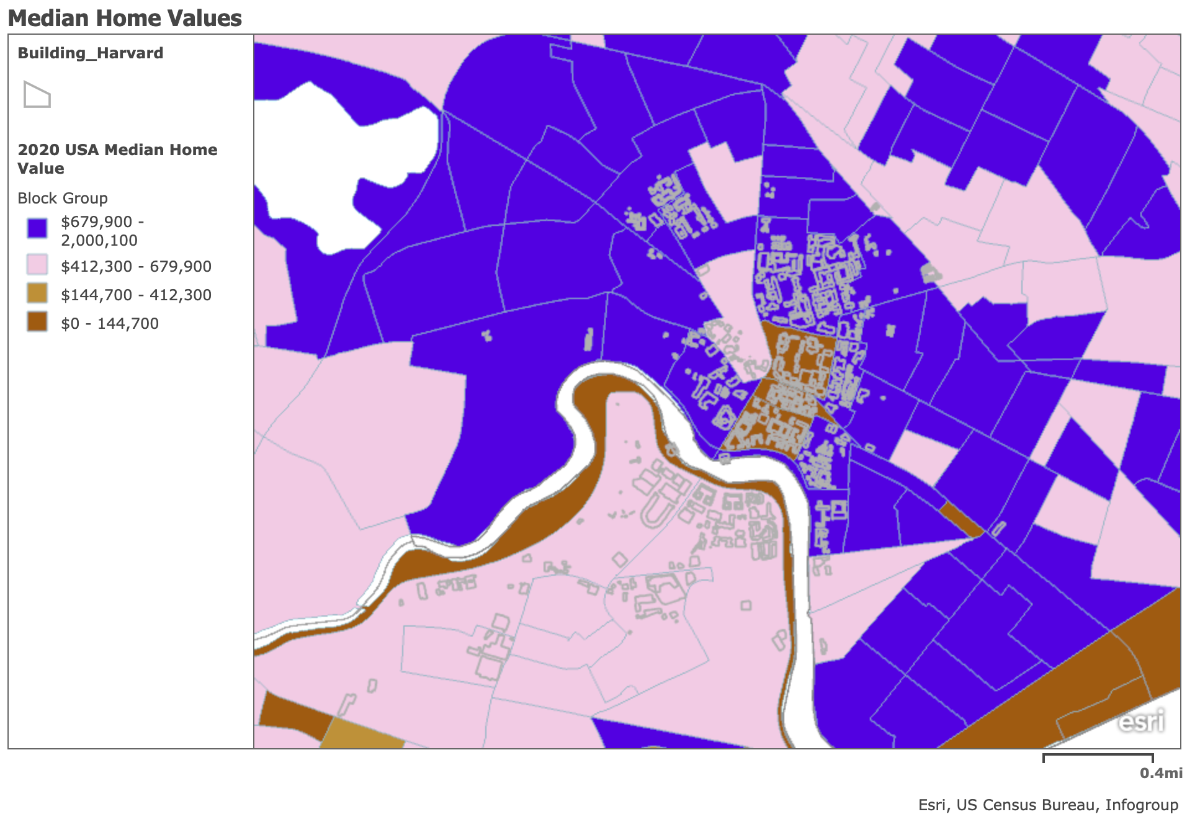
- 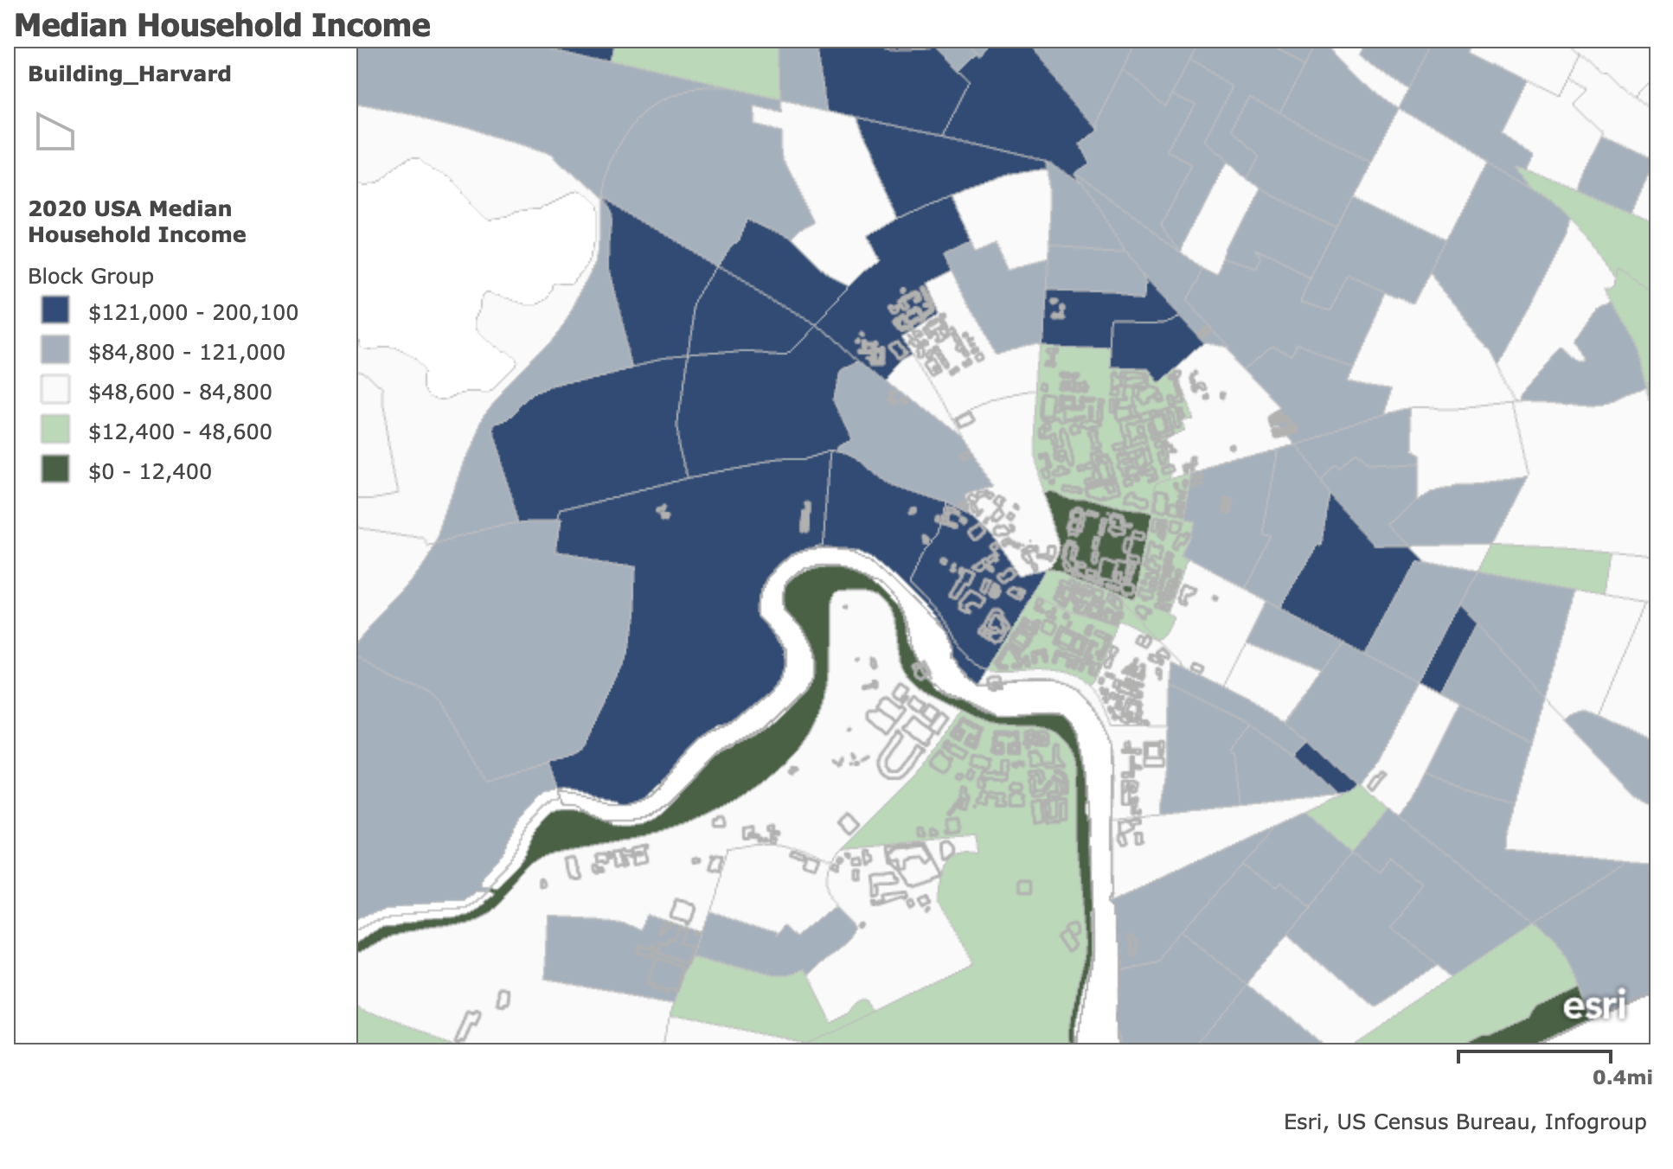
- 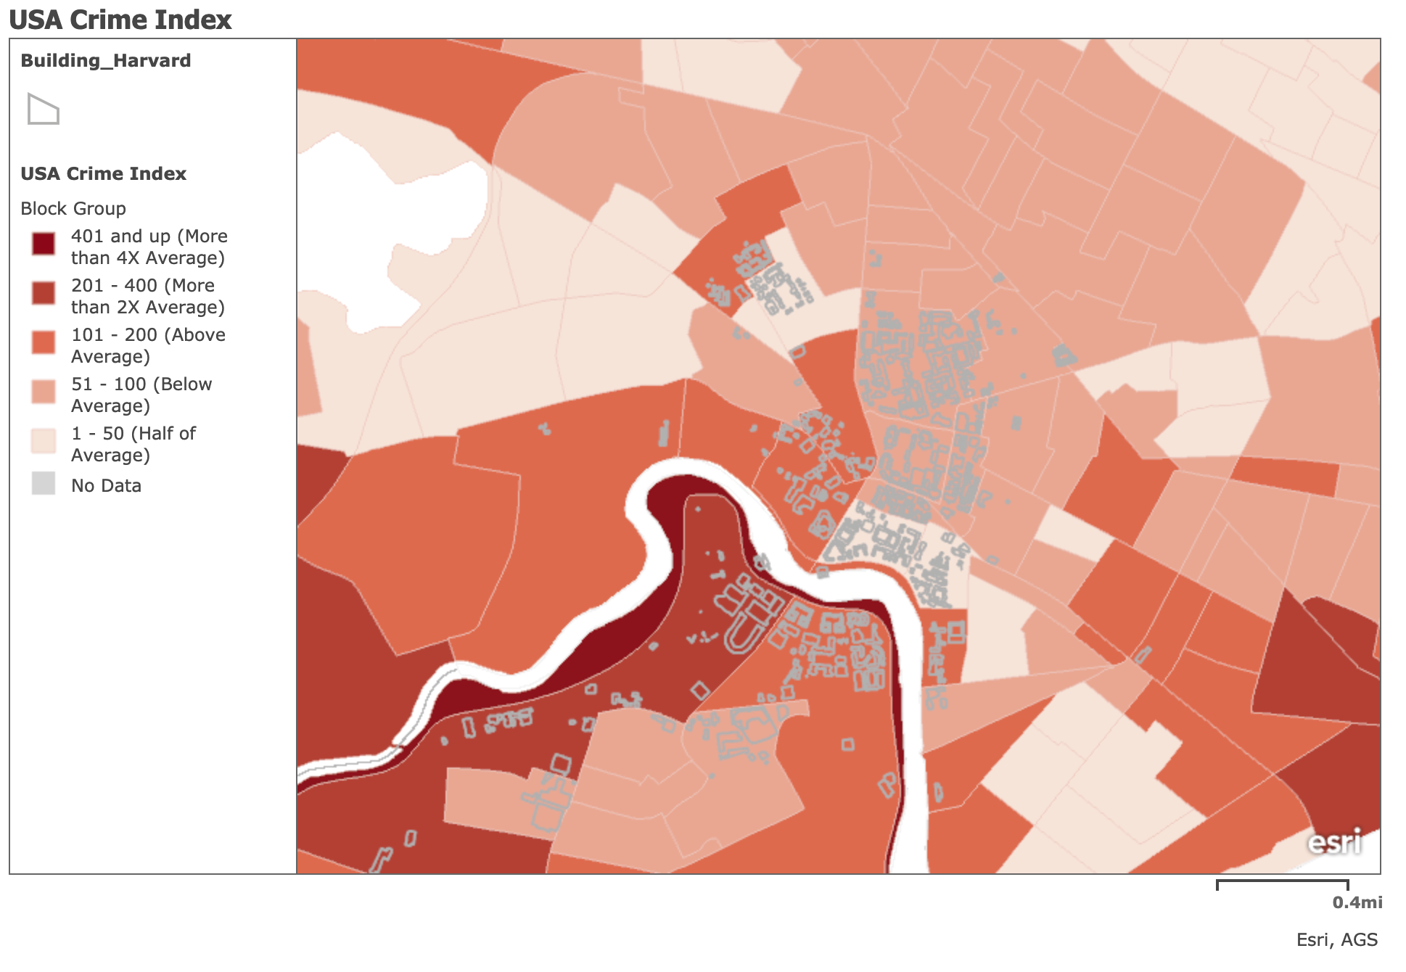
The area surrounding Harvard’s campus is saturated in predominantly dark purple— representing property values above $679,000 and below $2,000,000. There are also areas shaded in pink, representing the second highest value group between $412,000 and $679,000. Map A reveals that the concentration of high property values in this area is quite different from the distribution of wealth across the country: the national median home value is $235,127. In MA block group 250173541004, home to Harvard’s undergraduate river houses, the median home value in 2020 is $1,673,529. The yellow area in the center of Harvard’s freshman yard shows median home values from $0 to $144,700— as these are Harvard owned buildings, it is possible that this is a discrepancy related to Harvard’s unique property tax payment method which could skew property tax related value estimates of buildings.
Map B shows the majority of the land surrounding Harvard is saturated in either the dark blue color ($121,000 - $200,100 per year) or a grey color ($84,800 - $121,00)— the two highest income categories. Of course, the large student population living in the area may likely have little to no income during their time in school. The green color of some regions, indicating annual income between $12,400 and $48,600, can likely be explained by this population. Interestingly, Map A shows that in the same areas where there are high percentages of individuals whose income is in this low-income category, median property values remain hundreds of thousands of dollars over the national average.
Map C displays the geospatial distribution of crime in the Cambridge area. The crime index refers to the top eight crimes most frequently committed on a national level: murder, rape, robbery, aggravated assault, burglary, larceny, motor vehicle theft, and arson. The index value at the national level is 100 and any digit above or below 100 represents a percentage point difference from this national average index crime. The map shows that the area closest to Harvard Yard is a peach color, indicating a crime index in those areas over 50% below the national average. In the area on the Cambridge side of the Charles River most highly concentrated with Harvard buildings, the crime index remains in this below average rating.
Within the Harvard Bubble, there are low levels of disorder, high-income, and high property values. These characteristics are what make the Bubble a bubble: assurance of safety and necessities allows for Harvard affiliates to create a distinct community environment. In this environment, Harvard’s “multiversity” thrives: The Bubble is a safe place with an abundance of financial resources.
Housing for a “Private Club”
The Federal Fair Housing Act states that private institutions can legally provide exclusive housing to their “members”: “Housing provided for non-commercial purposes to the members of a private club, so long as the housing is never open to the public.” The US Department of Housing and Urban Development (HUD) details this exemption on a page of their website dedicated to “housing discrimination under the Fair Housing Act:”
“The Fair Housing Act covers most housing. In some circumstances, the Act exempts owner-occupied buildings with no more than four units, single-family housing sold or rented without the use of a broker and housing operated by organizations and private clubs that limit occupancy to members.”
Ultimately, universities are not the only institutions and landowners which benefit from the ability to restrict access to residential properties. Nonetheless, this exemption allows for Harvard to own and manage residential properties that are not accessible to the general public. In fact, Harvard need not adhere to Fair Housing law at all.
In short, Harvard’s properties are managed privately by Harvard’s own businesses— namely, “Harvard Real Estate Services,” “The Harvard Allston Real Estate Company,” and “Campus Services.” These entities build and manage all of Harvard’s property (with affiliation to contracted real estate professionals). Harvard Campus Services “University Housing” page looks like a real estate website— Harvard affiliates are made to submit rental applications after viewing properties as they would be listed in the general real estate market (including photos and videos, square footage, rent costs, neighborhood amenities, etc.). The only difference between this experience and that of a rental on the open market is that Harvard regulates their personal real estate market without intervention by the Fair Housing Act. Thus, Harvard can continue its now four-hundred-year-old tradition as a “private club” providing exclusive housing to their limited “membership.”
Some students are excluded from Harvard’s residential experience to begin with. There are some particular qualifications set by Harvard for residents of their properties. For example, undergraduate students who have children are not eligible to live in the undergraduate dorms. In particular circumstances, student parents are eligible to live in graduate student housing. Still, this restriction directly conflicts with Federal Fair Housing Act protections for “family status.” Thus, some members of Harvard’s “membership” are unable to access some exclusive benefits, though they are a part of Harvard’s “private club.”
There is a limited supply of Harvard’s exclusive housing and as such, many graduate students and affiliates are inherently unable to live in the Bubble. Broker A discussed Harvard’s housing shortage in an interview. He noted that although there are between 2,500 and 3,000 residential units available to graduate students, there is still not enough housing available for the entire student body. Indeed, many Harvard affiliates do live in the greater Boston area and not in Harvard’s residential buildings. Yet, the expensive cost of housing in Cambridge makes Harvard’s campus a difficult place to move near to. Broker A discussed compensation and financial aid as an opportunity for Harvard to mitigate this.
Harvard and its preferential treatment for affiliates regarding housing extends to home buying. Broker B detailed his experience working with Harvard affiliates to buy properties: both in purchasing properties from Harvard and in assisting affiliates in purchasing on the open market. He described the benefits some affiliates receive— in terms of housing— as part of their employment benefits with the University. He said,
“To facilitate some Harvard affiliates buying in the open market, I know from my own experience in assisting these people that Harvard will make some money available as part of their way of wooing the professor to come.”
In other words— without the Fair Housing Act restrictions, Harvard has the ability to wield their land holdings as an incentive for a person to become part of their “private club.” When Broker B noted that Harvard can “make some money available” to those potential affiliates who wish to purchase homes near to the University, he was referring to low interest loans— otherwise known as the Harvard Real Estate Advantage Program.
Harvard’s ability to assist affiliates with housing is meant to ease the impact of the rising cost of living in Cambridge on affiliates who need financial assistance. Broker A also noted that in his experience, “those drawn to the Harvard offerings are drawn to them because they’re on a reduced budget and if they didn’t take advantage of what Harvard is offering them, they’d otherwise not be able to own anything.” From this perspective, by offering financial assistance to those accepted to join the university in some way, Harvard is actually making itself more accessible by easing the burden of housing.
Over the past fifty years especially, the cost of living in Cambridge has increased dramatically. A 1986 New York Times article quoted Professor Emeritus of Sociology, George C. Homans who stated then that, “Cambridge as a home for Harvard people is dead.” Professor Homans perfectly described the potential for displacement of Harvard affiliates as a result of rising housing prices in Cambridge: without support from the university, affiliates renting or buying in the open market may be priced out of Cambridge and forced to live in more affordable nearby areas. Indeed, Cambridge, MA is the home of a uniquely competitive real estate market: regardless of ownership, there is simply a shortage of housing in the area. According to a 2006 Policy Briefing by the Harvard Kennedy School’s Rappaport Institute, it is this shortage of housing stock which has disrupted the equilibrium of the real estate market. The report describes the ways in which housing stock has not kept pace with demand, especially in the late 20th century. Notably, “In the 1960s, there were 172,459 units permitted in the Boston metropolitan area; in the 1980s, 141,347. However, despite the sharp rise in prices in the 1990s, only 84,105 units were permitted in that decade.” Increased demand for housing in Cambridge puts positive pressure on already rising prices.
Thus, despite remaining a hub for Harvard affiliates, businesses, workers, and otherwise, Cambridge lacks the housing stock to support its growing population. In 2019, the median home price in Cambridge, MA was over $1.9 million for a single-family home. This creates a considerable barrier for Harvard affiliates attempting to live near the university as students and academic professionals. Loans and cash assistance help Harvard to keep much needed faculty and staff close to campus and indeed, may “woo” anyone unsure of their opportunity to come to the university. These exclusive housing options and deals make it possible for people across the globe to make a home in the area.
Ultimately, high demand, high costs, and low supply of housing stock in Cambridge perpetuate the Bubble itself: Harvard has to control a huge portion of this already inaccessible housing market in order to exist. Arguably, if Harvard is to continue expanding as a university, while maintaining its tradition of hosting students and academics locally, the institution must continue to make housing exclusively accessible to its “membership”.
- Taxes and Accountability
At this point in history, Harvard owns hundreds of acres of land in Cambridge alone and its massive land holdings absorb surrounding Cambridge properties. According to Broker B, neighborhoods including “Harvard Square, Riverside, Agassiz, [and] Porter Square” are all enveloped by Harvard’s properties. He explained, for example, that “in West Cambridge where Harvard has a complex, they own on Concord Avenue, [he] listed and sold a home right over the rear lot line with a view onto it”. So, in fact, these properties were so close together that Harvard’s property could be accessed by walking across this particular private lot. Surely, this is not the only Cambridge property which is essentially on Harvard’s residential campus.
Unlike private owners nearby, Harvard pays property taxes through an exclusive deal with the local municipality. Harvard is a part of the City of Boston’s Payment In Lieu of Taxes (PILOT) program. This program asks for voluntary financial contributions from local institutions with over $15 million in assessed property. In the Boston area, these annual contributions are asked to be 25% of the assessed cash value of the tax-exempt land owned by each institution. Like other institutions, Harvard has never paid the full amount requested by the Boston municipality since the program’s inception in 2012. In 2019, Harvard was asked to pay $12.8 million and the city settled for $10.1 million instead. Ultimately, this amount included $6.3 million in “community benefits” and $3.8 million in cash contributions.
The “community benefits” aspect of the PILOT program encourages Harvard to engage with the public. As such, Harvard supports a broad range of community-based support efforts that often involve the student body as well as community members themselves, faculty, and staff. In Harvard’s 2019 Community Benefits report, the university listed pages of local support efforts. These included—among countless other services and initiatives—Harvard Law School’s pro-bono legal service for low-income Boston residents, partnerships with local public and charter schools, scholarships and tuition waivers, employment for local high school students, and funding for local non-profit organizations. Other notable examples include the Harvard Square Homeless Shelter and Y2Y: student-run homeless shelters for local folks in need of such services.
Harvard brings undeniable economic value to the City of Cambridge. Tangible “community benefits” aside, Harvard serves the Cambridge area as an “anchor institution.” In this role, the institution both indirectly and directly provides community oriented “resources and stakeholders” beyond those residing on Harvard’s properties. The positive influence that Harvard has on property values is one example of indirect resources provided to the greater Cambridge community: property near Harvard generally is expensive and has the potential to continue increasing in value. Broker A described Harvard’s real estate market as part of a greater whole— not a separate entity, but a contribution to the greater Cambridge area real estate market. He cited the “partnership” between local municipalities and Harvard specifically. Notably, he argued that if Harvard closed its doors, the real estate market in the entire state would collapse as a result.
Broker A cited Harvard Square as a place which exemplifies this partnership. The square’s business area took hundreds of years to develop, as the university itself gained world renowned prestige and wealth. Both Boston and Cambridge expanded as well, growing into the large metropolitan area it is today. Side by side, these municipalities, economies, and Harvard University supported the growing population in the area and beyond. Broker A said it best: “over hundreds of years, Harvard and the local government learned to live together: one provides water and the police and other— the GDP.” The needs of the Harvard community cannot be met without municipal services, and the economic might of Boston and Cambridge depends on Harvard’s institutional wealth.
Conclusions
Harvard is a powerful institution of higher education that owns massive amounts of land, of which it has unique autonomy over. The exception to Federal Fair Housing law allows Harvard to exclude its residential buildings from the general public and set qualifications for affiliates who seek housing. Harvard is not required by law to pay property taxes and the PILOT program allows contributions to the municipality to come in many forms— all dictated by Harvard itself. The barrier of wealth, safety, and security around the campus is only strengthened by the ability of the institution to own and designate accommodations exclusively for affiliates. As Kerr suggests, Harvard’s multiversity functions as “... a system of government like a city, or a city state:” it operates with sovereignty. With economic power and legal autonomy, Harvard has managed to create its own city village in the Bubble where there are low levels of disorder and expensive properties.
Recent events have challenged this: in March of 2020 —when the undergraduate student population of Harvard was suddenly removed from campus—the Bubble was metaphorically popped. Most undergraduates were forced to leave the pocket of wealth and safety where the Harvard experience normally plays out. Now, the bubble remains torn: with students and affiliates of all ages and specialties scattered across the globe— their former dwellings sitting vacant— Harvard has been forced to expand to all of the places people had to go. Outside of the campus’s protective enclave, Harvard’s “membership” has been forced to experience Harvard outside of the Bubble.
Certainly, this crisis has illuminated major differences in students’ backgrounds, identities, and socio-economic status and presented challenges for Harvard in accommodating students’ lives and needs through housing support. People come to Harvard from across the globe and represent a diverse group of people with varying nationalities, socio-economic positions, races, ethnicities, sexualities, and experiences— everyone has experienced this crisis differently.
Nonetheless, the actual expanse of space which Harvard takes up will likely maintain similar social conditions, even as the world experiences the great and lasting effects of the Covid-19 crisis. In the pandemic, Harvard’s stabilizing force and positive impact on property values is critical to homeowners in the area. Further, its influence on the surrounding environment will endure— the university is wealthy, well connected, and will likely maintain its ability to preserve the Bubble and the wealth and safety within its borders.
Ultimately, the Covid-19 pandemic reveals Harvard’s unique position as a wealthy landholder: it has the ability and potential to assist its affiliates and neighbors in getting through this crisis. Although people are near and far, Harvard is able to offer loans, cash and scholarships for housing costs per each student’s living situation and expenses. It is able to continue to house individuals who have leased apartments through the school; or purchased homes with financial assistance; as well as students who require housing due to extenuating circumstances. In this sense, the exclusivity of Harvard’s residential properties in the Bubble allows the university to make adaptive decisions to benefit its “membership” during this time. Each individual’s experience regarding housing and financial assistance from Harvard may differ with varying degrees of satisfaction, but the point is: Harvard can help, and Harvard will exist after this is all over.

References
Brown, R. (2018). Markets and Marketization in Higher Education. Encyclopedia of International Higher Education Systems and Institutions.
City of Boston. (2016, July 4). Payment in Lieu of Tax (PILOT) program. Boston.gov. https://www.boston.gov/finance/payment-lieu-tax-pilot-program.
Glaeser, E. L., Schuetz, J., & Ward, B. (2006). Regulation and the Rise of Housing Prices in Greater Boston. Pioneer Institute For Public Policy Research.
Goldrick-Rab, S. (2018). Alleviating Poverty and Promoting College Attainment in Philadelphia: September 2018. The Hope Center: For College, Community, and Justice, 1.
Gordon, C., & Behnisch, S. (2008). Harvard University's New Allston Campus. Bulletin of the American Academy of Arts and Sciences, 61(3), 23-29.
Harvard Campus Services. (2019, November 27). Harvard Real Estate Services. Harvard Square Real Estate Services. https://www.harvardsquare.com/venue/harvard-real-estate-services/.
Harvard Campus Services. Harvard University Housing. https://www.huhousing.harvard.edu/.
Harvard Real Estate Advantage Program. Harvard University. https://www.huhousing.harvard.edu/home-buying/real-estate-advantage-program-cash-back.
Harvard Square Homeless Shelter. https://hshshelter.org/.
Harvard University. (2019, December 19). Harvard Allston Land Company. https://www.harvardallstonland.org/home.
Harvard University. Harvard Campus Services. https://www.campusservices.harvard.edu/.
Harvard Undergraduate Student Handbook. Veterans, Married, and Family Student Housing. https://handbook.fas.harvard.edu/book/married-and-family-student-housing.
Harvard University Housing. Housing Eligibility. Harvard University Housing. https://www.huhousing.harvard.edu/apply/application-process/housing-eligibility.
Housing Discrimination Under the Fair Housing Act. U.S. Department of Housing and Urban Development (HUD).
Kerr, C. (1995). The Idea of a Multiversity. In The uses of the university (pp. 12–34). essay, Harvard University Press.
Koerner, A. (2020, December). The Harvard "Bubble": Maps. https://arcg.is/nDT1S.
Massachusetts Real Estate Pre-Licensing Course Study Guide. (2020). Freedom Trail Realty School, Inc.
Over 91-Acre Allston Purchase, a Fresh Political Maelstrom. Harvard Magazine. (2003, July).
Rosenberg, J. S. (2020, October 2). Harvard Endowment Valued at $41.9 Billion, Up 2.4 Percent. Harvard Magazine.
Riss, L. M., Deputy Assistant Secretary for Policy Development. (n.d.). Barriers to Success: Housing Insecurity for U.S. College Students (U.S., Department of Housing and Urban Development, Office of Policy Development and Research), 1.
Riskin-Kutz, O. (2019, March 8). For Seventh Year in a Row, Harvard Fails to Meet PILOT Program Recommendation. The Harvard Crimson.
Sharkey, Patrick. 2019 (paperback edition). Uneasy Peace: The Great Crime Decline, The Renewal of City Life, and the Next War on Violence. New York: W.W. Norton.167.
Special, R. E. (1979, December 4). A Diversity of Independence. The New York Times.
The City of Boston. (publication). Harvard FY20 Community Benefits Report: An Overview of Harvard University's Community Engagement in the City of Boston.
Y2Y Homeless Shelter. https://www.y2ynetwork.org/

Kerr, C. (1995). The Idea of a Multiversity. In The Uses of the University (pp. 12–34). essay, Harvard University Press.
Rosenberg, J. S. (2020, October 2). Harvard Endowment Valued at $41.9 Billion, Up 2.4 Percent. Harvard Magazine.
Kerr, C. (1995). The Idea of a Multiversity. In The Uses of the University (pp. 12–34). essay, Harvard University Press.
Gordon, C., & Behnisch, S. (2008). Harvard University's New Allston Campus. Bulletin of the American Academy of Arts and Sciences, 61(3), 23-29.
Over 91-Acre Allston Purchase, a Fresh Political Maelstrom. Harvard Magazine. (2003, July).
Goldrick-Rab, S. (2018). Alleviating Poverty and Promoting College Attainment in Philadelphia: September 2018. The Hope Center: For College, Community, and Justice, 1.
Riss, L. M., Deputy Assistant Secretary for Policy Development. (n.d.). Barriers to Success: Housing Insecurity for U.S. College Students (U.S., Department of Housing and Urban Development, Office of Policy Development and Research), 1.
Brown, R. (2018). Markets and Marketization in Higher Education. Encyclopedia of International Higher Education Systems and Institutions.
Riss, L. M., Deputy Assistant Secretary for Policy Development. (n.d.). Barriers to Success: Housing Insecurity for U.S. College Students (U.S., Department of Housing and Urban Development, Office of Policy Development and Research), 9.
City of Boston. (2016, July 4). Payment in Lieu of Tax (PILOT) program. Boston.gov. https://www.boston.gov/finance/payment-lieu-tax-pilot-program.
Riskin-Kutz, O. (2019, March 8). For Seventh Year in a Row, Harvard Fails to Meet PILOT Program Recommendation. The Harvard Crimson.
Massachusetts Real Estate Pre-Licensing Course Study Guide. (2020). Freedom Trail Realty School, Inc.
Kerr, C. (1995). The Idea of a Multiversity. In The uses of the university (pp. 12–34). essay, Harvard University Press.
Massachusetts Real Estate Pre-Licensing Course Study Guide. (2020). Freedom Trail Realty School, Inc.
Housing Discrimination Under the Fair Housing Act. Housing Discrimination Under the Fair Housing Act | HUD.gov / U.S. Department of Housing and Urban Development (HUD).
Harvard Campus Services. (2019, November 27). Harvard Real Estate Services. Harvard Square Real Estate Services. https://www.harvardsquare.com/venue/harvard-real-estate-services/.
Harvard University. (2019, December 19). Harvard Allston Land Company. https://www.harvardallstonland.org/home.
Harvard University. Harvard Campus Services. https://www.campusservices.harvard.edu/.
Harvard Campus Services. Harvard University Housing. https://www.huhousing.harvard.edu/.
Harvard Undergraduate Student Handbook. Veterans, Married, and Family Student Housing. https://handbook.fas.harvard.edu/book/married-and-family-student-housing.
Harvard University Housing. Housing Eligibility | Harvard University Housing. https://www.huhousing.harvard.edu/apply/application-process/housing-eligibility.
Housing Discrimination Under the Fair Housing Act. Housing Discrimination Under the Fair Housing Act | HUD.gov / U.S. Department of Housing and Urban Development (HUD).
Harvard Real Estate Advantage Program. https://www.huhousing.harvard.edu/home-buying/real-estate-advantage-program-cash-back.
Special, R. E. (1979, December 4). A Diversity of Independence. The New York Times.
Glaeser, E. L., Schuetz, J., & Ward, B. (2006). Regulation and the Rise of Housing Prices in Greater Boston. Pioneer Institute For Public Policy Research.
Koerner, A. (2020, December). The Harvard "Bubble": Maps. https://arcg.is/nDT1S.
The City of Boston. (publication). Harvard FY20 Community Benefits Report: An Overview of Harvard University's Community Engagement in the City of Boston.
The City of Boston. (publication). Harvard FY20 Community Benefits Report: An Overview of Harvard University's Community Engagement in the City of Boston.
Harvard Square Homeless Shelter. https://hshshelter.org/.
Y2Y Homeless Shelter. https://www.y2ynetwork.org/
Sharkey, Patrick. 2019 (paperback edition). Uneasy Peace: The Great Crime Decline, The Renewal of City Life, and the Next War on Violence. New York: W.W. Norton.167.
Koerner, A. (2020, December). The Harvard "Bubble": Maps. https://arcg.is/nDT1S.
Kerr, C. (1995). The Idea of a Multiversity. In The Uses of the University (pp. 12–34). essay, Harvard University Press.

