Too Rich for Aid, Too Poor for Tuition:
The College Affordability Dilemma for the Middle and Upper Middle Class
Jeffrey Prince ‘22
Concentration: Molecular and Cellular Biology
Course: SOCIOL 1104, Sociology of Higher Education

Abstract: With college tuition costs rising at a pace faster than inflation, middle and upper middle income families find themselves in a challenging position. While they are generally unable to qualify for significant need based federal and institutional grant aid or subsidized loans, they are also far from being able to afford college costs out of pocket. This paper utilizes a dual empirical approach consisting of an expert interview and student survey to investigate the ways in which three different types of institutions--Ivy League (and equivalent) universities, non-ivy private liberal arts colleges, and 4-year public universities--respond to the financial needs of middle and upper middle income families, as well as the consequences of these responses. The results suggest that Ivy League institutions are the most affordable for these families due to their robust and flexible financial aid programs, that 4-year public universities are the second most affordable as a result of their relatively low costs of attendance, and that non-ivy liberal arts colleges are least affordable as a result of high costs and insufficient aid to meet those costs.

​​The Harvard College Honor Code
Members of the Harvard College community commit themselves to producing academic work of integrity – that is, work that adheres to the scholarly and intellectual standards of accurate attribution of sources, appropriate collection and use of data, and transparent acknowledgement of the contribution of others to their ideas, discoveries, interpretations, and conclusions. Cheating on exams or problem sets, plagiarizing or misrepresenting the ideas or language of someone else as one’s own, falsifying data, or any other instance of academic dishonesty violates the standards of our community, as well as the standards of the wider world of learning and affairs.

X

Introduction

As higher education in the United States has transformed from a system catered only toward the social elites to a system of mass education and certification, affordability has become a central issue in higher education. In response to increasing tuition rates and growing affordability concerns, both universities and the federal government have created a number of financial aid initiatives, from grant aid packages to subsidized loans to work study programs, to ensure that students from low socioeconomic status backgrounds can afford higher education and gain access to the long term benefits that it can provide; however, the relatively low upper cutoff for most generous aid programs has left a large sect of American families, stranded in the middle. While their incomes are not low enough to qualify for most types of grant aid, they do not earn enough to even begin to cover the costs of higher education out of pocket. Students from these squeezed families are forced to make challenging decisions about what types of institutions they can afford to attend as well as what they are willing to sacrifice to finance their education.
My own experiences have suggested that different types of institutions respond differently to the financial needs of this “squeezed” middle to upper-middle class: I come from a family of six children whose parents belong to this income bracket, and my own experiences with college affordability and financial aid have varied drastically from the experiences of my siblings who have attended different types of universities despite us having the exact same family income level. As a Harvard student, I have been fortunate enough to receive approximately 40% grant aid and have had access to highly subsidized institutional loans. While securing that aid required a massive amount of paperwork and a letter of special circumstance, Harvard was willing and able to meet my financial needs and allow me to graduate with only modest loan debt, all of it coming from institutional or federal loans with low, subsidized interest rates. For one of my sisters who attends a non-ivy league private liberal arts college, however, the reality has been much more harsh. They have offered her no grant aid, and as such she has had to absorb a significantly higher degree of private loan debt to finance her education. Another one of my sisters attends a large public university, and she too was never offered any sort of grant aid as a result of our family’s income being too high to qualify. Although her base tuition is lower than that of some private universities, she still relies on large private loans to finance her education. My family’s personal experience with the challenges of affording higher education coming from this middle to upper middle income bracket, as well as the ways in which my experiences as a Harvard student have differed from those of my siblings who attend different types of institutions, motivated me to ask the following research question: How does affordability and access to financial aid differ between Ivy League universities, non-ivy private liberal arts colleges, and 4-year public universities for families with middle to upper middle annual incomes?
In pursuit of this question I employed two complementary empirical research methods. The first method included conducting an expert interview with a high ranking Ivy League financial aid administrator. In this interview I asked questions about the financial aid application process, the constraints that offices must navigate in awarding aid, and more. My second method focused on the student perspective: I designed an anonymous survey for Harvard students that gathered data on their family income and financial aid at Harvard as well as if they have any siblings in college, what types of institutions those siblings attend, what type of financial aid those siblings receive, and more.

Literature Review

While a four-year degree used to be a credential reserved for only the social elites, recent decades have seen a massive expansion in higher education enrollment and a parallel redefinition of the four-year degree as a requirement to gain or maintain a position in the middle class (Zaloom, 2019, p. 2). As institutions have expanded their enrollments and services over this time, college costs have also ballooned. The average combined cost of tuition and room and board for public, 4-year universities in the United States, which stands at $21,422 annually, has increased by 65% since the year 2000 and has more than doubled since 1980 (Hanson, 2021). Similarly, the average cost of attending a private, 4-year university, which is currently $46,448, has increased by 40% since the year 2000 and by 162% since 1980 (Hanson, 2021). While these numbers represent nationwide averages, the cost of attending many selective private universities has skyrocketed to greater heights at faster rates. For instance, according to the Harvard University Fact Book the total cost of attending Harvard has increased from $32,164 in the year 2000 to $74,500 in the year 2021, growing by an astonishing 132% in only 20 years time (Harvard Office of Institutional Research, 2016). In response to growing concerns about affordability, different actors--from the federal government to higher education institutions themselves--have instituted and reinforced a number of financial aid programs and policies aimed at increasing access to higher education to students who otherwise could not afford the high costs. While federal aid programs such as the Pell Grant have existed since the Higher Education Act of 1972, its maximum value has increased​ from $3,300 in 2000-2001 to $5,550 in 2010-2011 (Davidson, 2013). Moreover, Democratic Senators have recently introduced legislation to double its value by the 2027-28 award year and index its value to inflation for each subsequent award year (Gravely, 2021b). Institutions themselves have also made efforts to increase their need-based financial aid offerings. Recent analyses have shown that the average institutional financial aid rate for full time, first year undergraduates has increased from 18% in 2008-2009 to 24.1% in 2017-2018 (Gray, 2020). Moreover, at research universities the total amount of financial aid awarded to full time, first year undergraduates has increased by 125.8% over this same period (Gray, 2020). Recent data from the Pew Research Center suggests that these efforts are having a positive effect on accessibility for low-income students: The share of undergraduates enrolled at two and four year higher education institutions from families below the poverty line has increased from 12% in 1996 to 20% in 2016 (Fry & Cilluffo, 2019).
While these data are encouraging for the prospects of low-income families, the cutoff for substantial aid has remained relatively low despite ballooning costs, putting middle and upper middle-income families in a challenging position. On the federal side, the Consolidated Appropriations Act of 2012 reduced the income threshold for an automatic zero estimated financial contribution, a key factor that plays into being eligible for a full Pell Grant, from $32,000 to $23,000, and has also eliminated eligibility for students who would have received less than 10% of the maximum award (Davidson, 2013). Because even at public universities institutional need-based aid depends on many factors beyond family income, from the number of siblings one has to their marriage status, there are no explicit income cutoffs published for receiving significant need-based financial aid. For private universities, the calculation of one’s aid eligibility is even more complicated, often taking into account detailed information about parent and student assets from the tax rate that they pay to the value of real estate that they own to the current values of their savings and retirement accounts. As a recent investigation into net price calculators from the University of Pittsburgh described, variation in individual financial aid packages from the same institution among socioeconomically similar students can be substantial (Anthony et al., 2015). What is clear, though, is that many middle and high income families are not receiving sufficient aid to meet their financial needs.
A recent report from the American Enterprise Institute revealed that the share of first-year undergraduate loan takers whose families make more than $114,000 annually has increased from 16.4% in the 1995-1996 academic year to 29.9% in the 2015-2016 academic year (Delisle, 2019). In contrast, the share of first-year undergraduate loan takers whose families make between $22,000 to $42,000 rose by only 8.1% over that time period and is actually lower in 2015-2016 than the share of first-year undergraduate borrowers in the $114,000+ annual income bracket (Delisle, 2019). Moreover, the average amount borrowed among all first year-undergraduates in the $114,000+ annual income bracket is nearly double that of first year-undergraduates whose families make less than $42,000 annually (Delisle, 2019). Additionally, a smaller scale yet still illustrative report released by the Tennessee Higher Education Commission on the status of financial aid across the Tennessee Board of Regents’ thirteen community colleges and six universities found that a preponderance of students with expected financial contributions above than the Pell cutoff have unfunded tuition needs and that these needs may drive students to borrow (Deaton, 2014, p. 8). Another recent study on financial aid packaging at community colleges found that for students who receive a combination of grant aids and loans in their financial aid packages, a greater proportion of higher-income students rely more on loans than lower-income students (Luna-Torres et al., 2019). With this forgotten group of students gaining attention in recent years, Caitlin Zaloom has argued that membership in the middle class can now actually be defined by the experience of being too wealthy to qualify for major financial aid but too poor to pay their “expected” family contribution (Zaloom, 2019, p. 4). The increase in loan prevalence for this group suggests that a growing percentage of families find themselves in this position.
While assigning large grant aid packages to students from low-income families is a relatively simple task, a financial aid officer’s work becomes more complicated when disbursing aid to families in the middle to upper middle class gray area. Even the most detailed online forms are going to reduce complexities and rely on simplifications and standardizations, which as Zaloom describes leads to inevitable inaccuracies (Zaloom, 2019, p. 71). The growing prevalence of such inaccuracies, manifesting as discrepancies between what middle and upper middle income families are expected to pay and what they can actually afford, is evidenced by the recent increase in the number of families that are requesting financial aid appeals, a process by which financial aid administrators are asked to review students' financial needs more closely on a case-by-case basis: A survey of 224 community colleges, public and private nonprofit institutions, and for-profit colleges carried out by the National Association of Student Financial Aid Administrators in May 2021 found that 56 percent of surveyed institutions had experienced an increase in financial aid appeals since March 2020, with some institutions experiencing a greater than 50% increase in appeal rates (Gravely, 2021). This is where many middle to upper middle income families find themselves, entrenched in ongoing battles with financial aid offices in an effort to prove their unseen financial need with the COVID-19 pandemic only exacerbating the issue. In many cases this is a losing battle, and as such many families and students take on large amounts of debt to finance their education, refusing to compromise on what they see as their best chance for cultivating their futures (Zaloom, 2019, p. 191). There is a wealth of literature that describes the personal downsides and risks associated with taking on college debt, from the stifling of future student economic mobility to the limiting of future opportunities for asset accumulation (Bruecker, 2016). On a larger scale, accumulation of student debt in excess of the workable debt load for the degree obtained has also been shown to sharply decrease the general economic productivity and societal value potentially gained by accessing postsecondary education in the first place (Fincher, 2017). The economic impact of borrowing is not limited only to students: As college costs have grown to consume a larger share of family income than ever before, participation in parental loan programs has increased with parental loan values greatly exceeding those of student loans (Bowen et al., 2009, pp. 153-154). These risks situate the growing insufficiency of financial aid for middle and upper-middle class families as a major social and economic problem that should only increase given the current trajectory of tuition costs.
Applying for financial aid is not easy. A 2019 study from the University of Texas at Austin found that 75% of financial aid application instructions are unreadable by the average high school graduate with 41% of instructions written at or above a 14th-grade reading comprehension level (Taylor, 2019). For as challenging as it is to apply, financial aid is even harder to study given the complexity of award disbursement and the variation between institutional capabilities to provide need-based aid. Additionally, much of the research on financial aid and affordability has focused on low-income groups. For those reasons, as well as the general reluctance of middle and upper middle class families to publicly admit and discuss their financial struggles, there is very little existing literature that focuses on financial aid availability and college affordability for these groups. My research aims to fill this crucial gap. Given the heterogeneity of costs and financial aid offerings across Ivy League (and equivalent) universities, non-ivy private liberal arts colleges, and 4-year public universities, a one-size fits all approach is insufficient to studying the core issue of affordability for the middle and upper income group. Because of this, I employ a comparative approach meant to determine to what extent these different universities are affordable for this group as well as what enables them to be affordable (or not). In pursuit of these questions, my research focuses on the experiences of and relationship between two key groups: middle and upper middle class families, and the financial aid officers at different institutions who are responsible for preparing and disbursing their awards.

Methods:

In the course of this study, I sought to investigate how affordability and access to financial aid differ between Ivy League (and equivalent) universities, non-ivy private liberal arts colleges, and 4-year public universities for middle to upper middle class families. While databases managed by the US Department of Education like the National Student Loan Data System (NSLDS®) provide information on federal student aid loans and grants, there was very little publicly available data on the specifics of the financial aid provided by private institutions. Moreover, net price calculators use such reductive algorithms and vary so widely across different types of institutions that using them to simulate expected financial aid offerings for a set of model families was not a viable investigative strategy. This lack of readily available data, coupled with the lack of literature that investigates college affordability for the middle and upper middle classes through this comparative lens, necessitated that I collect new data in order to answer my research question. Additionally, in order to tell a complete story about financial aid I had to collect information both from the administrative and student sides, which in this case took the form of a financial aid administrator and the families applying for financial aid respectively.
For families in the middle to upper middle class, my primary goal was to gather data on the financial aid offerings available to them across the previously described three types of institutions, how the relationship between these aid offerings and the cost of attendance make the institutions affordable or not, and in the latter case how families finance their educations. Because family financial situations are so heterogeneous, any low throughput method of investigation such as conducting interviews would have failed to provide enough data to draw reliable conclusions. Additionally, in order to derive comparative information about the affordability of different types of institutions, I had to control for as many factors as possible that influence aid awards. One strategy that allowed for this was to survey students from families like mine who have multiple children that attend and have applied for financial aid at different types of institutions because students from the same family are highly likely to have the equivalent determinants of financial need (with the exception of the potential influence of time-dependent factors, like parents losing or gaining employment). As such, the true population of interest for this study was students from middle to upper middle income families who had applied for financial aid and had one or more siblings that attend or have attended a different type of institution than them and had also applied for financial aid at that institution. Because there was no way to readily identify members of this population, and given the constraints of who I could easily access, I constructed and sent an anonymous survey to Harvard students in Adams House, a population of approximately 450 students readily available to me by email. Given my research question, I constructed the survey in a way that gathered data on the Harvard student’s family income, their financial aid details, and the type of institution that their sibling(s) attended and the aid that they received among other things. Because Harvard students who apply for financial aid must annually fill out the CSS profile, which requires providing information about sibling financial aid packages and cost of attendance, it was fair to assume that they were likely to know--or at least have a good estimate of--this information.
For financial aid administrators, acquiring the depth of information necessary to understand the financial aid options available to middle and middle income families necessitated a more detailed, hands on approach than a simple survey. With this and my Ivy, non-ivy private liberal arts, and 4-year public comparative lens in mind, I planned on conducting expert interviews with at least one financial aid officer for each of the aforementioned types of institution. Over the course of a month I reached out to financial aid administrators from twelve different institutions, including four Ivy League universities, four non-ivy private colleges, and four 4-year public universities. Of the twelve, only two responded. After back and forth discussions with both, only one administrator ultimately agreed to an interview on the condition that it was anonymous and unrecorded. The one Ivy League financial aid administrator that I ended up interviewing suggested that I likely received such a low response rate for two key reasons. The first reason was that the month of November is especially busy for many admissions and financial aid offices given that they are processing early applications. The second reason was that in general it is rare for people to be friendly toward administrators at universities; despite the academic nature of my project, the recent history of lawsuits and media hit-pieces against admissions and financial aid offices is likely to have made any administrator reluctant to discuss behind the scenes information with an outsider. I postulated that financial aid officers might have ignored my requests out of a desire to keep their aid disbursement processes private, but the administrator whom I interviewed refuted this idea with the suggestion that schools actually want to have a program that is transparent towards families. Over the course of this interview I also asked about the specifics of their institution’s financial aid application and process, the constraints that they must navigate in awarding aid, and the flexibility that they are able to afford families applying for aid among other things.
Thus, my two key types of data for this study included the responses to a survey administered to Harvard students and my written notes from an interview with an Ivy League financial aid administrator. The survey was open from November 13th to November 22nd and was publicized over the Adams House email list on November 14th and November 16th. Overall, 39 Adams House students responded to the survey with 29 completing it fully. Because of my focus on investigating differences in college affordability and financial aid accessibility for siblings within the same family who attended different types of institutions, I centered my analysis on the 22 Harvard students who reported having at least one sibling who attends or has attended a postsecondary educational institution. I describe the step by step analytical approach that I took to further parse and analyze the survey data over the course of the findings section, as reviewing this information in that section of the paper provides the necessary immediate context for interpreting the data. Given the qualitative nature of the interview, I use it only to provide important context for the quantitative information derived from the survey responses. Finally, given the lack of existing literature on this type of analysis, I employed an inductive approach in researching the research question. Any hypothesis derived from existing literature would have been too narrow to effectively capture the research presented in this paper.
While the goal of employing a multi-faceted data collection approach was to acquire the most detailed and accurate information possible, there were several limitations with my method. First, the survey portion of my data collection depended entirely on the willingness of students to fill it out, which in this case resulted in a less than optimal number of complete responses. Moreover, given that my true target population was quite specific, the final sample size of middle to upper middle class respondents with siblings that received financial aid from one of the other types of institutions identified in the survey was fairly small. A more rigorous approach would have involved actually distributing this survey to students from each of the three different types of institutions, but doing so was not feasible for the scope of this project. In terms of my expert interviews, the general lack of responsiveness limited the efficacy of the interview strategy as a context providing tool.
While I have alluded to this previously, I also want to make it explicit that I come from an upper middle income family, receive financial aid at Harvard, and have siblings at other types of institutions that do not receive comparable aid packages. Although this experience served as an initial motivation to pursue my research question, I took great care to ensure that those experiences were not reflected or elevated in the survey or interview materials. While the survey was aimed at a particular population, it was designed to avoid the promotion of any result one way or another. Similarly, the interview questions were designed to gather detailed information but were deliberately designed to avoid biasing the interviewee in any way.
Given the involvement of human subjects in this research I also took a number of measures to ensure that my research met the highest standards of ethical conduct. First, both survey participants and the interviewee were provided detailed consent forms that informed them of the purpose and nature of their role. These forms also informed them that their participation was completely voluntary, that they could skip any questions, and that they could stop the survey or leave the interview at any time. Survey participants were further informed that the survey was completely anonymous and were asked to not provide any information that could be used to identify them in the survey responses. The interviewee was further informed that their interview was confidential and that no personal information or information that could be used to identify them was shared. Finally, the survey was conducted through the Harvard Qualtrics software with its responses being stored on a confidential third party server.

Findings

As described in the methods section, I focused my analysis on the 22 students that reported having at least one sibling who attends or has attended a postsecondary educational institution. In order to identify which of these student could be categorized as coming from middle or upper-middle class families, I plotted the distribution of annual family incomes for the 22 sibling cohorts represented in the survey:

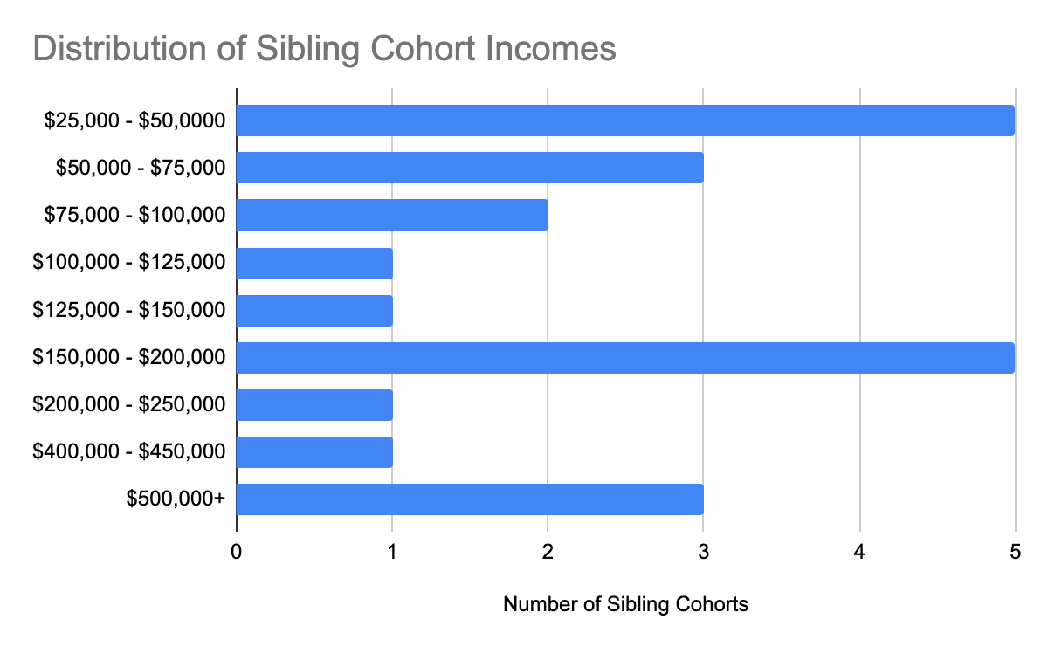

Interestingly, the annual family incomes formed a bimodal distribution with the $25,000 - $50,000 and $150,000 - $200,000 annual income categories being the most common. Each of the 3 sibling cohorts with annual family incomes of $500,000+ had their post secondary educations funded entirely out of pocket, so I excluded them from any further analysis given that they provide no insight into college affordability or financial aid access. Additionally, 37.8% of households in the United States had annual incomes of less than $50,000 in 2020, so I considered this a reasonable lower bound cutoff for the middle and upper middle income population of interest (U.S. Income Distribution 2019, 2021). Thus, excluding the responses reporting less than $50,000 of annual income or $500,000+ of annual income, the dataset contained 14 sibling cohorts from middle to upper middle class families. Of these cohorts, 10 included 1 sibling, 2 included 2 siblings, and 2 included 3 siblings. Taken together, these cohorts included 14 Harvard students, 2 other Ivy League students, 8 non-ivy liberal arts college students, and 8 4-year public university students. Because of the small sample size of non-Harvard Ivy League students, I did not focus on differences in affordability and aid availability between Harvard and other Ivy League universities, instead using Harvard students as a proxy for the entire Ivy League category.
After establishing these 14 middle to upper middle class sibling cohorts as the focus of my analysis, I turned my attention back toward addressing how financial aid access and college affordability differs by institution type for these families. In focusing first on financial aid accessibility, I calculated the average % of institutional financial aid received by Harvard students and their siblings who attended non-ivy private liberal arts colleges only for cohorts with both types of students present. Similarly, I calculated the average % of institutional financial aid received by Harvard students and siblings who attended 4-year public universities only for cohorts with both types of students present. Limiting the sample in each case to only sibling cohorts that contain both types of students is essential for normalizing the averages with respect to each cohort’s unique determinants of aid. Additionally, for the sibling cohorts in which two siblings attended non-ivy private liberal arts colleges or 4-year public universities, I double counted the Harvard student in the calculation of the averages, treating each non-Harvard to Harvard sibling comparison as its own entity for the same reason as above. Finally, I focused only on institutional aid because the uniformity of federal aid eligibility and disbursement all but ensures that siblings within the same cohort will receive the same federal aid. This is supported by the survey responses: For each cohort, either every sibling received federal aid or none of the siblings received federal aid. There were no mixed cases.

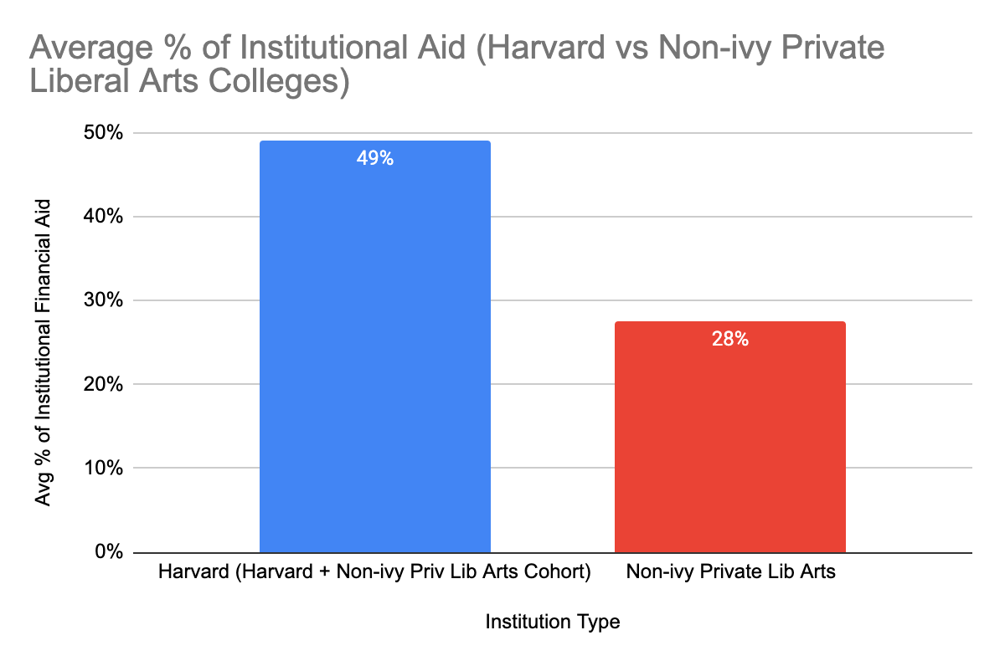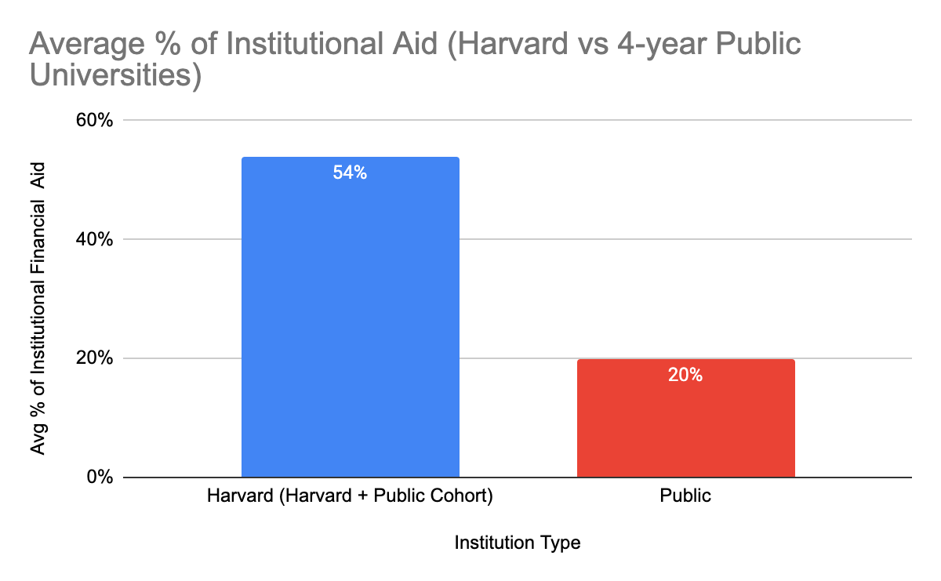
Although the sample sizes are quite small (n=4) for each graph due to the incomplete nature of some of the sibling aid information and the limited distribution of the survey, the responses do paint a consistent picture on the availability of institutional aid for middle and upper-middle class families. While Harvard students on average receive high percentages of need based financial aid (49% in Harvard plus non-ivy private liberal arts cohorts and 54% in Harvard plus 4-year public university cohorts), their siblings who attend non-ivy private liberal arts colleges on average receive a significantly smaller percentage of institutional aid (28%) with 4-year public university attending siblings faring even worse (20%). The lack of a large sample size prevents us from drawing any major quantitative conclusions, but these general relationships on aid availability are qualitatively informative. Given the high variation in cost of attendance across different types of institutions, however, more context is needed to comment on college affordability in general for middle to upper middle class families.
With this in mind, in order to examine affordability I began by calculating the average net cost (i.e. the total cost of attendance minus the institutional aid received) for the same two groups as above: Harvard students and their non-ivy private liberal arts college siblings in cohorts with both present, as well as Harvard students and 4-year public university siblings in cohorts with both present.

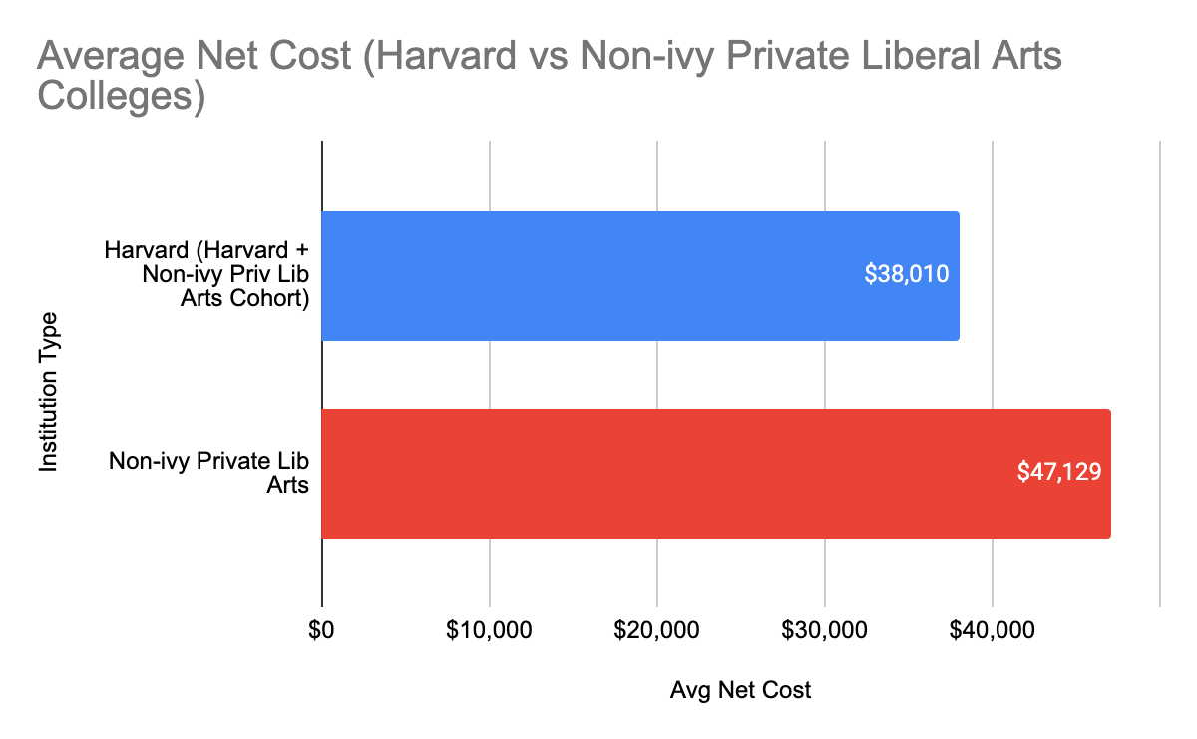

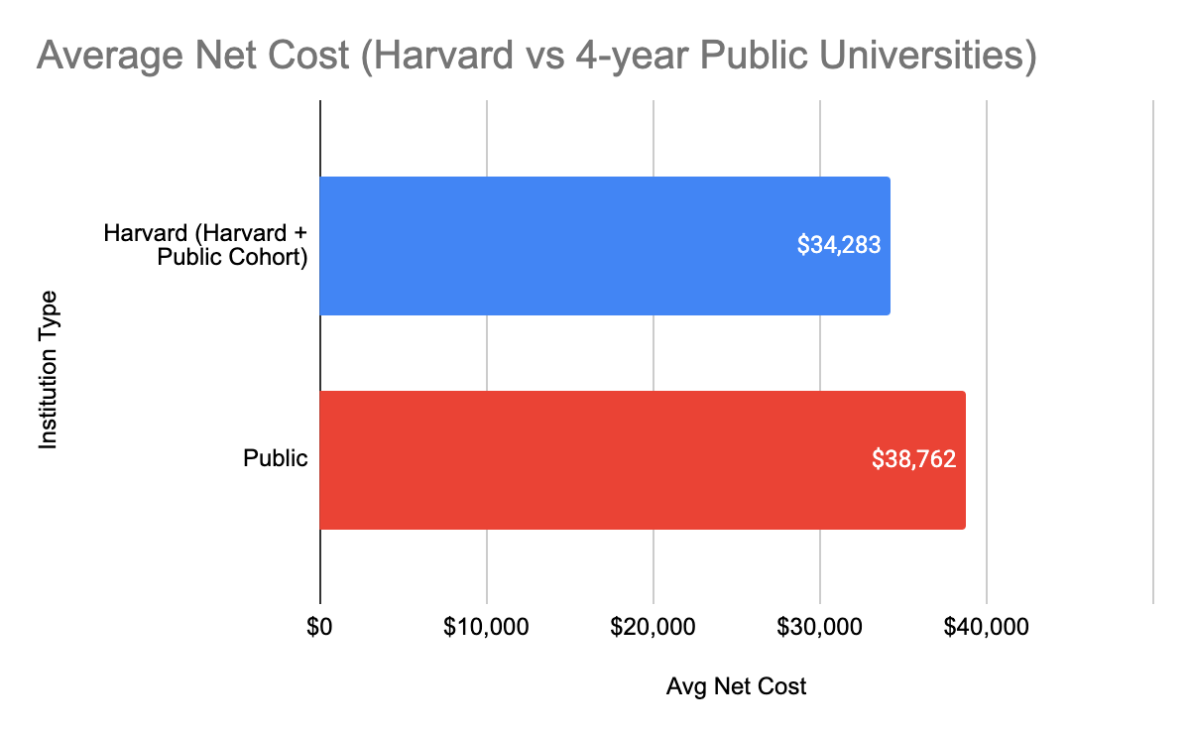
Again, although the small sample size limits our ability to conduct any rigorous statistical analyses, we can observe a clear qualitative hierarchy of net cost. Non-ivy liberal arts college attendees have an average net cost that is 24% higher than their Harvard siblings, whereas 4-year public university students have an average net cost 13% greater than their Harvard siblings. When considered in the context of the previous figures on financial aid, these data indicate that of the three categories, Harvard has on average the lowest net cost despite a high $74,500 cost of attendance before aid because of the significant institutional aid that it awards. Non-ivy private liberal arts colleges, on the other hand, on average have a much higher net cost as a result of maintaining a cost of attendance similar to Harvard without providing aid that is comparable to what Harvard offers. While 4-year public universities provide relatively low levels of institutional aid, their reduced cost of attendance before aid relative to non-ivy private liberal arts colleges keeps their net cost lower than those institutions (though it is still higher than that of Harvard).
Whether or not a postsecondary education is affordable, however, goes beyond observing its net cost. At its core, the affordability of an institution depends on the measures that families must take to finance its costs. With this in mind, I also examined the different approaches that siblings who attended different types of institutions took to finance their education. Each individual often used more than one method to pay for their education, so I created a plot that compares the frequency of these different methods for Harvard students and their siblings. Again, in order to control for family to family variation I compared the financing measures for Harvard students and their non-ivy private liberal arts college siblings only in cohorts with both present, and I applied the same strategy to the comparison of Harvard students and their 4-year public university attending siblings.

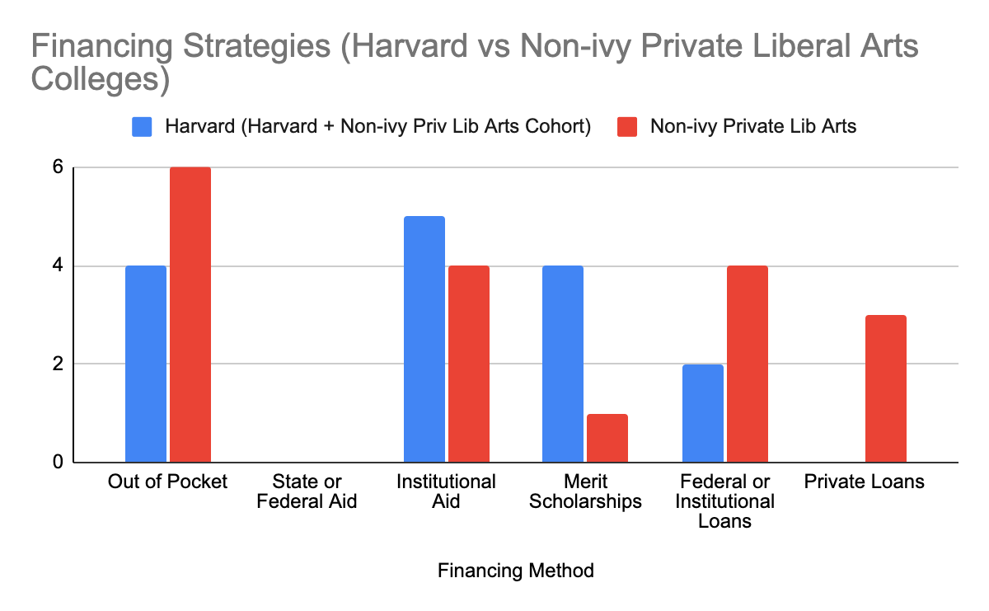
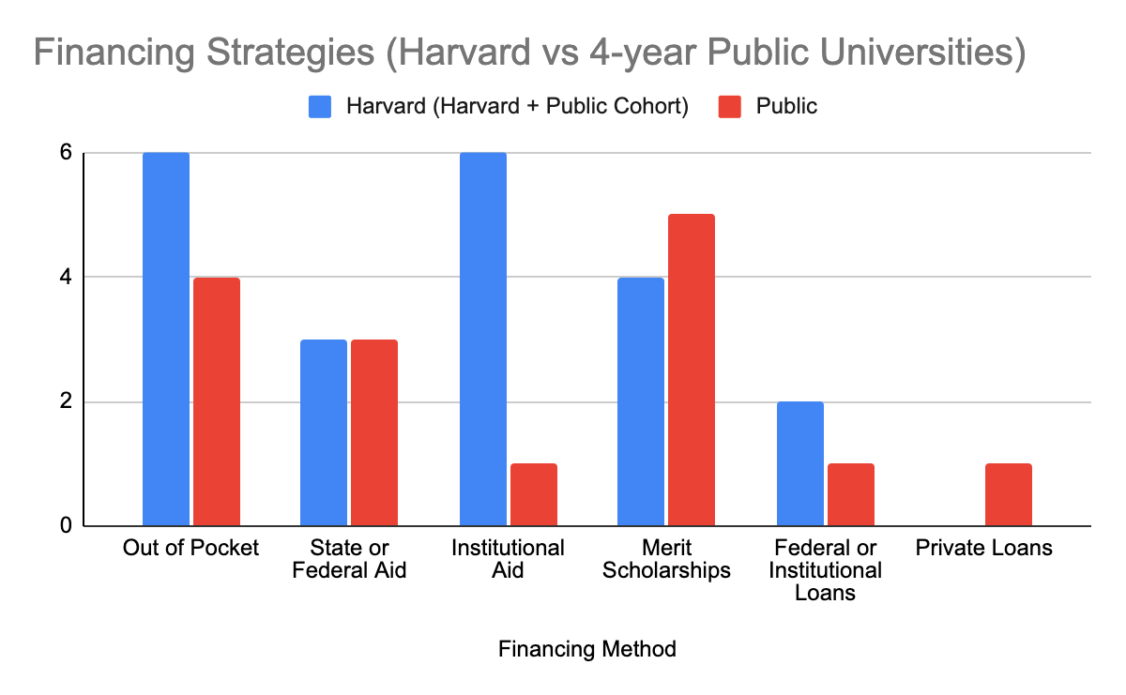

The first striking observation from these figures is the discrepancy in loans taken out between Harvard students and their non-ivy private liberal arts college attending siblings. Of the six sibling cohorts analyzed, non-ivy private liberal arts college attending siblings took out federal or institutional loans in 4 instances and private loans in 3 instances. Their Harvard siblings, on the other hand, took out federal or institutional loans in only 2 instances with no private loans whatsoever. Whether or not a family takes out a loan to finance a postsecondary education is an important piece of data because the act of taking out a loan indicates that the combination of a student’s aid and their immediately available family resources is not sufficient to support their college costs. For this reason, the frequency with which families take out loans to finance a college education is reflective of the affordability of an institution.
It is also important to note the difference between federal or institutional loans and private loans and the implications of taking each type of loan. Federal and institutional educational loans tend to have low, fixed interest rates. Additionally, many of these loans are subsidized and do not begin accumulating interest until the conclusion of a fixed grace period following a student’s graduation. Loans taken through private agencies, on the other hand, often provide less desirable financial terms including higher interest rates and the accumulation of interest immediately following disbursement. Because of this, it is preferable for a family to rely only on federal and institutional loans. These desirable loans, however, tend to have fixed maximum values. For instance, a first year undergraduate can borrow up to a maximum of $5,500 in federal loans annually with that number increasing to $7,500 for third year undergraduates and beyond (Subsidized and Unsubsidized Loans | Federal Student Aid, n.d.). “Harvard Student Loans”, which are loans with highly favorable terms available only to Harvard grant aid recipients, have a maximum annual value of $3,500 (Student Loan Request Form, n.d.). Thus, taking out private loans is a last resort financing measure that families only turn to if the combination of a student’s aid, their out of pocket resources, and the maximum amount available to them through federal and/or institutional loans is not sufficient to meet their college costs. This is substantiated by the fact that every student in the survey who used private loans to finance their education also used federal or institutional loans with the reverse not being the case.
This is all to say that the fact that non-ivy private liberal arts college attending siblings in this dataset relied on federal or institutional loans in 4 out of a possible 6 cases and private loans in 3 out of a possible 6 cases suggests that those institutions are less affordable than Harvard given that their Harvard siblings relied on federal or institutional loans in only 2 cases with no need to ever turn to a private loan. As a caveat, it is worth noting that Harvard students in these cohorts outpaced their non-ivy private liberal arts college attending siblings 4 to 1 in receiving merit scholarships, which could contribute to the loan discrepancy observed above.
The second interesting observation from these data is the major difference between Harvard students and their 4-year public university attending siblings in frequency of receiving institutional aid. While all 6 of the Harvard students with 4-year public university attending siblings received institutional aid, the same was true for only a single public university attending sibling in that group. This suggests a stark contrast in strategies from an institutional perspective: While Harvard seeks to make themselves affordable through the generous disbursement of grant aid, public universities opt for a different route, which could include but is not limited to maintaining a lower cost of attendance and encouraging students to apply for institutional merit scholarships. The relative similarity in loan data between Harvard students and their 4-year public university attending siblings suggests that these institutions do not differ significantly in terms of affordability.
While the data presented to this point paint a clear picture of the broad differences in institutional financial aid availability across Harvard, non-ivy private liberal arts colleges, and 4-year public universities, it has said little of some of the more nuanced, rarely studied aspects of financial aid availability. One understudied component of the financial aid landscape that I find to be particularly interesting is the financial aid appeal. A financial aid appeal is a process in which a family, after receiving their financial aid award, submits additional information to be reviewed by the financial aid office in an effort to receive a stronger award. This occurs most often but is not limited to instances in which a family’s financial situation changes between the time that they initially submitted their financial aid application and the present. Submitting a letter of special circumstance along with the traditional materials in the initial application process can also be considered an appeal. Harvard students can initiate this process by submitting a “reconsideration form”, which is linked on Harvard’s financial aid website. Having undergone this process multiple times personally, I was curious as to whether or not this was common to other institutions. As a result, the final question in each section of the survey asked whether or not a student or their sibling(s) had successfully submitted a financial aid appeal to their institution. For the data below, I employed the same cohort grouping strategy as described for each of the previous three sets of figures:
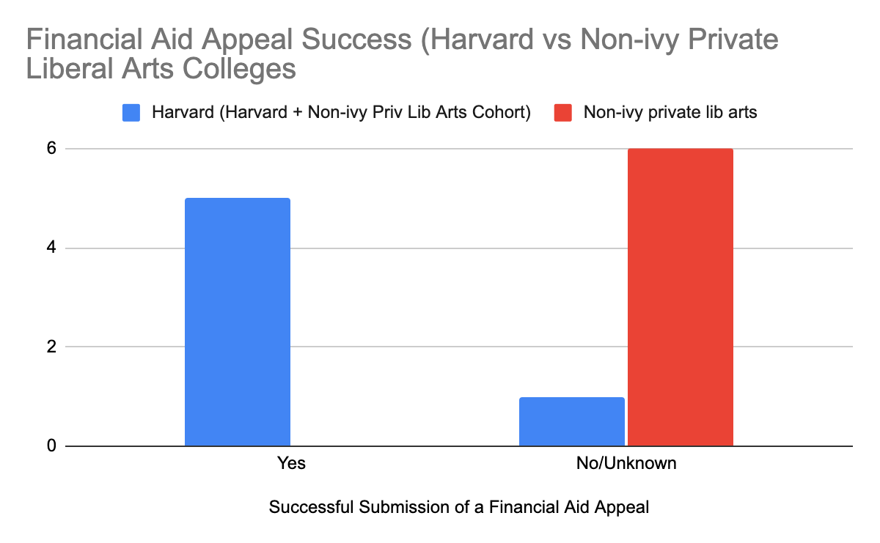
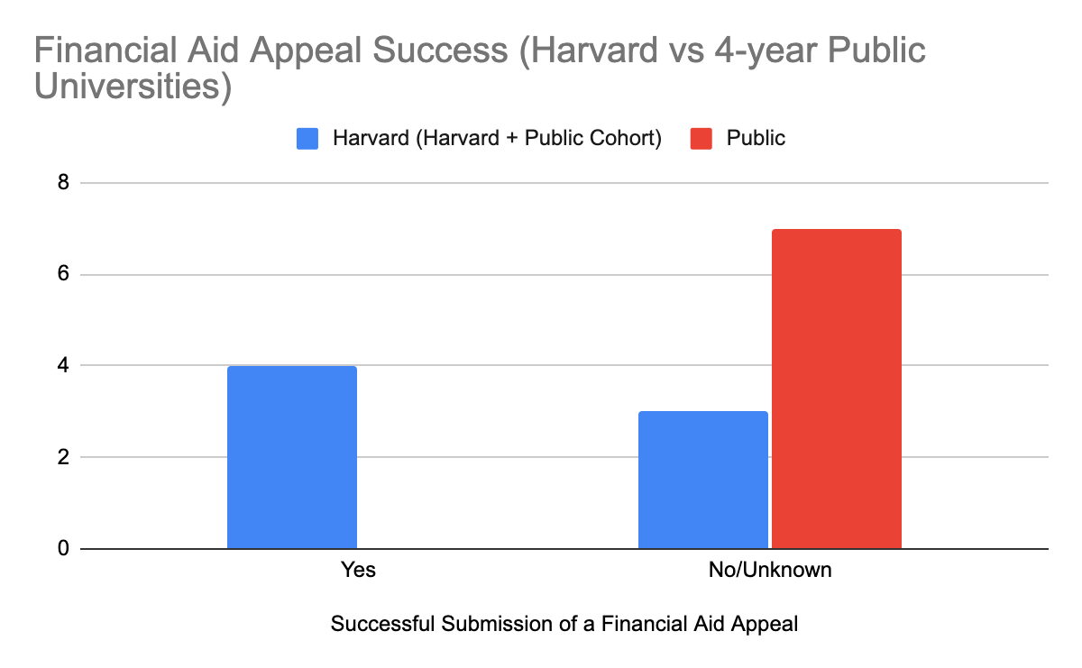
Upon reviewing these figures, the glaring difference in the frequency of successful financial aid appeals between Harvard students and their siblings from different types of institutions immediately stands out. While not a single non-ivy liberal arts college or 4-year public university attending sibling ever submitted a successful financial appeal, a majority of Harvard students did so in both sets of cohorts with an astounding 5 out of 6 Harvard students with non-ivy liberal arts college attending siblings submitting successful appeals. Harvard’s unique ability to respond to individual appeals says a lot about their financial aid process in general: Having the capacity to take the time to review a student’s financial situation a second time, as well as the ability to award more aid if needed, requires a certain critical mass of staff as well as a budget without strict limits. Ultimately, these findings demonstrate that while students from middle and upper middle class families who attend non-ivy liberal arts college or 4-year public university get what they get in terms of institutional aid, their Harvard siblings are able to effectively negotiate for an award that meets their needs by presenting more detailed or nuanced information than is normally requested and are often successful in doing so. This further supports the notion that Harvard is more affordable for middle and upper middle class families than non-ivy liberal arts colleges or 4-year public universities. While not included in any of the analyses or figures above, it is worth noting that of the 5 sibling cohorts with annual family incomes of less than $50,000, not a single Harvard student or sibling submitted an appeal, likely because they received high levels of aid on the basis of their family income alone. Going through the appeal process, it seems, is a primarily middle to upper middle class path.
Collectively, the data presented in the figures above make it clear that there are differences in affordability and financial aid accessibility for middle and upper middle class families across different types of postsecondary educational institutions. What the data lacks, however, is context from an expert that can provide insight into the reasons behind these differences. Fortunately, I had the opportunity to conduct a 60 minute interview with a high ranking Ivy League financial aid administrator with decades of experience in the field who was able to provide some of that key context.
Our first topic of discussion focused on the financial constraints that their office must navigate in preparing financial aid awards for students. They affirmed first and foremost that their office is committed to meeting 100% of financial need. I challenged this by asking if they would be able to meet this need if every single student admitted needed full financial aid. They suggested that because the admissions process and therefore the pool of admitted students is fairly consistent from year to year, they rarely encounter a situation where meeting 100% of student need exceeds what their allotted budget allows, but that they could find the funding if need be and that financial aid is an institutional priority. They do have a budget that they need to respect, but because their institution is highly committed to admitting a diverse class of students each year financial aid is the last thing to go in times of financial hardship. They further suggested that other types of institutions that are not as well resourced are likely to have much stricter budget cutoffs that prevent them from offering the same levels of aid to middle and upper middle class families. This difference between a flexible budget and a fixed budget could explain why an Ivy League institution like Harvard is able to provide higher levels of grant aid to students than other types of institutions as seen in the survey data.
We then discussed the financial aid application review process at their institution. They said that like every school they require the FAFSA because this form determines Pell Grant and federal loan eligibility, but they also suggested that the estimated financial contribution (EFC) determined by the FAFSA can grossly overestimate what a family can actually afford to pay. They also require the CSS profile, which is more nuanced, takes in more information about income and assets, and usually provides a more generous estimate of the EFC. They suggested that generally speaking, any school that uses the CSS profile is trying to be more generous with their aid and therefore is capable of being more generous with their aid. Interestingly, most public universities do not accept the CSS profile with many of the institutions who do accept it being Ivy League universities and non-ivy private liberal arts colleges (CSS Profile Participating Institutions and Programs, n.d.). The Ivy League administrator went on to explain that their institution has their own computational tool that makes a nuanced calculation based on the CSS and FAFSA before trained staff digest and scrutinize the information suggested by the tool. They strive to be even more generous than the CSS profile estimate.
I then asked about the financial aid appeal process at their institution. The administrator explained that Ivy League institutions and equivalents are able to respond to special circumstances as a consequence of their strong financial and human resources. At their institution in particular, students can appeal at any time of the year, and the appeal will be presented to a committee of 15 people where its merits are thoroughly considered on a case by case basis. Evidently, the ability to individually review appeals and letters of special circumstance in a thorough manner requires a significant amount of trained staff attention. The administrator explained that outside of the top Ivy League institutions, most offices are struggling with staffing shortages. A recent article from Inside Higher Ed suggests the same (Gravely, 2021c). This relative lack of manpower, coupled with tighter budgets, for other types of institutions explains why Ivy League financial aid offices are uniquely capable of providing students with the opportunity to appeal their aid awards.
Finally, when the discussion turned to comparisons between different Ivy League institutions, the administrator suggested that many Ivy and Ivy equivalent private research institutions (Stanford, MIT, etc.) have financial aid models and capabilities that are similar to one another. For this reason, I was comfortable with using survey data on only Harvard students to make comments about Ivy League institutions in general.

Conclusion

In this study, I sought to investigate how affordability and access to financial aid differ between Ivy League universities, non-ivy private liberal arts colleges, and 4-year public universities for middle to upper middle class families. In order to answer this question, I employed two complementary empirical research methods. First, I designed an anonymous survey for Harvard students that gathered data on their family income, financial aid at Harvard, the measures they took to finance their Harvard education, as well as if they have any siblings in college, what types of institutions those siblings attend, and the same set of financial aid and financing information for that sibling. From this survey, I ended up with 14 sibling cohorts from middle to upper middle class families that I analyzed in great detail. First, I found that while Harvard students on average receive high percentages of need based financial aid, their siblings who attend non-ivy private liberal arts colleges on average receive a significantly smaller percentage of institutional aid with 4-year public university attending siblings faring even worse. Second, I found that non-ivy liberal arts college attendees have an average net cost that is 24% higher than their Harvard siblings, whereas 4-year public university students have an average net cost that is only 13% higher than their Harvard siblings. Third, I found that non-ivy private liberal arts college attending siblings took out federal or institutional loans and private loans at higher rates than their Harvard counterparts. Fourth, I found that Harvard students received institutional aid far more frequently than their 4-year public university attending siblings but that there was no significant difference in loan data between these two groups. Finally, I found that while a majority of Harvard students had in the past submitted a successful financial aid appeal, not a single non-ivy liberal arts college or 4-year public university attending sibling had ever done the same.
My second research method involved interviewing a high ranking Ivy League financial aid administrator in an attempt to gain context for the survey data. In this interview I asked questions about the financial aid application process, the constraints that offices must navigate in awarding aid, the logistics of a financial aid appeal process, and more. First, I learned that while Ivy League institutions have large, flexible budgets, other institutions have smaller budgets with stricter cutoffs. Second, I learned that for the most part only Ivy League and non-ivy private liberal arts colleges require the CSS profile, a document that gives a more detailed and generous assessment of financial need than the FAFSA, which helps to explain why 4-year public universities who use only the FAFSA to determine aid eligibility give relatively low amounts of institutional aid. Third, I learned that the financial aid appeal processes found primarily at Ivy League institutions are rare because of the large staff and budget flexibility that they require. Taken together, the results in this paper suggest that Ivy League institutions are the most affordable for middle and upper middle class families due to their robust and flexible financial aid programs, that 4-year public universities are the second most affordable as a result of their relatively low costs of attendance, and that non-ivy liberal arts colleges are least affordable as a result of having high costs without sufficient aid to meet those costs.
The biggest limitation on the generalizability of this study is the small sample size of middle to upper middle class sibling cohorts in the dataset. Thus, my first recommendation for future research would be to repeat the survey with distribution to thousands of students to enable more quantitative analyses. Additionally, I would recommend distributing the same survey directly to non-ivy liberal arts college students and 4-year public university students to increase the dimensions of comparison and ensure a more complete dataset. Finally, I would recommend carrying out this study over a longer period of time to ensure that it is possible to interview financial aid administrators from each of the institution types in question.

Bibliography

Anthony, A. M., Page, L. C., & Seldin, A. (2015). In the Right Ballpark? Assessing the Accuracy of Net Price Calculators. SSRN Electronic Journal. https://doi.org/10.2139/ssrn.2555051
Bowen, W. G., Chingos, M. M., & McPherson, M. S. (2009). Crossing the finish line: Completing college at America’s public universities (Nachdr.). Princeton University Press.
Bruecker, E. M. (2016). Book Review: The Real College Debt Crisis: How Student Borrowing Threatens Financial Well-Being and Erodes the American Dream. Journal of Student Financial Aid, 46, 4.
CSS Profile Participating Institutions and Programs. (n.d.). Retrieved December 17, 2021, from https://profile.collegeboard.org/profile/ppi/participatingInstitutions.aspx
Davidson, C. (2013). Changes to Federal Pell Grant Eligibility: The Effect of Policy and Program Changes on College Students at Public Institutions in Kentucky. Journal of Student Financial Aid, 43(3), 22.
Fincher, M. E. (2017). Debt Profiles of Model Students: The Projected Debt of Highly Productive Students and Its Economic Impact. Journal of Student Financial Aid, 47(1), 16.
Gravely, A. (2021a, June 3). Pandemic Fuels Increase in Financial Aid Appeals. Inside Higher Ed. https://www.insidehighered.com/quicktakes/2021/06/03/pandemic-fuels-increase-financial-aid-appeals
Gravely, A. (2021b, June 17). Democrats Introduce Legislation to Double Pell Grant. Inside Higher Ed. https://www.insidehighered.com/quicktakes/2021/06/17/democrats-introduce-legislation-double-pell-grant
Gravely, A. (2021c, November 2). Financial Aid Offices Face Staffing Shortages. Inside Higher Ed. https://www.insidehighered.com/news/2021/11/02/higher-ed-staff-shortages-hit-financial-aid-offices
Hanson, M. (2021, August 15). Average Cost of College & Tuition. Education Data Initiative. https://educationdata.org/average-cost-of-college
Jason Delisle. (2019). The surprising role of high-income families in student debt trends: Examining undergraduate borrowing by income, 1995–96 to 2015–16. https://www.aei.org/research-products/report/the-surprising-role-of-high-income-families-in-student-debt-trends-examining-undergraduate-borrowing-by-income-1995-96-to-2015-16/
Luna-Torres, M., McKinney, L., Burridge, A. B., Horn, C., & Jones, S. J. (2019). Financial Aid Packaging at Community Colleges: Which types of awards packages increase student persistence? Journal of Student Financial Aid, 49(1), 30.
Office of Institutional Research. (2016, June 29). Harvard College tuition, fees, room, and board. Harvard Office of Institutional Research. Retrieved October 27, 2021, from https://oir.harvard.edu/fact-book/undergraduate_package.
Richard Fry & Anthony Cilluffo. (2019, May 22). A Rising Share of Undergraduates Are From Poor Families. Pew Research Center’s Social & Demographic Trends Project. https://www.pewresearch.org/social-trends/2019/05/22/a-rising-share-of-undergraduates-are-from-poor-families-especially-at-less-selective-colleges/
Russ Deaton & David L. Wright. (2014). A Student Level Analysis of Financial Aid. Tennessee Higher Education Commission.
Steffon M. Gray. (2020, August 11). Trends in Institutional Financial Aid at U.S. Public Colleges and Universities. NACUBO. https://www.nacubo.org/Publications/The-Solutions-Exchange/Trends-in-Institutional-Financial-Aid-at-US-Public-Colleges-and-Universities
Student Loan Request Form. (n.d.). Harvard College. Retrieved December 16, 2021, from https://college.harvard.edu/student-loan-request-form
Subsidized and Unsubsidized Loans | Federal Student Aid. (n.d.). Retrieved December 16, 2021, from https://studentaid.gov/understand-aid/types/loans/subsidized-unsubsidized
Taylor, Z. W. (2019). Six Easy Steps: Do Aspiring College Students Understand How to Apply for Financial Aid? Journal of Student Financial Aid, 48(3), 19.
U.S. income distribution 2019. (2021, September). Statista. https://www.statista.com/statistics/203183/percentage-distribution-of-household-income-in-the-us/
Zaloom, C. (2019). Indebted: How Families Make College Work at Any Cost. Princeton University Press. https://doi.org/10.1515/9780691195421

Appendix 1: Interview and Survey Guides

Survey Guide:
- What is your approximate family income level?
  - Visual: A drop down bar listing different incomes ranging from $0 - $500,000+ in increments of $25,000 up to $150,000 and increments of $50,000 from then on
- Describe your level of Harvard Financial Aid:
  - Visual: A sliding scale from 0% to 100%
- Have you ever successfully appealed your financial aid decision or submitted a letter of special circumstance?
  - Visual: Multiple choice with the options Yes or No
- Which of the following measures do you use to fund your education?
  - Visual: Checkboxes with the following options … “State or Federal Aid”, “Institutional Aid”, “Merit Scholarships”, “Out of pocket”, “Federal or institutional loans”, “private loans”
- If you have siblings, how many attend or have attended a postsecondary educational institution (4-year college, 2-year community college, etc.)?
  - Visual: Multiple choice with the options 0, 1, 2, 3, 4, 5+

Conditional design: Using Qualtrics logic functionality, for every sibling that a student indicates attends or has intended a postsecondary educational institution, a new set of the following questions will be displayed (i.e. if 2 siblings are indicated, the following questions will be asked twice; if 0 siblings are indicated, no question will be generated)

Sibling generated exemplar questions:

- Which type of institution did/does this sibling attend?
  - Visual: multiple choice with the options “Ivy league college (or equivalent i.e. Stanford, MIT, University of Chicago etc.)”, “non-ivy private liberal arts college”, “public university (4 years)”, “community college (2 years)”
- Describe their level of Financial Aid:
  - Visual: A sliding scale from 0% to 100% with the option “Unknown” at the bottom
- Describe the annual “sticker price” of their tuition plus room and board (i.e. cost before aid)
  - Visual: A sliding scale from $0 to $100,000 with the option “Unknown” at the bottom
- Have they ever successfully appealed a financial aid decision or submitted a letter of special circumstance?
  - Visual: Multiple choice with the options Yes, No, or Unknown

- Which of the following measures do they use to fund your education?
  - Visual: Checkboxes with the following options … “State or Federal Aid”, “Institutional Aid”, “Merit Scholarships”, “Out of pocket”, “Federal or institutional loans”, “private loans”, or “Unknown”

Interview Guide

Draft Interview Questions:

- Please describe your professional role
- What does the financial aid application process look like at your institution? Specifically, what documents and information do you collect from families?
- What does the financial aid application review process look like for your office? How are decisions made regarding a student’s financial aid award?
- What types of financial aid does your office offer to students?
- What type of financial constraints must your office navigate in preparing financial aid awards?
- Is your office receptive to individual appeals and letters of special circumstances? In other words, do you award aid to students who might otherwise not qualify for financial aid under your traditional procedures?
- Does your office have or collect data on the financing measures that families take to pay for tuition?
- I reached out to 16 financial aid officers, 2 responded, and 1 agreed to an interview. Why might this be?

Appendix 2: Recruitment Letter

Interview Recruitment Letter

Dear […],

My name is Jeffrey Prince, and I am a senior at Harvard taking a course on the sociology of higher education (SOCIOL1104). As part of this course, I am researching financial aid availability and college affordability for middle and upper middle class families. I would like to conduct one short, max 20 minutes interview via Zoom at a time convenient to you to understand the details of the financial aid application and disbursement process at your institution.

Your answers will be kept confidential and your name will not appear in any data records (transcripts), any information that could possibly identify you will be removed, and no names or other identifiable information will be used in the final paper nor on HUSRHE platform: https://husrhe.fas.harvard.edu/ where our paper will be showcased. Immediately after the interview is conducted a special code will be generated for the record and the label will include following terms “administrator/faculty member-date of interview”.

The project is exempt from CUHS approval since it qualifies as course-related research.

We hope you can support our research by agreeing to be interviewed. Please let me know if you would be willing to be interviewed and when you would be available.

Thank you,
Jeffrey Prince

Survey Recruitment Email Blurb

Dear Adams House Students,

I am taking a course on sociology of higher education (SOCIOL1104). As part of this course, I am researching financial aid availability and college affordability. I would greatly appreciate if you could take no more than 5 minutes to fill out this completely voluntary and anonymous survey on you and your family’s financial aid experience:

(link will be available in the actual blurb)

Appendix 3: Letters of Consent

Interview Letter of Consent

SOCIOL1104 Sociology of Higher Education - Course Projects

CONSENT FORM for INTERVIEW

My name is Jeffrey Prince, and I am asking you to take part in my course research project on financial aid availability and college affordability for middle and upper middle class families in the course SOCIOL1104 Sociology of Higher Education offered at the Department of Sociology, Faculty of Arts and Sciences, Harvard University.

I would like to conduct a short interview with you as part of my research project. The interview will last about 20 minutes. Your participation is voluntary. Please tell me if you do not want to participate. You can skip questions that you do not want to answer or stop the interview at any time.

I am asking you to consent to a confidential interview. If you consent to a confidential interview, then I will keep the information I gather from this interview confidential and will not share your personal information or any information that could identify you with anyone. If I use any quotes from the interview, I will not disclose your name or position or any other information that could identify you. I will refer to the source of the quote in generic terms for the position and organization or group you are involved in (for example, “a Harvard administrator” or “a member of a student group” or “a leader of a student group”).

I am also asking you to consent to audio recording of the interview for confidential use
If you consent to recording of the interview for confidential use, I will audio record this interview to enable me to focus on the questions and keep a record of your statements for further analysis. I will treat this recording as a part of a confidential interview. I will keep the information I gather from this interview confidential and will not share your personal information or any information that could identify you with anyone. If I use any quotes from the interview, I will not disclose your name or position or any other information that could identify you. I will refer to the source of the quote in generic terms for the position and organization or group you are involved in (for example, “a Harvard administrator” or “a member of a student group” or “a leader of a student group”). Only my course instructor will have access to the transcript.

Please inform you consent to:

Do you consent to a confidential interview? YES NO

Do you consent to audio recording the interview for confidential use? YES NO

Participant name: ______________________________________________________________
Participant signature :_______________________________________________________________________
Date: ________________________

Questions? Please contact the SOCIOL 1104 course instructor Dr. Manja Klemencic at manjaklemencic@g.harvard.edu .

Survey Letter of Consent

SOCIOL1104 CONSENT FORM FOR ONLINE SURVEYS

My name is Jeffrey Prince, and I am asking you to take part in my class project on financial aid availability and college affordability for the research-intensive course SOCIOL1104 Sociology of Higher Education, in which I am an enrolled student this Fall 2021.

If you choose to participate, I ask you to complete a survey. This survey will help me learn more about you and your family’s financial aid experience

You can skip questions that you do not want to answer or stop the survey at any time. Participating in this study is voluntary.

The survey is anonymous, and no one will be able to link your answers back to you. Please do not include your name or other information that could be used to identify you in the survey responses.

Please mark your decision:

I consent to this anonymous survey (A check box will be provided next to this option at the beginning of the Qualtrics survey).

Please close the web page if you do not want to participate.

Questions? Please contact the SOCIOL1104 course instructor Dr. Manja Klemencic at manjaklemencic@g.harvard.edu .

