Ellie Grueskin ’22.5
“Playing Your/The Part: Examining The Optimal Leadership Structure For Kirkland Drama Society”
Sociology 1130 Research Design
Concentration: Economics
Honor code: Members of the Harvard College community commit themselves to producing academic work of integrity – that is, work that adheres to the scholarly and intellectual standards of accurate attribution of sources, appropriate collection and use of data, and transparent acknowledgement of the contribution of others to their ideas, discoveries, interpretations, and conclusions. Cheating on exams or problem sets, plagiarizing or misrepresenting the ideas or language of someone else as one’s own, falsifying data, or any other instance of academic dishonesty violates the standards of our community, as well as the standards of the wider world of learning and affairs.
Signed: Eleanor Grueskin, 5/12/22

Abstract: Leadership structure is an integral, yet often overlooked, component to the success and sustainability of student theatrical organizations. In this research project, I examine the optimal leadership structure for Kirkland Drama Society (KDS), an undergraduate drama organization at Harvard. I surveyed a group of KDS members from Fall 2021, conducted five expert interviews with current and former KDS leaders, and interviewed four leaders of other undergraduate drama organizations. From the survey, my primary findings were that most KDS members were content with a small leadership structure, but some were interested in a clearer schedule. Based on my expert interviews with KDS leaders, I learned that there have been modifications to the leadership structure over time to improve communication and that tutors see setting expectations as the biggest challenge. Through the interviews with other undergraduate theater leaders, I found that each organization has a stage manager position that helps with scheduling, many incorporate a mix of election and appointment to their roles, and they provide clear delineation of roles within leadership. Using this data along with my careful literature design, I set forth four recommendations for KDS leaders moving forward. The recommendations are to add a stage manager position, move to a nomination-based system for choosing leaders, designate a split of responsibilities across leaders prior to each show, and conduct an audit of members and resources before each show. My deliverable, a guide for KDS leaders included these recommendations along with a timeline of responsibilities, former email templates, and a scene-by-scene guide for stage managing.
- Introduction:
My research project examines the optimal leadership structure of Kirkland Drama Society. This overarching research question can be broken into two specific research questions. Firstly, does the current KDS leadership structure fulfill its mission and/or achieve its goals? And, secondly, would restructuring KDS leadership and distributing responsibilities across more members be beneficial?
Kirkland Drama Society (KDS) is a semesterly student-produced, acted, and often written show open to all students of Kirkland House at Harvard College. KDS’s fall play is traditionally based on a famous Shakespeare play and the spring play oscillates between being based on a movie or musical. Kirkland House started performing winter plays from its beginning years, the 1930s, and this eventually grew into a Kirkland Drama Society. It continued until around the 1980/90's and was revived in Kirkland House in the early 2000's under Faculty Deans Verena and Tom Conley. It involves no cuts in acting or writing, so it is known as a staple of Kirkland’s inclusive and quirky house community.
I had the pleasure of interviewing three KDS alumni - tutor and former Co-President Wilson Qin, former Co-Director Nathan Sharpe, and former Co-Director Matthew Holloway - to learn more about the modifications KDS has undergone in the last decade. When Wilson Qin was a Kirkland student, KDS was led by a Co-President who would sometimes direct the show but also had the option to appoint directors for a given show. Leaders were sometimes appointed by successors or nominated and elected by KDS members at the beginning of the semester. Over the years, the positions seems to have melded such that the President also serves as the Director, with the title "Director," and the election process has been constant as an appointment.
After Jacob Sherba led the KDS show through 2017 Fall, he appointed Nathan Sharpe to be the next Director, and Nathan invited his roommate and close friend Matthew Holloway to make the responsibilities more manageable. They spent the spring of 2018 shadowing Jacob, helping with various tasks along the way. Prior to Nathan and Matthew's tenure, the President/Director typically enlisted an individual or small group of Kirklanders to write the entire ~60-page script. Matthew reformed this structure by opening a writers' room to all Kirklanders who were interested in helping build the script.
Currently, the leadership structure involves two student co-directors and two Kirkland tutors. The tutors primarily help with lighting, sound, staging, communication with House administrators, and other logistical details that come up. In a complementary style, the co-directors oversee writing, directing, casting, producing, publicizing, and financing the play. The writing process takes about a month, which entails co-directors leading a writer’s room of about 10 Kirklanders, scheduling weekly meetings, and producing a 60-page script that includes as many characters as actors. During the writing process, the co-directors host no-cut auditions and modify the play if they need to add or subtract roles. The acting schedule is much more compact, involving one week of rehearsals leading up to two nights of the show.
One of the most unique parts about Kirkland Drama Society is that we are constantly surrounded by our castmates in the house. Unlike other productions where a play ends and people begin new chapters of their semester, KDS members get to run into each other in the dining halls, entryways, and laundry rooms, building a sense of continuity and family.
When I entered Kirkland House as a sophomore in the fall of 2019, I spent the first month feeling rather lukewarm about house life. I missed living in close proximity to my classmates and felt anxious about beginning conversations in the dining hall with other Kirklanders, as social groups were more defined than they had been in Annenberg. Through word of mouth, I began hearing more and more great reviews about a Kirkland-only drama organization aptly named "Kirkland Drama Society," or KDS for short. After receiving welcoming emails from KDS leaders over the Kirkland House email list inviting us to come audition, I reached out to my friend Andrea Zhang, who also seemed interested. We decided to try it out, excited that it was a no-cut cast and one week rehearsal period. Neither of us came into it having any drama experience, unless you count some plays prior to middle school.
Acting in KDS's fall 2021 production, Twelfth Night, will forever remain a highlight of my time in college. Under the wonderful leadership of Matthew Holloway and Nathan Sharpe, I was able to meet a cast of 15 Kirklanders of different ages, discover a joy for acting, and feel included in the house life I had been looking for. Since Matt and Nate were graduating in the spring, they reached out to me and Andrea to ask if we would be interested in being the next co-directors and shadowing for the spring. We began our 2020 spring at the KDS writers' room, learning about their creative process in scripting the play. Unfortunately, we had to leave campus on March 10th, 2020 due to Covid-19, but we were still able to put together a "KDS movie" with recordings taped together.
During my tenure co-directing KDS with Andrea, we ran a live virtual production in the spring of 2021 along with live in-person plays in Fall 2021 and Spring 2022. Although our time has certainly been different from expectations, I have felt extremely lucky to learn more about comedy, acting, directing, and leadership through Kirkland Drama Society. While it has been one of the most rewarding and genuine activities I have been able to join at Harvard, it has also been a taxing responsibility. KDS is a student-written, produced, and acted show led by two students and two House Tutors. I personally found it challenging to focus on the traditional duties of a director when also carrying roles such as head writer, producer, treasurer, and stage director. The exact roles are demonstrated in the timeline below:
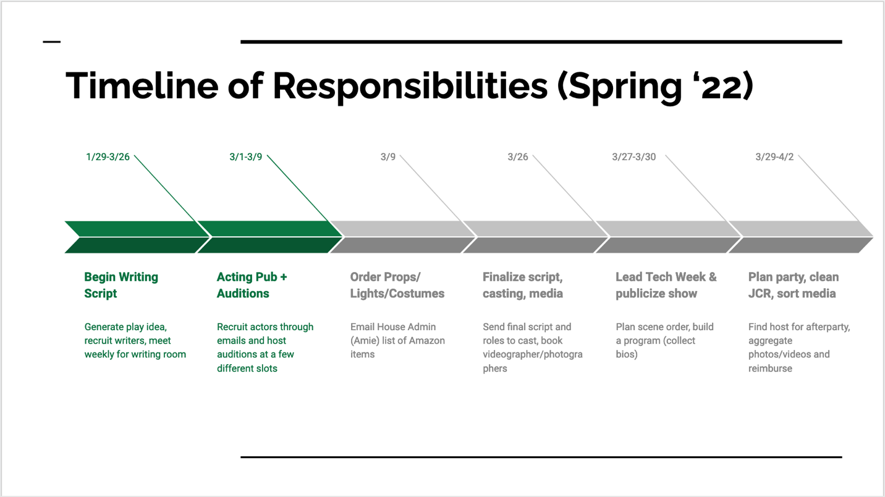
As an outgoing Co-Director for KDS, I have been thinking carefully about what could have been better during my unusual tenure. Through this research project, I hope to use interview and survey data from members within and outside KDS to create a current pulse report of KDS and leave tangible ideas for how to improve the KDS leadership structure.

- Literature Review:
To better understand theater leadership structures, I looked to academic literature on undergraduate theater, management in theater, and best practices for planning out plays. The following sources below provide unique frameworks for examining the structure of Kirkland Drama Society, methods to carry out research, and models to adopt for the organization’s future.
In “The Need for Production Organization,” Williams argues that the quality of school theater is most dependent on the organizational structures, rather than the commonly understood problems in school theater like funding and resources. He believes that coordination is the foundation of theater but can only be realized through an effective and intentional design. Specifically, Williams suggests that responsibilities should be clearly delineated such that each member understands their expected contributions to the production. By applying this to KDS, it would appear worthwhile to survey leaders on how they perceive their roles and then see how that data compares to the overarching understanding of leadership. Williams further asserts that this organizational structure is lacking, all parts of the cast will end up wasting more time and energy than necessary. This suggests that organizational structure plays an important part in shaping the creative vision of the club because when it is failing, members will lose their creative energy (Williams, 1950).
It is not so simple as to make theater structures more hierarchical or defined, as there is tension to determining the rigidity of social structures in theater leadership. Raduški examines this in his study of theater financing in Serbia, where he discusses the conflicting histories of capitalism and theater. Raduški asserts that since theater was often use as a tool of rebellion and source for creativity rather than autopilot behavior, many theater programs were late to incorporate updated management practices. Applied in a more modern context, Raduški argues that theaters should take note from technological project management practices. Firstly, Raduški believes that the manager should be well-versed in all forms of production from financing to writing to set design, and so forth. Building upon these skills, Raduški suggests that the project management style is applicable because directors can “anticipate the future tasks and activities classified into phases and procedures, as well as to determine the necessary personnel, material and technical as well as financial resources” (Raduški, 2019 p. 285). Raduški also separates the manager from the creative role, which may prove to be an interesting setup for Kirkland Drama Society in the future. Irrespective, this project management approach provides an illuminating framework for breaking down the daunting challenge of a large play into smaller, more actionable chunks.
Regardless of the exact approach, there is growing evidence to suggest that theater directors reveal what humans desire in a leader. In Posner’s reflection on observing the San Jose Repertory Theater, he argued that the director embodied the seven key practices for leadership, which are: “establish a vision, remember that it is not just the leader’s vision, enable people to find their voice, empower through coaching, foster experimentation and learning from experience, facilitate mutual respect, and provide feedback and encourage the heart” (Posner, 2008, p. 35). These practices are very similar to the “Ten Commitments of Exemplary Leadership” in his article with Kouzes, demonstrating that theater and leadership literature are very interconnected and can be used to assist the other (Kouzes et al., 2011). Hence, traditional leadership journals, like the ones we have seen in Sociology 1130, are useful for examining theater leadership just as theater leadership may provide helpful in revealing new insights about student leadership.
Similarly, Dunham and Freeman study the latter relationship in their journal “Leadership Lessons from the Theater,” looking at theater directors’ best practices as a useful lens for improving professional business leadership. Their primary findings are that business leaders should follow successful theatrical directors by building a shared vision from the personal elements of the play, prioritizing casting, working in small chunks while “embracing complexity,” maintaining focus on the present, and balancing creativity alongside learning (Dunham, Laura, and R. Edward Freeman, 120-121). This information guides my methods in that it encourages me to ask KDS leaders about the impact KDS has had on their leadership development and survey the tutors on how they see their role as leaders in the organization.
To conceptualize how successful KDS was this past semester, I will also rely upon Batillana’s 3P (Process, Person, Pathway) framework for success. Mainly, I will seek more clarity on the exact mission of Kirkland Drama Society to remove my own biases from the problem statement (Batillana, 2019). Similarly, I am inspired by Kramer’s article ““Communication and Social Exchange Processes in Community Theater Groups,” where he implemented Social Exchange Theory to better understand community theater groups. Kramer summarizes Social Exchange Theory (SET) as an individual’s focus on their returns from a relationship relative to their “investment costs.” In Kramer’s study, he empirically researches 12 different community theater groups and finds that while members often had complaints with various components of the play, they refrained from voicing them in fear that it would stall the production’s progress. This provides further support for conducting a membership survey because such members may not have had a space to voice their concerns otherwise. Based on empirical survey responses, Kramer concludes that members in community theater organizations report primary satisfaction by their relationships but also have higher rates of quitting if managerial communication is unclear. This informs my research by highlighting the importance of asking members their reasons for joining KDS in the first place and asking other organizations best practices for communication. (Kramer, 2005).
Another key measure of KDS’s success will be through surveying members’ expectations versus outcomes from the fall production. In “The Differences and Implications of Student Participation in Academic versus Non-Academic Organizations,” the authors noted that the reasons for joining the two types of groups were very different but that their main reason for continuing involvement was largely similar: “their expectations were met” (Holzweiss, Peggy, et al., 146). Hence, this extends my previous assertion to not only survey members on their motivations for joining KDS, but also collect data on beliefs about whether their expectations were met and involvement statistics.

- Methods:
To answer the first research question, I interview a range of leaders and members in Kirkland Drama Society. First, I interviewed my co-director, Andrea Zhang, with the draft in Appendix I: Part a. Next, I interviewed the two former co directors, Matthew Holloway and Nathan Sharpe, with the script in Appendix I: Part b. The two current tutors have vastly different experiences relating to KDS: Wilson co-directed it as an undergraduate and has served as a tutor for multiple years. On the other hand, Katilau was new to Kirkland Drama Society this past fall and had a more conventional theater experience as an undergraduate at Vassar College. Given this, I have detailed separate exact interview drafts in Appendix I: Parts c and d.
Additionally, I conducted a survey using KDS writers and actors from the past semester to get feedback from members who do not hold leadership positions. For the survey, detailed in appendix part III, I made sure that I get at least 6 responses from the total group of writers and actors. Since the entire group is only 24 people, 15% would be lower than this threshold, so I considered 6 to be the minimum size. Regardless, I publicized the survey multiple and ended up getting 17 responses, reaching a 74% response rate.
To answer my second research question, I conducted expert interviews with prominent theater organizations at Harvard. I conducted an interview with the Yale Dramat, Yale’s Dramatic Organization, through the case study interviews. Given that these questions worked well for the data I am aiming to collect, conducted the same interview with Harvard’s equivalent: The Harvard Radcliffe Drama Company. These drafts are specifically laid out in Appendix II: Parts a and b, and help me understand how they go about overseeing plays at their respective college communities. While both aforementioned organizations provide worthwhile information for understanding leadership structures in undergraduate theater, KDS is most similar to Harvard’s Hasty Pudding Theatricals. As a student-written, produced, and acted show, Hasty Pudding is a much more professional production than KDS and involves a more hierarchical leadership structure. I interviewed leaders at the Hasty Pudding to learn about their past challenges and successes in leadership, as detailed in Appendix II: Part c.

IV. Data and Results:

My survey had a response rate of 74%, where 17 out of the 23 emailed responded. The sample includes 15 actors, 1 writer, and 1 writer/actor. The mean score for communication rating from leaders was 4.58, where 4=very satisfactory and 5=outstanding. 53% of sample did not participate in spring, all of which cited the specific show's timing, busy semester schedule, or not being enrolled as the reason. 88% (15) said they thought KDS had the right number of leaders, 12% (2) said there should be more, indicating interest in a stage manager position. Moreover, two respondents advised for a clearer rehearsal schedule. All respondents said it fulfilled their goals, which are described below, or reasons for joining KDS in the fall.
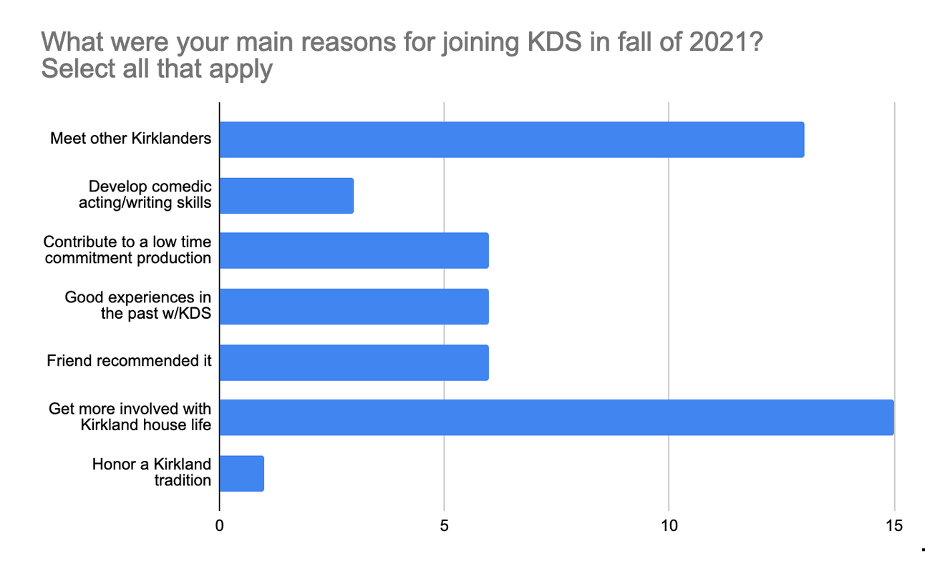
I also chose to select a few quotes from open feedback sections that I thought were particularly salient. One writer stated that: "KDS is one of those things that only works because everyone agrees on basically what they want to do. Leadership is more about communicating logistics than keeping unruly people in line, which, for a house drama society, is as it should be. That feeling of controlled anarchy, where anyone can pitch a joke or ask for a prop, is what makes KDS feel so organic and fun, and having a big leadership structure would work against that in my opinion." Another comment on leadership was an actor suggesting that "Knowing which scenes would be rehearsed on each day would be helpful, although understandably difficult with such fluctuating schedules." These two quotes provide evidence that some members like how small the leadership structure is while others would benefit from a stage manager to help with scheduling.

Certain members also spoke very eloquently about their favorite parts of KDS. One actor who had graduated in the fall recalled meeting “so many cool Kirklanders through KDS. It made the house feel like a home, which was especially meaningful to me because we were coming back from a virtual school year." Another actor noted the uniqueness of KDS: “This is a feat, and probably a very interesting one to study -- opening up and fostering a community for just a few days in a way that is both led by passionate directors while also allowing for some level of improvisation and creativity on the part of the participants. A really special and exceptional experience!"
One of my key findings from KDS expert interviews is that while directors acknowledge that KDS takes a significant toll (about 4-5 hours/week in the 6 weeks leading up to the play and 25-30 hours/week the week of the play), they have very fond memories of leadership. Former Co-Director Nathan Sharpe believes that his experience in KDS “makes him feel more comfortable leading groups now. It’s definitely scary to lead a full three-hour rehearsal (…) Having that confidence in myself that I can do this, lead this, and have people enjoy their time here was a huge step forward and something that has helped me out of college.” Similarly, current Co-Director Andrea Zhang remarked that “KDS was the best activity I’ve undertaken in college by far, [based off the] pure amount of enjoyment personally, community I’ve seen built, and what I’ve personally learned from it.” Hence, the results of this study are bidirectional: the leadership affects the theater experience and the theater experience affects’ the individuals’ leadership growth.
The tutors believe that KDS should be student-run, meaning that decisions should be made by the student leaders, regardless of whether the tutors always agree. The tutors see themselves in more of a supporting role, making sure the play goes on. Current tutor Katilau Mbindyo believes that the lessons she learned in undergraduate theater provided valuable skills for the job market. She tries to strike a balance in her role to let us learn in the same way. She noted that "You all deserve the opportunity to challenge yourselves to have this project be your own (...) and we just so happen to be the adults to support, not so much have the final say in it.”
I also learned that there have been various structures for leaders (and their appointments) over time. As detailed in the introduction, the undergraduate leadership has ranged from about two to four Kirklanders, including the roles of: Co-Presidents, Co-Directors, and Writer. All of the interviewees were open to expanding the leadership structure, but one was nervous about the toll of communication across more people, particularly in our crunched time period.
One of the hardest parts of KDS is that there are such limited resources (time, closet space, etc) and defining expectations can be very variable. Over time, challenges in KDS have often arisen from directors expecting too much out of the actors, tech crew, writing room, physical resources, and more. As such, tutors have set forth these recommendations: doing an audit of resources at the beginning of the semester and running a fall meeting to set expectations. There is currently no explicit mission statement written down. However, KDS's old website, which has not been updated since around 2017, says that "The Kirkland Drama Society exists to support all kinds of dramatic art in the house." The leaders believe that the evolving mission statement comes through in our actions.

Based off my interviews with leaders from other undergraduate drama organizations, my first takeaway is that each of these theater organizations runs their productions with a minimum of a director and stage director. In the Cabot Theater Group, the only other house-based drama organization, their stage manager collects the cast's schedules weekly and works with the rest of the creative team to determine the scheduling of the individual scenes. All the other groups interviewed require a triumvirate structure, which adds on a Producer role. Many have multiple more directors for lighting, tech, props, etc.

While the large leadership structure can at times makes communication "a game of when2meet" for Hasty Pudding Theatricals (HPT), the prescribed leadership roles in the Constitution give useful clarity in moments of disagreement. HPT President Lyndsey Mugford elaborated, “What’s really interesting about HPT leadership is that it is simultaneously something that is very steeped in tradition (…), [and] because people are cycling through so quickly, it is very dynamic (...) Yes it is something we are inheriting, but it also belongs to the people in the organization at any given moment.”
Additionally, there is a mixture of appointment and election-based processes for determining leadership within plays. For the Cabot Theater Group, members interested in leadership roles meet in the fall to discuss which roles they're interested in. On the other hand, HRDC, the Yale Dramat, and HPT run membership-wide elections for their executive board and then have the executive board appoint a creative team. Applied to KDS, this would manifest like previous leadership iterations where members elected the Co-President, who was then responsible for appointing directors and writers.

V. Recommendations:
My first recommendation is to add a “Stage Manager” position if there is interest within KDS. The stage manager would be responsible for organizing rehearsal schedules, coordinating lighting and tech cues with tech crew, and ordering props and costumes. Two survey members indicated that they would like to have a clearer schedule of when scenes will be rehearsed, which is the role of a stage manager. Similarly, 2 members indicated that they would be interested in KDS adding a stage manager role. All undergraduate productions surveyed (Cabot Musical, HPT, Yale Dramat) have a stage manager. In my time as a KDS leader, I found it challenging to balance roles as head writer and director along with managing stage logistics. Moreover, the role could serve as a nice "transition" role for Kirklanders who are interested in becoming directors the following year as juniors/seniors. The modified leadership structure is shown below:
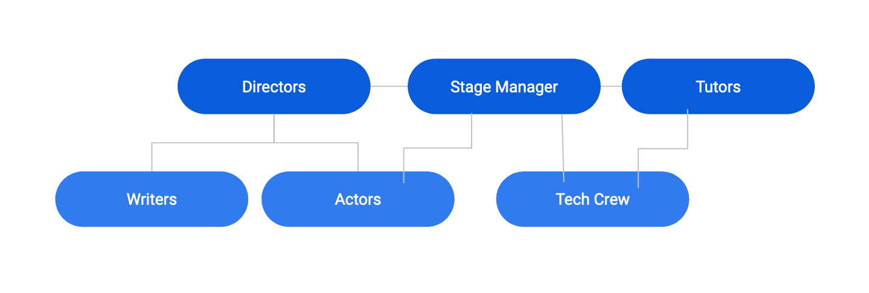

For my second recommendation, I suggest moving to a self-nomination system for leadership roles. The current appointment process may be excluding potential wonderful leaders and/or make certain members feel less valued. At the beginning of the leaders' final semester, I recommend that leaders should send an email to all former KDS actors and/or writers asking to fill out a form if they are interested in a leadership position. Members could indicate whether they would be interested in co-leading with anyone member. Current leaders should still be encouraged to reach out to members whom they believe would excel at the position. In the case that there are more people interested in the leadership position(s) than available, I would recommend that the present leadership team asks prospective leaders to send in a statement of interest and then deliberate. This could work similarly to Cabot's Musical.

Next, I believe that leaders should create a split of responsibilities at the beginning of the semester. Given that the leadership positions are loosely defined, I found it useful to delineate responsibilities across leaders. This helped improve communication between leaders and to our actors, writers, and tech teams. Specifically, if there are two directors, it can be nice to have one that is more focused on writing and another more focused on acting (like Matthew and Nathan). However, this dichotomy is not necessary; rather, it is most important to have a clear understanding of which responsibilities each leader feels excited and comfortable pursuing. Particularly if one chooses to expand the leadership structure, being clear with specific tasks can make communication much more fluid, as the President from Hasty Pudding suggested.

My final recommendation is to run an interest meeting and audit before each show. It can be difficult to assess the size of the cast, tech crew, and overall team at the beginning of the semester. On the other side, members may be unclear about expectations going into the semester. I would recommend hosting an interest meeting to get a sense of the resources at KDS's disposal and write the play with those expectations in mind. The current KDS tutors recommended this based on experience in past KDS shows and other undergraduate theater productions. The Cabot Musical, among other theater organizations, does a few fall meetings before their spring show to better assess whether they need outside help for tech crew, publicity, and other tasks. I believe that the interest meeting would allow leaders to develop and communicate their mission statement at the beginning of the semester.

- Conclusion/Statement of Positionality:
Coming into this project, I had just completed my tenure as KDS Co-Director. I was overwhelmed with pride and joy from the various productions, but also felt a cloud of exhaustion from the responsibilities of leadership. I was interested in exploring more leadership positions would reduce the burden on future directors. Through this careful research project, I have come up with a set of recommendations that I think will help KDS continue to fulfill its goals while making the leadership positions less strenuous. As opposed to expanding to a more traditional triumvirate structure, I took the data that many members within KDS were happy with the existent size of the leadership structure and opted towards just recommending the adoption of a stage manager.
I have attached my official deliverable here, which is a guide for future KDS leaders. It is
very similar to this page, including a clear description of directors' roles, a timeline to visualize the trajectory of the show, a set of recommendations for future shows, an archive of past emails, and a template of a scene-by-scene guide.
It is worth noting that my own positionality as a Co-Director may influence the objectivity of the study. While the surveys responses were collected anonymously, members might have been nervous to voice complaints knowing that I was reading them.

VII. Reflection
Through the careful structure of Sociology 1130, I learned that I am a researcher who likes to have a clear timeline of the overall process. If I were to do this again, I would continue to follow up with my interviewees and survey responders because each perspective provided nuanced data. I also learned how important it is to acknowledge your own positionality at the beginning of the project, as it helped me challenge my biases and craft questions that were less tainted by my own beliefs. As I noted in my Scalar chapter and Research Design, I entered the project with a sense of exhaustion and idea that more leaders would improve the experience for future KDS leaders.
I found this research process to be deeply engaging, as it helped me understand how leadership is an iterative process that is best conducted when it engages various members of the community. I had little exposure to qualitative research prior to this class, so the process of collecting data showed me that many of the academic practices I have learned over time are applicable to being a better leader.
I believe that my blueprint has a high potential for leading to tangible changes. While I am unsure whether my first recommendation about adding a new position will be enacted, I believe that the latter three are all low-barriers, concrete, and worthwhile to implement. Given that I will be involved with Kirkland Drama Society next semester, I will work closely with the current leaders to ensure that they create a breakdown of tasks and change the leadership process from appointment to nomination.
- Bibliography:
Battilana, Julie. “Problem, Person and Pathway: A Framework for Social Innovators.” Handbook of Inclusive Innovation, 2019, pp. 61–74., https://doi.org/10.4337/9781786436016.00012.
Dunham, Laura, and R. Edward Freeman. “There Is Business Like Show Business: Leadership Lessons from the Theater.” Organizational Dynamics, vol. 29, no. 2, 2000, pp. 108–122.
Holzweiss, Peggy, et al. “Are All Student Organizations Created Equal? The Differences and Implications of Student Participation in Academic versus Non-Academic Organizations.” The College Student Affairs Journal STUDENT AFFAIRS JOURNAL, vol. 27, no. 1, 2007, pp. 136–150.
Kouzes, James M., and Barry Z. Posner. The Five Practices of Exemplary Leadership. Pfeiffer, 2011.
Kramer, Michael W. “Communication and Social Exchange Processes in Community Theater Groups.” Journal of Applied Communication Research, vol. 33, no. 2, 2005, pp. 159–182., https://doi.org/10.1080/00909880500045049.
Posner, Barry Z. “The Play's The Thing.” Journal of Management Inquiry, vol. 17, no. 1, 2008, pp. 35–41., https://doi.org/10.1177/1056492607313444.
Raduški, Dragoljub. “Redefining the Model of Theater Organization and Financing in Serbia on the Project Management Principles.” Proceedings of the 5th IPMA SENET Project Management Conference (SENET 2019), 2019, https://doi.org/10.2991/senet-19.2019.47.
Williams, Dallas. “The Need For Production Organization.” Educational Theatre Journal, vol. 2, no. 2, 1950, pp. 159–162., https://doi.org/10.2307/3204287.

- Appendix:

- Survey

Report:
- 53% of sample did not participate in spring, all of which cited the specific show's timing, busy semester schedule, or not being enrolled as the reason.
- Mean score for communication rating from leaders was 4.58
- 88% (15) said they thought KDS had the right number of leaders, 12% (2) said there should be more, indicating interest in a stage manager position.
- 2 respondents advised for a clearer rehearsal schedule

Survey Screenshots:

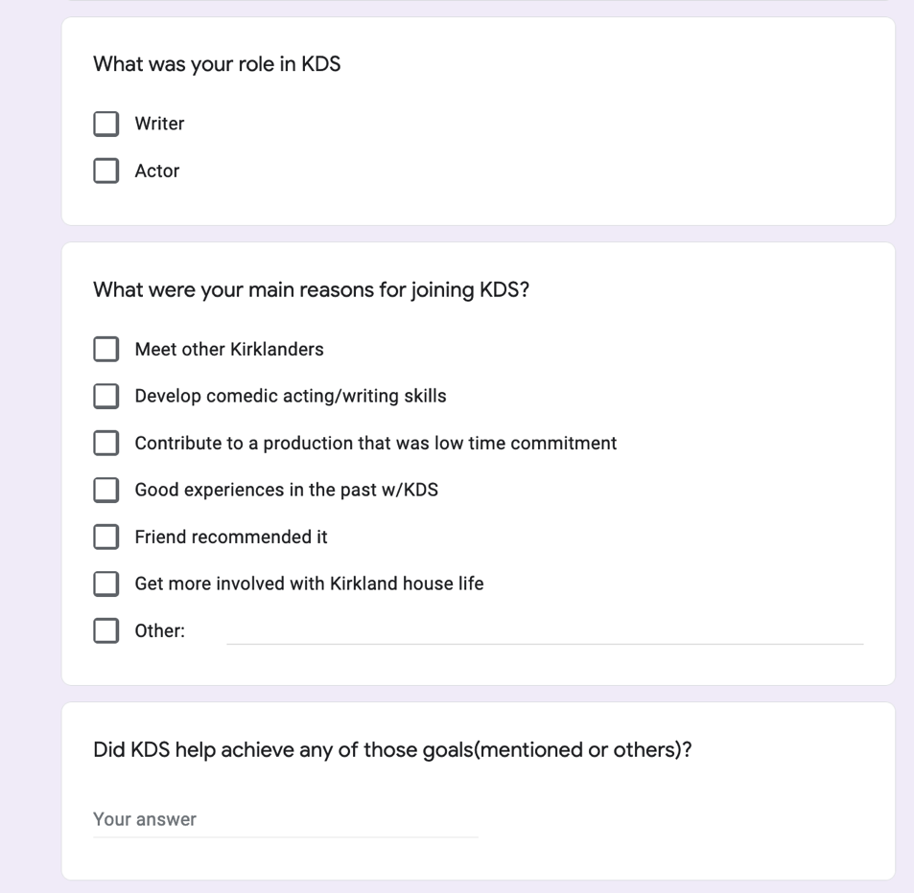

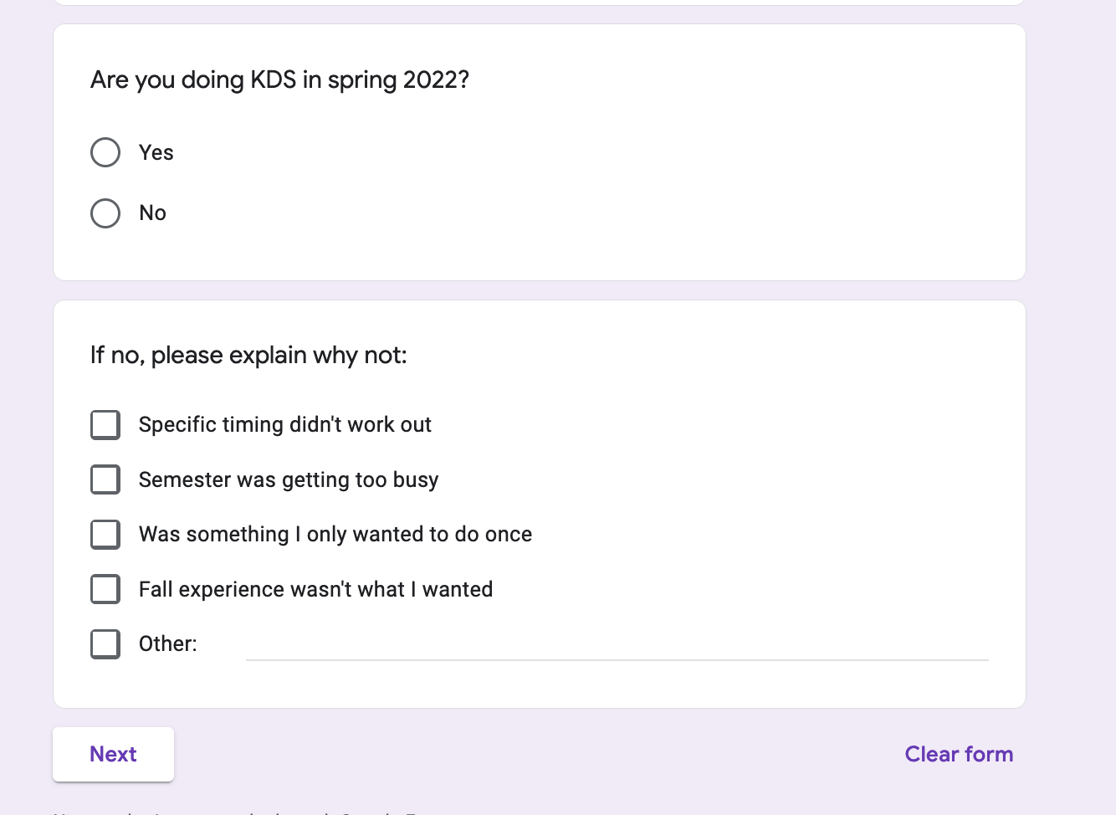

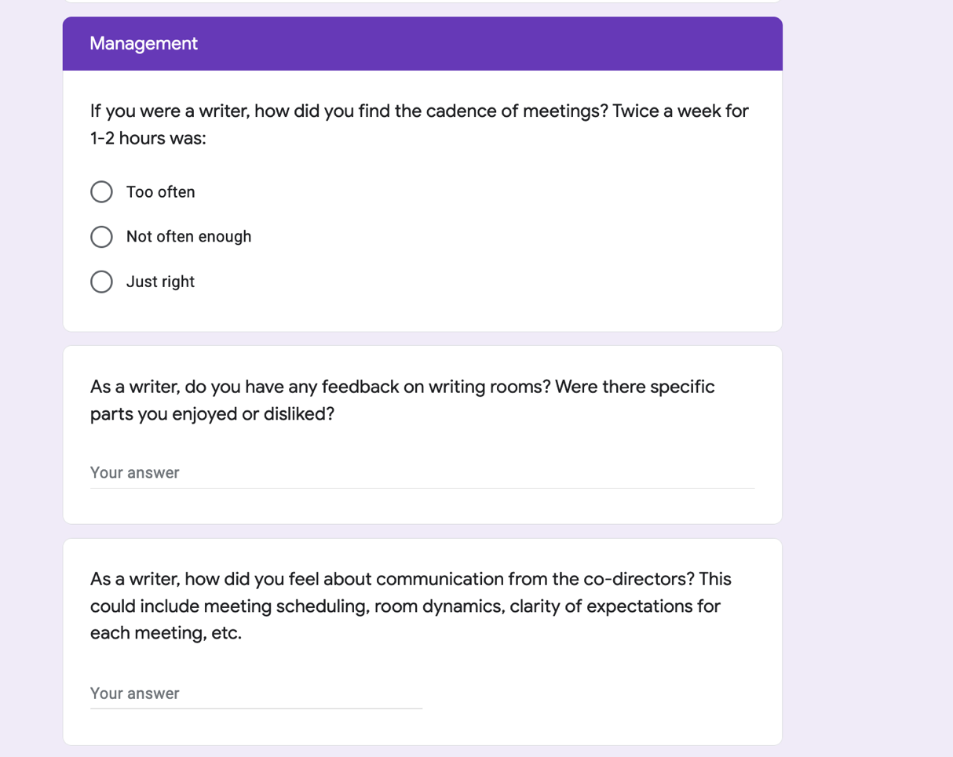

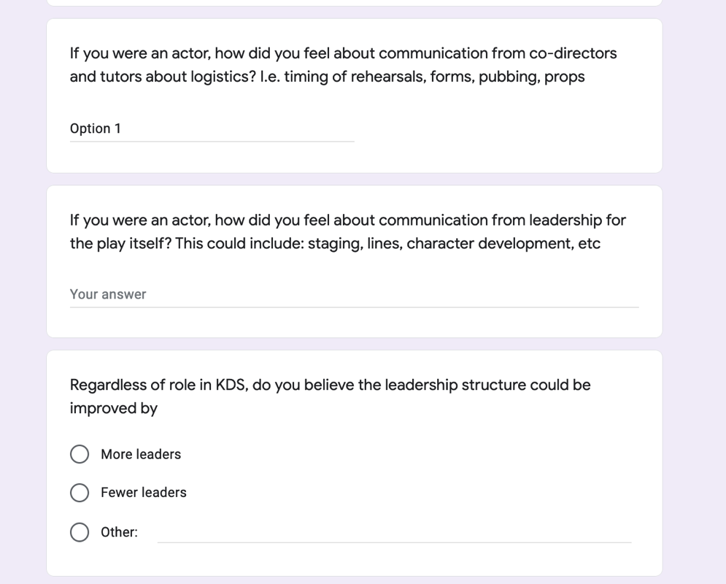

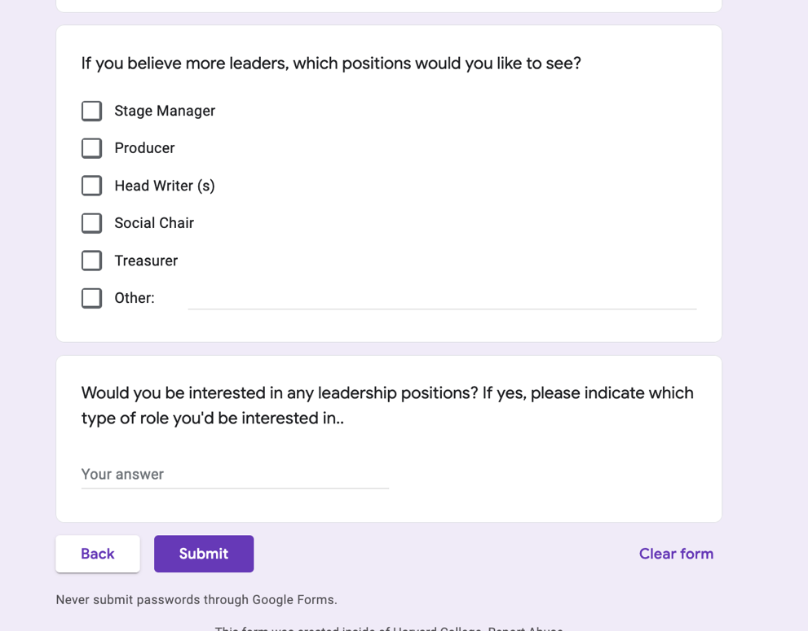

- Questions for KDS Leadership Interviews:
a. Andrea Zhang (Co-Director '20-22)
- How have you found being a co-director for KDS? Are there any components about the experience you would like to see changed for future leaders/members?
- How has the leadership structure for KDS differed from your experiences in other clubs: HoCo, Harvard Computer Society, etc.?
- Given that you have a technical background, do you ever attempt to treat KDS from a project management standpoint? Or is there another framework you use for organizing the steps throughout production?
- What was it about KDS that made you interested in being a leader in the organization? Are the reasons similar to those that led you to join KDS in the first place?

b. Matthew Holloway and Nathan Sharpe (Co-Directors '18-20)
- Was the leadership structure within KDS 2 co-directors and tutors throughout your time?
- Were there specific criteria you had in mind when deciding your successors?
- How many hours did you generally spend per week leading up to the show and during the show itself?
- What were the biggest challenges in leading KDS throughout your tenure?

c. Katilau Mbindyo (Tutor '21-22)
- How did the leadership structure in Kirkland Drama Society parallel or contrast your previous experiences in college theater at Vassar?
- Are there any components of KDS that you would like to see changed for future leaders/members/tutors?
- How did you decide to become involved with KDS? Were you satisfied with the appointment process?
- How does communication within Kirkland Drama Society parallel or contrast your previous experiences in college theater at Vassar?

IV. Wilson Qin (President '14-16, Tutor '19-22)
- Was the leadership structure within KDS 2 co-directors and tutors throughout your time?
- How has being a co-director, and then tutor, informed your time in Kirkland?
- How have KDS co-directors and tutors historically been elected? Are there specific criteria, do leaders traditionally check it by the tutors, etc.?
- Are there any components of KDS that you would like to see changed for future leaders/members/tutors?

- Questions for outside KDS interviews:
a. Yale Dramat - President Sam Bezilla and Producer Casey Tonnies:
- How is leadership traditionally structured in Yale plays, particularly those that are student-run? Is there a traditional structure or significant variance?
- Is there an application portal for electing the leaders of each specific play or is the process more free-form?
- Are there any shows at Yale that are no cuts or entirely inclusive? These could be Dramat-produced or otherwise
- Were there any virtual productions in the age of zoom? Building off of that, how has the transition to leadership positions been after such a unique period?
- I’m interested about the interactions with faculty. Do the Dramat or individual plays have faculty advisors or frequent interactions with a dean?
- Regarding finances, do you have a connected bank account or do you use a different method?
- Is there anything else you would like to add regarding student leadership in Yale theater?

b. Harvard Radcliffe Dramatic Society - President Ian Chan
- How is leadership traditionally structured in HRDC-run plays, particularly those that are student-run? Is there a traditional structure or significant variance?
- Is there an application portal for electing the leaders of each specific play or is the process more free-form?
- Are there any shows that the HRDC produces that are no cuts or entirely inclusive?
- Were there any virtual productions in the age of zoom? Building off that, how has the transition to leadership positions been after such a unique period?
- I’m interested about the interactions with faculty. Does the HRDC or do individual plays have faculty advisors or frequent interactions with a dean?
- Regarding finances, do you have a connected bank account or do you use a different method?
- Is there anything else you would like to add regarding student leadership in Harvard theater at large?

c. Hasty Pudding Theatricals - President Lyndsey Mugford:
- How would you describe the leadership structure from a high level? Who directs the show? And, does the director of tech operate as the “stage manager?” Do producers do publicity or mainly just finances?
- Who decides which show proposal gets chosen?
- What is the timeline/process for appointing leaders of the executive board and members of the creative staffs?
- What have been best practices for managing a big board with related tasks? How do you streamline communication between creative side and production? Are there any specific challenges that arise every year?
- What is the communication like between exec board, creative staff, directors? Do the writers get more say beyond the script?
- Have there been changes to the leadership structure and/or timeline over time, particularly in the context of Covid?
- Do you interact with any faculty or admins throughout the year? If yes, how do you understand their roles?

d. Cabot Theater Group - Director Sonia Kangaju
- What is the leadership structure for Cabot Musical? Are any admin members/tutors of the house been involved?
- What is the timeline/process for appointing leaders of the executive board and members of the creative staffs?
- Is it no cut? If so, how do you anticipate the high roles? Ensemble?
- Have there been changes to the leadership structure and/or timeline over time, particularly in the context of Covid?
- How do you manage finances? Is it through the house or otherwise?
- What does the schedule for rehearsals look like?

