A Sense of Community on Campus in Pre-Professional Student Groups

Collaborative Research Paper

Danielle Green (2020, Psychology), Chelsea Guo (2023, Sociology), and Arnav Srivastava (2023, Biomedical Engineering)
Professor Manja Klemenčič
GENED 1013: Higher Education
Harvard University

We affirm that we have abided by the Harvard College Honor Code in the completion of this assignment.
Danielle Green
Chelsea Guo
Arnav Srivastava

Abstract
In this paper, we explored how exclusivity contributes to a sense of community in exclusive pre-professional Harvard College student groups (clubs mandating multiple interview rounds for admission) in contrast with Harvard-mandated “default” communities (the Harvard dorm/housing system). We sought to find the most impactful attributes that fulfill one’s sense of belonging within a community, and potentially advise how to build more fulfilling communities. Specifically, we chose two prominent and visible pre-professional organizations on campus and surveyed students on various community-evaluating questions. We found that default communities produced a greater sense of community in many scenarios than more exclusive student groups in which membership was handpicked. Some of the underlying mechanisms for these results might be that default communities involve cooperative or collaborative living, which lends itself to giving up certain aspects of privacy and likely makes it easier to communicate and share private matters in general. Nevertheless, more than 90% of students in both pre-professional groups still believed exclusivity of their pre-professional community to be valuable to the sense of community established.
Reflecting upon our research implications, we suggest that more exclusive pre-professional student groups can make efforts to strengthen their sense of community through group outings, socials, and mixers. We also commend the university for making efforts to create more intimate and close-knit social spaces beyond the realm of more exclusive student groups, which are necessary to celebrate/encourage intimacy, warmth, and inclusion regardless of students’ personal and professional interests.
Introduction
Community is an essential support-system for student success, from offering an outlet for consolation and support to developing crucial social skills. Being part of communities enables students to embrace the liminal and developmental aspect of studenthood, as communities encourage students to explore their identity and intersectionality. Moreover, communities on campus serve as an important mental and emotional support system for young adults who are oftentimes navigating high-stress and/or unfamiliar situations. Without a strong sense of community on campus, the experience of higher education becomes extremely detrimental to young students’ health, and a lack of structured guidance can inhibit one’s ability to seek help for themselves. Ultimately, failure to satisfy a meaningful sense of community can impair academic achievement and retention.
Given the undeniable importance of community in fulfilling higher education’s mission of providing students with a supportive environment to grow and explore, it is important to evaluate the effectiveness of Harvard’s mandatory community-facilitation programs, as well as explore the effectiveness of more exclusive community-fostering opportunities for students.
Harvard’s “default” communities are defined as communities in which every enrolled student is required to be a member of. Freshmen at Harvard are assigned to entryways, where they are surrounded by first-years who together share similar experiences as first-year students, while also having a Proctor (a mutual guidance counselor). Meanwhile, upperclassmen are assigned into randomly assigned Houses at Harvard with equal proportions of sophomores, juniors, and seniors, where students bond with one another and conventionally get meals together alongside enjoying in-House facilities. In the spring of freshman year, students select their own “blocking groups”: up to 8 of their friends who are all placed into the same House. Harvard prides its “default” communities as a valuable portion of the transformative Harvard experience (TheHub at Harvard College, 2019).
There are several mechanisms by which students can become members of exclusive groups, such as by application, interview, and/or invitation. Practices of exclusion are complex and multifaceted. The first is the more traditional and culturally familiar practice of expressing one’s interest by submitting an application. Students may also engage in the conceptually similar practice of the audition if the group is dedicated to the creative or performing arts. Social clubs on campus also practice a months-long admissions process called “punch,” as it’s termed in college vernacular. One cannot express interest by comping or applying to these organizations; they are exclusively handpicked by the current body of members.
Students may also participate in the widely popular “comp” process of an extracurricular organization. The comp process is generally considered to be unique to student organizations at Harvard College. The Harvard Crimson (2019) defines comp processes as “a series of training or vetting exercises” to recruit new members of student groups. Comp processes may be categorized into competitive or cut-based comps and completion-based comps. Competitive or cut-based comps consist of a months-long comp process during which students may be rejected in subsequent rounds of cuts. Students participating in completion-based comps are required to complete a series of tasks or activities before formalized induction into the organization.
Many critics of the comp process argue that university affiliates have a duty to review such practices in organizations where comp seems arbitrary or unnecessary to membership (Narayanan & Zwickel, 2019). Ultimately, practices of exclusion in student organizations are complex and multifaceted. With our research, we aim to inspire continued discourse around this topic.
In a broader notion, our project seeks to evaluate the effectiveness of exclusive communities in contrast with default communities. We seek to explore how does exclusivity contribute to a sense of community in student groups in comparison to “default” university-enabled/university-required communities? In exploring the various intricate and interconnected factors empower the most meaningful community-based experiences, we seek to better understand the complex nature of social belonging to find the most impactful attributes that fulfill one’s sense of belonging within a community, and potentially advise how to build more fulfilling communities.
A Note on University Jargon
To lay the groundwork for this project, it will be necessary to familiarize readers with the nomenclature of the institution as well as the vernacular of student groups. Harvard University is unique in the system of higher education in that its naming system is rooted in the Oxford tradition of learning and scholarship. First, we must differentiate between “default” and “exclusive” communities on campus. “Default” communities on campus are characterized by automaticity of membership. Essentially, they signify a lack of choice in one’s belonging and the absence of any sort of selectivity in membership. Examples of default communities include campus living spaces like residence halls and freshman entryways. Freshman entryways are considered “default” communities because they are obligatory rather than opt-in. Your membership is mandated by the university. Freshman entryways also maintain a network of resources and institutionalized support with proctors and peer advising fellows. They also hold inclusive social events like study breaks, movie nights, and entryway mixers. Although blocking groups are technically self-selecting, because they can only have up to 8 members, we still consider the overall House to be the community that the members of the blocking group belong to, and each House has hundreds of members.
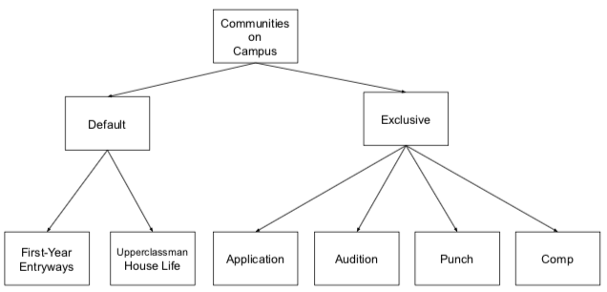
Next, we must differentiate between inclusive versus exclusive student organizations and the admissions processes inherent within. Exclusive student organizations are generally characterized by restrictive conditions of entry; membership often contains some element of curation. They build their membership off shared interests and values, and in order to gain admission, they require an element of vetting and cultural matching. One cannot elect to become a member of an exclusive student group: they must be handpicked.
Literature Review
Sociological literature reveals that previous studies of elite institutions generally prioritize examining the conditions of students’ entry into these schools (Binder, Davis, & Bloom 2016). However, student organizations at elite schools may also be highly competitive institutions as well. However, what does it mean for an organization to be exclusive or elite? How do scholars conceptualize and define exclusivity? Khan (2012) describes elites as those with vastly disproportionate access, power, and control over a resource. Today, elitism is not simply characterized by wealth or income seizure; it has conceptually and definitionally broadened to include many different forms of capital (Khan, 2012). Likewise, elitism in student organizations is also characterized by selectivity in admissions criteria -- more specifically, the imposition of exclusive or restrictive conditions of entry. Members of very exclusive social organizations may be perceived as socially or culturally elite by their peers. Ultimately, admissions is the metric by which prestige is built and strengthened in these organizations.
Previous research on student involvement reveals that engagement is generally perceived to be a good thing: students benefit psychologically and socially from participating in clubs and extracurricular activities (Kilgo, Mollet, & Pascarella, 2016). Finding a sense of purpose and meaning beyond the classroom has been demonstrated to have a positive effect on student wellbeing by enabling personal growth and creating the opportunity to develop long-term relationships with others (Kilgo et al., 2016). However, what extracurriculars students ultimately decide to partake in and how exactly they benefit from those activities may be influenced by a number of factors.
For example, participation in extracurricular life may also be stratified by socioeconomic status. Class often influences what activities students take part in and how they ultimately allocate their time (Stuber, 2009). Upper-middle class students often arrive on campus with more social and cultural resources than their peers, which facilitates their involvement in extracurricular life. For example, amongst upper-middle class students, Greek Life is generally perceived as desirable and normative: part and parcel of the extracurriculum (Stuber, 2009). These students also hold the cultural resources (experience, familiarity, and talent) to acquire fancy research assistantship, positions in student government, and roles in school plays. These stocks of capital subsequently give upper-middle class students more access to social worlds through friendships and network-building. In contrast, lower-income students are more likely to spend their extracurricular hours beyond the classroom working part-time jobs (Stuber, 2009). The Greek system also requires its participants to pay semesterly membership dues, which impose further economic constraints upon lower-income students.
Logically, this discrepancy in one’s ability to exploit their is rooted in one’s social background. Students who come from lower income classes have a more difficult time mastering the “student role,” and have less experience with self-advocacy. Logically, these different experiences lead to a short-term barrier in building social communities amongst peers of more privileged backgrounds, and can lead to different degrees of choices as to personal comfort of entering new/unfamiliar communities (Vaccaro & Newman, 2016). Ultimately, it is possible that communities have self-selecting mechanisms for students based on student-comfort influenced by socioeconomic background.
Students may also be influenced by a sense of exclusivity and prestige. Research on drivers of student perception of status and prestige in the realm of careers reveals that students are highly susceptible to the influence of their peers (Binder et al., 2016). While they often entered college with a lack of career directionality, many students learned to “define and desire” prestigious jobs through employer visibility on campus and word-of-mouth from their peers (Binder et al., 2016). Desire was often a matter of accessibility, or lack thereof. Likewise, students often enter college with a tabula rasa with regard to pathways in the extracurriculum. However, they may quickly identify areas of prestige in extracurricular life based on the interests and influence of their peers. Ultimately, extracurricular life may serve as a source of social and cultural differentiation between students; it’s a visible imprimatur of privilege.
Furthermore, students’ involvement in extracurriculars and fulfillment in sense of marginality may be impacted by student personalities. In a meta-analysis, Allen et al. (2018) explores various factors which influence a sense of belonging. Alongside faculty support being the strongest community factor, the study’s consideration of positive characteristics such as friendliness and approachability underscores the influence of interpersonality on individual's sense of belonging. The crucial ability of fitting societal norms and having social skills to bond with others inherently is the foundation of one personal/subjective satisfaction within different communities, and although these varying views are difficult to standardize, mutual values of community may be standardizable.
Interrelated with one’s social skills is social how society perceives individuals. In Mangold et al.’s (2002) analysis on the success of a community-building initiative decreasing drop-out rates, gender and race were important factors affecting one’s likelihood to drop-out (in particular, female and black participants had higher retention rates). These differing impacts of community emphasize that a standardized community does not yield standardized results: individuals’ identities are variable factors of successful communities that can impact marginality dynamics.
Nevertheless, marginality dynamics can be impacted positively and negatively. Blomfield and Barber (2010) suggest that extracurricular activities can lead to positive or negative development in different cases, bringing light to the fact that not all communities fulfill a sense of belonging, and there can be inclusive/exclusive communities that can potentially exacerbate marginality. Whereas community is an important aspect in facilitating a successful higher education experience, one has different requirements from a community as well as differing expectations in the level of intimacy a community requires. Therefore, in an analysis of successful communities, our study can also enable the opportunity to explore factors of unsuccessful communities.
Harvard College places significant emphasis on having established, or “default” communities that students are automatically a part of when they join campus, such as their first-year entryways, or their upperclassmen houses. One of the key aspects of such “default” communities that differentiates them from student-run organizations is that they are intended to be diverse, and it is a known mission of the College to purposefully bring together students of different backgrounds in order to facilitate conversations that might not otherwise occur between students that may not have voluntarily interacted with each other otherwise. The benefits of this mission are outlined in the paper “Student Life as Text: Discovering Connections, Creating Community” (Smith, 1993), which documents a specific university’s experience with close-knit, diverse residential communities and the types of community discussions that arose as a result of this diversity in student backgrounds. This research leads to important questions on how effective this design of diversity actually is to make students inclined to interact with each other. Does more thought-provoking conversation necessarily also make students feel closer with each other as a community? Erb et al.’s (2015) article goes further into three specific factors of residential life: identity, interaction, and solidarity, which can be used as three areas of focus in survey questions to directly compare and contrast these factors in residential life and in student-run organizations, and in interview questions, these factors can be used to document the types of identities, interactions, and definitions of solidarity that might differ among communities. At Harvard, it is very common to voluntarily join a student organization, and therefore the lack of research on the combined (and perhaps different) senses of community between student organizations (Padilla-Angulo, 2019) and residential or default communities would contribute greatly to the understanding of creating a better college experience for each student.
Despite the variety of intricate and interdependent factors, this study ultimately strives to consolidate and emphasize which factors of communities are the most valued, with the specific lens of how belonging in default communities compares to belonging in exclusive communities at the numerous different communities at Harvard.

Data and Methods
Data collection for this project consisted of a mixed-method approach including a combination of quantitative surveys and qualitative interviews with students who identify as members of exclusive organizations on campus. Specifically, our research team was seeking to investigate and examine the experiences of students who’ve participated in same-category exclusive groups to gain a more thorough and comprehensive analysis. For this project, we targeted our efforts on analyzing the experiences of students who identify as members of comp- and application-based pre-professional organizations on campus. Specifically, we compared the experiences of students in “Student Organization A,” which organizes a business/international relations-themed conference, with that of “Student Organization B,” a consulting group (names changed to preserve confidentiality), both of which are prominent and visible pre-professional organizations on campus. These groups are recognized by and registered with the Office of Student Engagement, where they are classified within the category of pre-professional student organizations (TheHub at Harvard College, 2019). We used this data to compare student experiences within their more exclusive pre-professional groups to experiences in university-enabled and university-required default communities. Interestingly, pre-professional groups are widely perceived as elite organizations by students on campus as they are seen as resume sparklers and launchpads into the prestige industries like consulting and finance.
Originally, we intended to compare the experiences of students who identified as members of Student Organization B with that of another prominent consulting group. However, the other group unfortunately declined our invitation to participate in the collaborative research design citing constraints with time. This was a bit of a setback at first, but it encouraged us to search for a great alternative which presented itself as Student Organization A. Ultimately, our research team was able to deliver on the goals of our research question in comparing two student organizations with conceptually similar programming and outcomes.
The annual conference of Harvard College’s Student Organization A attracts hundreds of attendees, and has invited many renown speakers to its events in the past as well.
Student Organization B works with many prominent companies and startups, according to TheHub at Harvard College, and has been established for over 10 years.
The admissions process to both organizations is quite similar, consisting of an application along with an interview and networking events with the current body of members. Because there are cuts with each subsequent interview round, we consider these admissions processes to be highly exclusive comps. This is reflective of The Harvard Crimson’s definition of the comp process as “a series of training or vetting exercises” to recruit new members of student groups (Narayanan & Zwickel, 2019).
Ultimately, our research strategy utilized a mixed-methods approach consisting of a quantitative survey along with a series of in-person qualitative interviews. We argue that a division of interviews and surveys would allow us to effectively gauge and compare the experiences of the members in each organization as well as understand the comp processes inherent within them. Specifically, we targeted students of all class years (including freshmen, sophomores, juniors, and seniors) on campus who’ve had significant and timely experiences both within their extracurriculars as well as the college dormitory system to get a sense of their experiences in both communities. Each interview was subsequently coded to assess commonalities and shared insights. For each organization, we aimed to survey as many members of the body of current membership as possible to collectively analyze their experiences in the organization. Although our survey’s response rate (41.2% for one student group and 29.3% for the second student group) did not reach 100% of the current body of members, we feel that we ultimately gleaned a sufficient number of both quantitative and qualitative insights.
We used a series of methods to get in touch with the members of both organizations. First, we reached out to each organization individually and independently via listservs and organizational mailing lists. TheHub at Harvard College serves as a contact and events directory for recognized student organizations on campus. This resource is accessible to any current student enrolled at the college and was crucial in our outreach success. Students in leadership roles such as presidents, treasurers, and general club officers are explicitly noted as key points of contact. This resource allowed we as researchers to draw our sample amongst the current body of membership.
Students were asked via email to complete a survey with a number of questions about their experiences in their pre-professional groups. Survey questions, which could be answered on a scale from 1 to 5 included: How close are you with members in this student organization? as well as How would you prioritize your membership within this community in comparison to other Harvard commitments? Students also responded to questions where they quantified their comfort levels with other members of the group. These questions were inspired by those posed on the McGill Friendship Questionnaire. The four questions with directly comparable answers asked participants about their closeness with other members of the group, whether they felt comfortable to tell private things to members of that group, their ability to get help if needed, and the ability for other members to know when the respondent is upset. These four topics were chosen to measure sense of community since they are generally common indicators of strong friendships within the group. At the end of the survey, students were then asked to identify demographic characteristics like age, ethnicity, and gender. After we established initial contact with an introductory message with the survey, potential interviewees from those groups who answered the survey could then be contacted privately. Please see Appendix A and B for our study outreach template sent via email and interview questions.
We also recruited study participants by more selective and curated methods of sampling, as we as researchers investigating understudied and underexplored phenomena already knew students who identified as members of these exclusive organizations; our curiosity about their experiences centrally motivated our research question. For example, researcher Chelsea Guo was highly acquainted with the members of Student Organization A and thus, she was able to recruit them for interviews. Similarly, researcher Arnav Srivastava was acquainted with a current member of Student Organization B and was able to disseminate our survey via their private organizational mailing list with the assistance of that member. We believe that our connections with study participants greatly facilitated outreach and offered valuable insights. We auger these served as key resources for our collaborative research design.
Additionally, we aimed to understand the insider’s worldview through both explanatory and confirmatory factor analysis (Akar-Vural, 2013). Definitionally, explanatory analysis involves allowing students to explain what factors they perceive as influential in generating a sense of belonging, whereas confirmatory analysis permits students to give feedback on belonging factors we previously specify (Akar-Vural, 2013). We aimed to capitalize on explanatory analysis through our interviews with students and confirmatory analysis through our surveys distributed to each organization’s body of current membership. We integrated each approach to questioning in our study to generate even more comprehensive research.
At the end of our data collection period, we were able to survey a total of 31 students and we interviewed 3 students. Student Organization A had 17 survey respondents out of 58 members (29.3%), and Student Organization B had 14 survey respondents out of the 34 members contacted from the mailing list (41.2%).

Ethical Conduct
For our methods of data collection, we distributed consent forms which clarified that any identifying information from the surveys would be kept anonymous and only known by our research group and teaching staff. Our surveys did not ask for names, and a question about emails was optional and only for individuals who wanted to also be interviewed. Individuals who were interviewed could choose as to whether to have a confidential or on-record interview, so that their name and/or email would not be connected with their answers if they chose not to. This would allow for students to feel as though they could speak freely on issues that they had with the university’s sense of community or their organization’s sense of community without fear of punishment of any kind.
Researcher Positionality
As current students at the university, we recognize the impact of student organizations on generating a perceived sense of community and wellbeing. We are fascinated by the many pathways into student organizations, and ultimately, we aim to investigate how students forge a sense of belonging in “default” versus “exclusive” and “opt-in” communities on campus. However, as members of both inclusive and exclusive student groups, we acknowledge the bias we may have entering this research project. We aimed to remedy these as much of these biases as possible through cognizance and recognition.
We recognize that our data will not be inclusive of the experiences of every self-identified member of an exclusive student organization. We acknowledge this limitation of our study. Because of the sensitive nature of our research topic (some students may be uneager to speak negatively about the way their residential or extracurricular group is designed), we also understand that accessibility may present an issue. However, we aimed to craft a representative sample of student voices through intensive questioning and vigorous outreach. We acknowledge that we interviewed some individuals that we have already met before or perhaps have interacted with in the past, whether that has been through casual settings or for general academic purposes. We therefore aimed to ensure that these interviews were conducted by more than one member of our research group to remedy such biases influenced by previous interactions.
Lastly, our group also includes two first-years and one senior, and therefore each of our experiences regarding student organizations and default communities are extremely varied because of the amount of time we have spent at the College and groups we have been exposed to. However, we each bring a set of unique viewpoints and experiences to the group and we aim to take advantage of such factors when levering our social networks and conducting outreach. Ultimately, we can each learn from one another and harness our collective experiences to best position the group for research success.

Results
- Sense of Communities on Campus:
In comparing the sense of belonging amongst students in the two organizations and their respective “default communities,” the results of our survey were striking. Compiling data from both pre-professional groups, we sought to holistically compare the sense of belonging within default communities and more exclusive communities. Looking at the data regarding the average answer per question on a scale of 1 to 5, default communities overall were considered to maintain a stronger sense of community (demonstrated by a higher level of average comfort for each question) for 3 of the 4 questions inspired by the McGill Friendship Questionnaire.

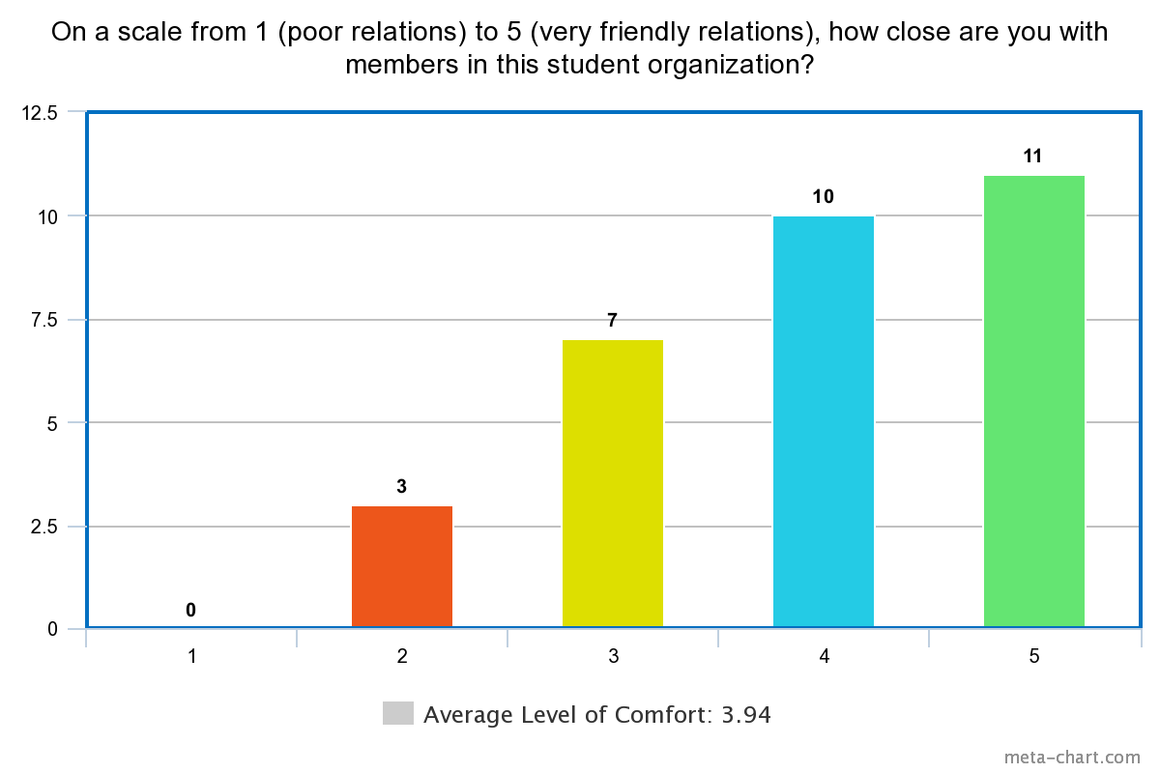
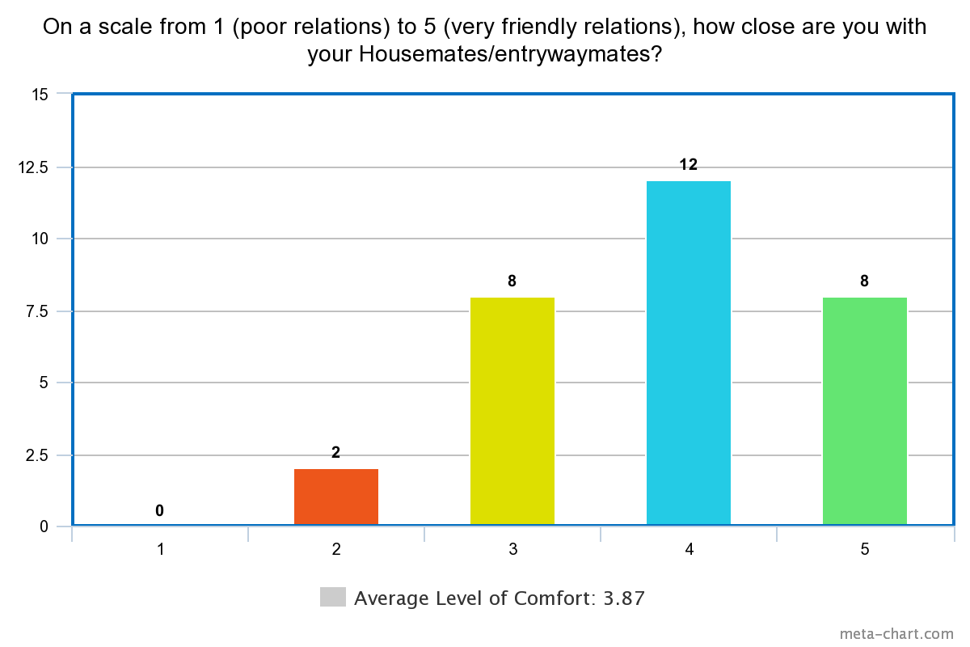
Average level of friendliness between student organization members is .07 greater than those of default communities.
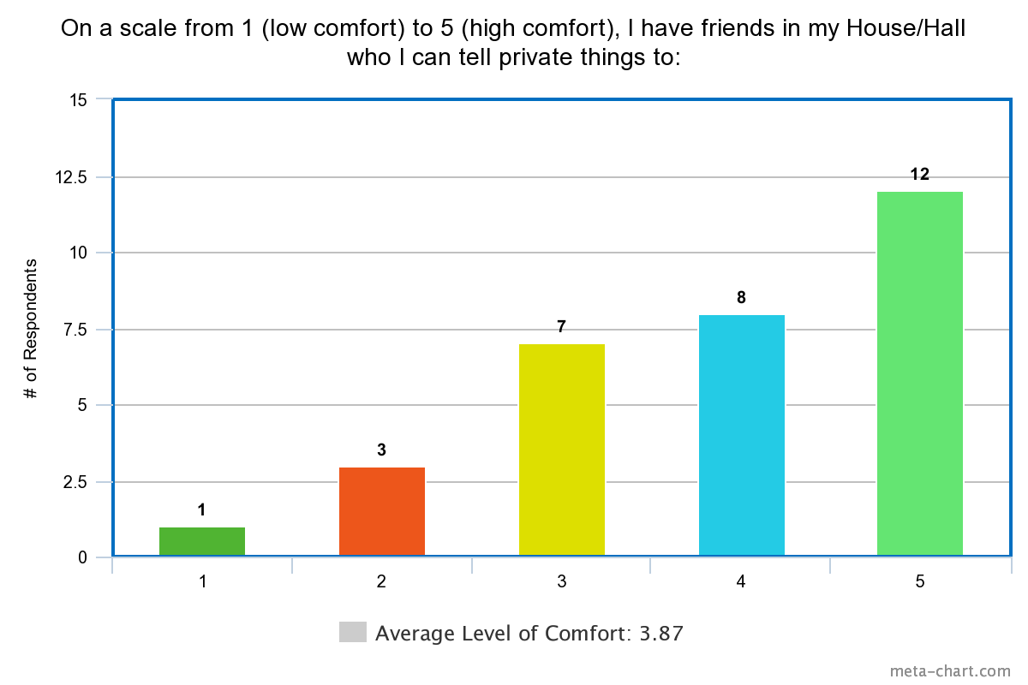
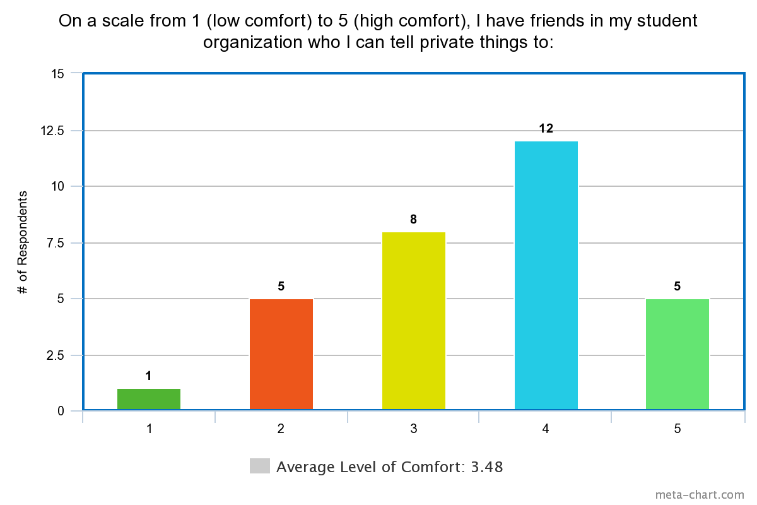
Level of Comfort in sharing private things for default community members is .39 greater than that of student organizations.
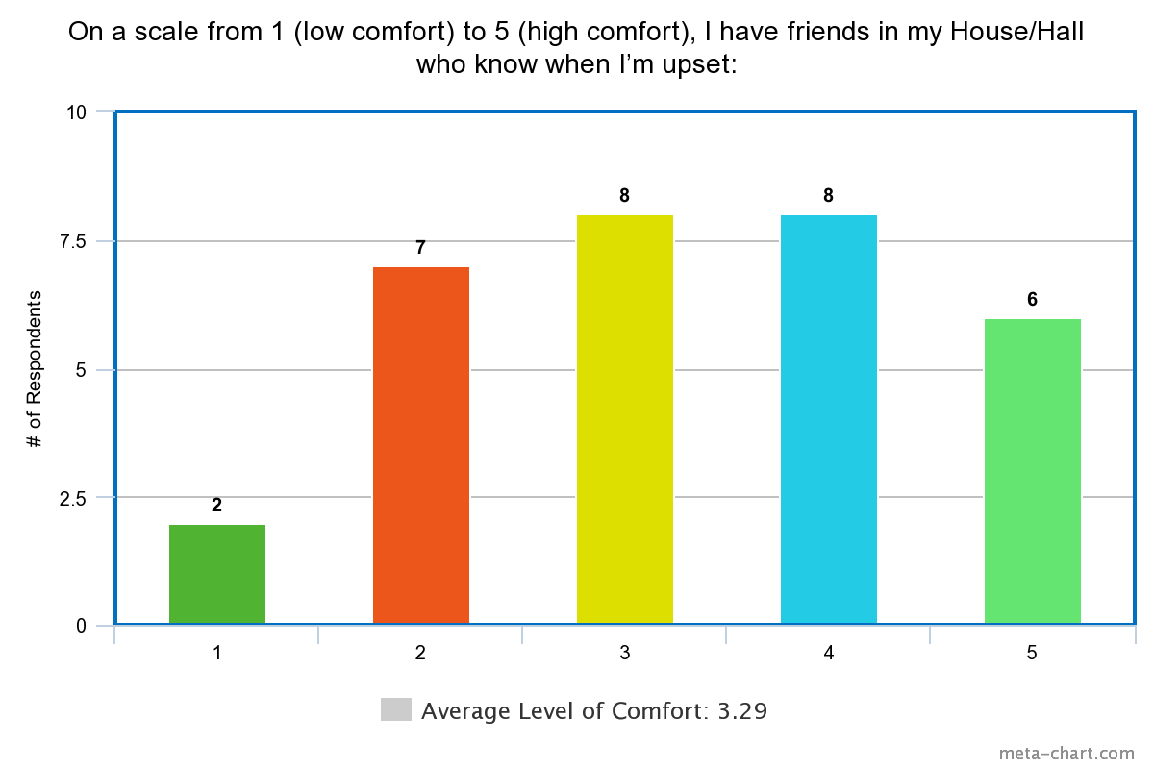
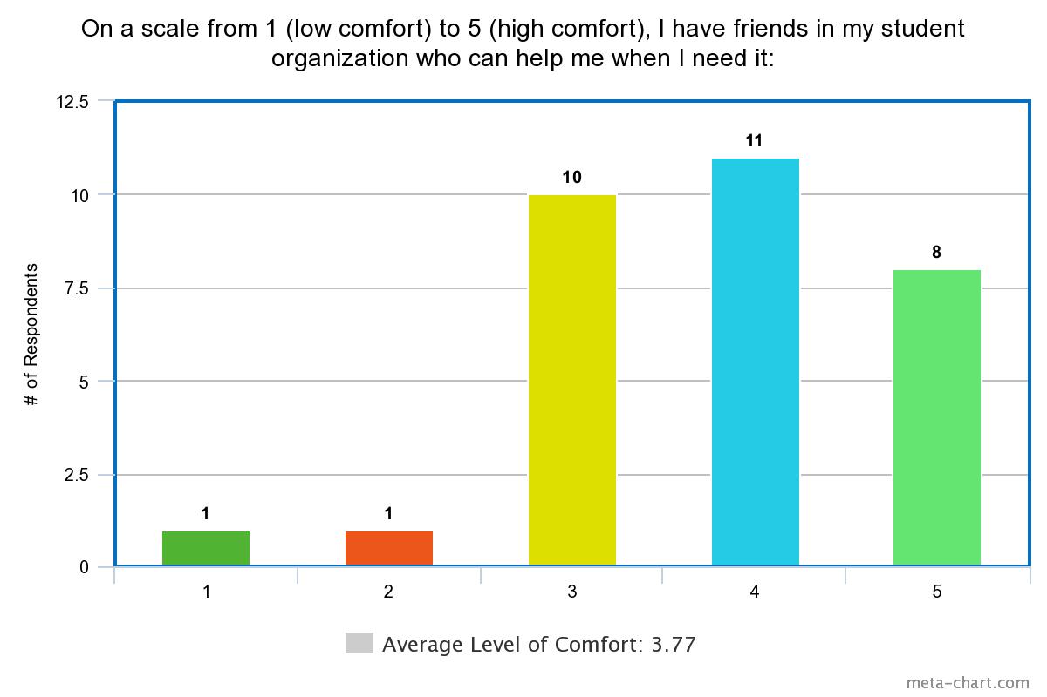
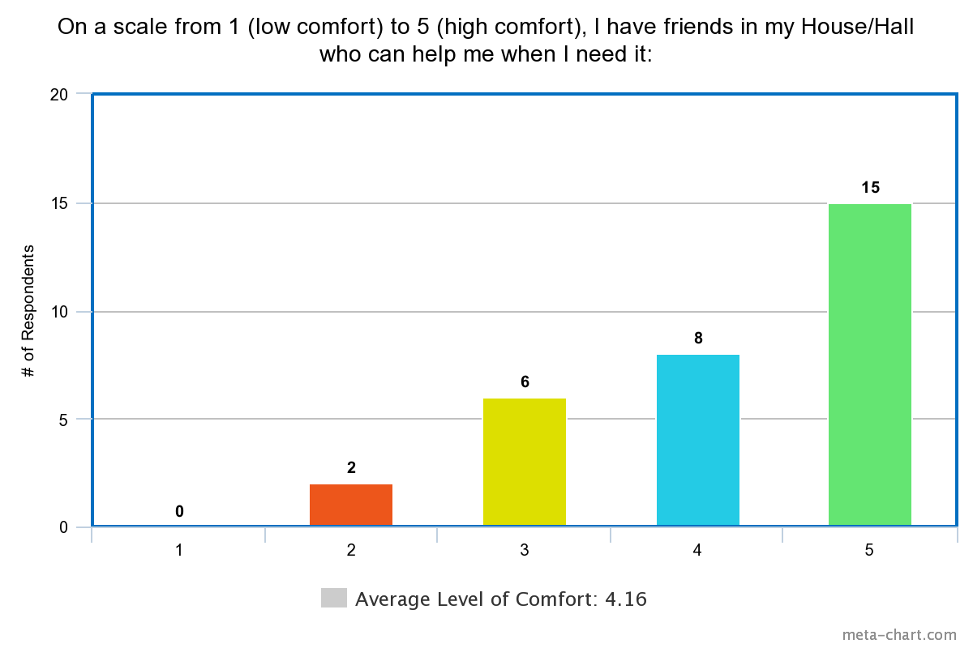
Level of Comfort of friends receiving help when in need for default communities is .39 greater than that of student organizations
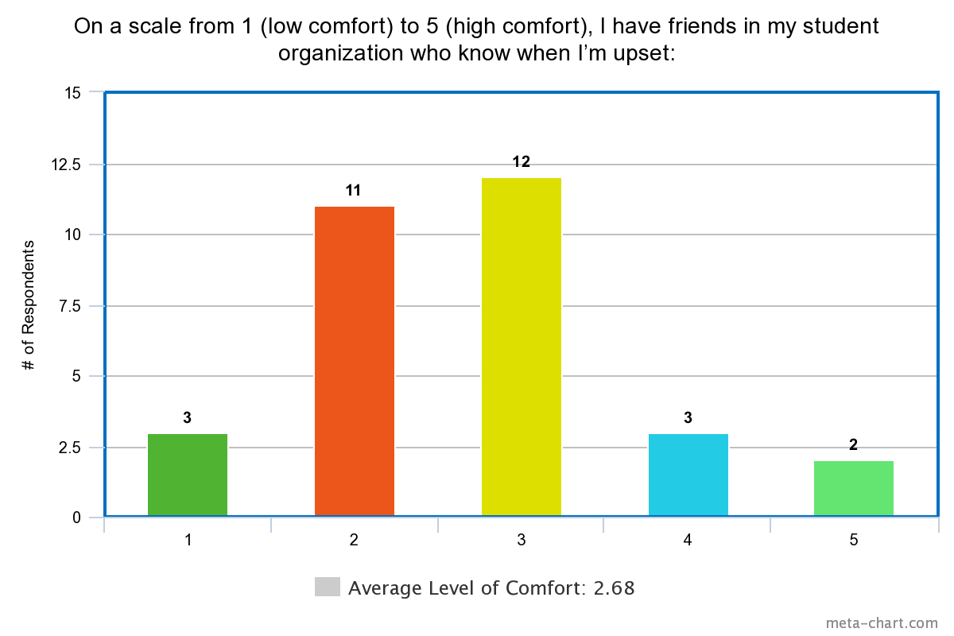
Level of Comfort of friends recognizing each others’ anger for default communities is .61 greater than that of student organizations

Our studies indicated that individuals considered themselves to be about equally as close with friends in their exclusive communities as in their default communities. Meanwhile, respondents found it easier to share more private and personal information with their blocking group, the people with whom they choose to live on campus for years at a time. For example, when participants were asked with whom they feel more comfortable sharing private information, there was a slight preference for their blocking group, which demonstrated an average increase of comfort in sharing of .39.
Furthermore, we also observed that where students spent more time with each other for non-activity events, they are more likely to have closer relationships with their peers. In Student Organization A, 47.1% of students reported spending more than 1-2 hours for non-work-related events (i.e. optional organized socials or social events), and these same students had an average comfort level of 4.06 for friendly relationships within A. Meanwhile, in Student Organization B, 28.6% of students reported spending more than 1-2 hours for non-work-related events, and had an average comfort level of 3.78 for friendly relationships within B.
Finally, our results do show that members of pre-professional groups do seem to value exclusivity or see it as something that is important to the organization. In fact, an overwhelming 94.2% of Student Organization A members and 92.9% of Student Organization B members surveyed answered that they thought their club should either have no change in its exclusivity, or be more exclusive.
- Demographics and Generalization of Findings
Student Organization B had a response rate of 41.2% from the total 34 members contacted, with the 14 respondents consisting of 5 freshmen and 9 upperclassmen respondents. Meanwhile, Student Organization A had a 29.3% response rate from its its total 58 members, with the total of 17 respondents consisting of 5 freshmen respondents and 12 upperclassmen respondents. Therefore, the compiled average level of comfort in default community comparisons are slightly more biased to upperclassmen halls’ blocking groups compared to freshmen houses.
Both organizations had a slightly higher female-to-male ratio. On the gender spectrum, Student Organization A had 7 male respondents (41.2%) and 10 female respondents (58.8%), while Student Organization B had 6 male respondents (42.9%) and 8 female respondents (57.1%).
Finally, we kept in mind when analyzing our results is that although the organizations are similar in their size and application/comp process, one key difference among the general population of both groups that may have affected the sense of community is that Student Organization A does tend to attract people with similar cultural ties and values, especially as many members are among the same race/ethnicity, many of whom are also international students and/or can speak other languages together. Student Organization A had 16 out of its 17 respondents identify as Asian, Asian America, or Pacific Islander. On the other hand, Student Organization B had a much more diverse population with 7 respondents identifying as Asian, Asian America, or Pacific Islander; 3 respondents identifying as White; 2 respondents identifying as Asian, Asian America, or Pacific Islander and White; and 2 respondents identifying as Black or African American. The focus of our research specifically is not to analyze the degree to which cultural/ethnic homogeneity affects sense of community; however, we do want to recognize that this may be part of the reason why in Student Organization A, students spend more time with each other for non-work-related events and exhibit higher reflections of friendliness amongst peers in that group.
This theory was confirmed by our interviews. Due to a low number of interested interviewees, we were not able to holistically interview the groups, and therefore we do not want to make overarching generalizations regarding the opinions of the entire organization or both organizations. However, we were able to conduct three interviews with three members of Student Organization A, in general, the students did acknowledge that “a lot of people in [A] being [of the same ethnicity], makes it easier to connect on some levels” and that “cultural fluency” made it easier to get along well. All three students expressed wanting communities that had a “welcoming, kind, and caring” environment, as well as being “inclusive [and] wholesome.” Even though the students acknowledged differences between the general sense of community or interactions in their residential communities versus their opt-in organizations, an environment that felt safe, friendly, and comfortable was obviously important regardless of the type of group. Finally, the students interviewed were able to give us some insights into student outlook on the comp process itself. All three students either “did not like” the idea of the process, or found the idea to be “intense,” revealing that students themselves do feel the competitive pressures that many associate with comping; however, all students also then acknowledged they saw the process in a better light when going through it and afterwards, even seeing why it was necessary. These interviews show how understanding student perspective is crucial to strengthening the sense of community in any type of organization, and more research is definitely needed to gain insight on possible solutions or what methods to continue.
- Suggestions for Future Research
We recognize that one limitation of our study is that we only surveyed and interviewed students who identified as members of exclusive pre-professional organizations. Thus, we as researchers acknowledge that our study faces limitations in terms of generalizability. We therefore suggest that future research should aim to survey and interview students who identify as members of a variety of exclusive organizations, including social clubs, acapella groups, journalistic/media and creative writing collectives, groups dedicated to the performing arts, and even athletic teams. We were unfortunately unable to gain a high number of in-depth interviews in addition to the survey responses from the two organizations; therefore, future adaptations of this study would likely benefit greatly from having more in-depth interviews in which students could be asked to explain their answers further and to find their opinions about what sense of community looks and feels like.
On a similar note, doing background interviews with the people who try to create a sense of community would be very beneficial to add to the understanding of why certain groups might feel closer than others. For example, in our study, doing interviews with deans and other administrators who work to design residential/community life, plus interviewing student leadership in exclusive clubs, might be able to explain some of the trends in the responses given by the student members themselves.

Discussion/Conclusion
Default communities produced a greater sense of community in many scenarios than more exclusive student groups in which membership was handpicked. Some of the underlying mechanisms for these results might be that default communities involve cooperative or collaborative living, which lends itself to giving up certain aspects of privacy and likely makes it easier to communicate and share private matters or private concerns in general. Living together in shared spaces also results in a reduced need for planned social outings since cohabitation also lends itself to spur-of-the-moment interpersonal and relationship-building activities.
Interestingly, about 70% of respondents said they only spent about 1-2 hours per week with their organization’s members on non-work, non-professional related events and activities. This data point may be exclusive to pre-professional groups since they are often perceived as resume sparklers and launchpads into the prestige industries like finance and consulting. We are uncertain as to whether our respondents were intrinsically or extrinsically motivated to join these organizations. However, there is a pervasive belief on campus that students are motivated to join these groups in order to reach and achieve their professional goals. Students don’t typically join these groups to build friendships or acquaintanceships with their peers; instead, they want to network by making valuable connections with established businesses in the world of work. This is perceived to give students an edge in the summer internship search and the culminating job recruitment process. Ultimately, students’ motivations for joining these groups may be more self-interested and careerist in nature. Therefore, default communities like blocking groups or entryways may produce more genuine and warm interactions with university peers. Friendships built in default communities are likely to be more authentic and more organic since they are not driven by professional goals or achievement.
Reflecting upon our research implications, we believe that more exclusive pre-professional student groups can make efforts to strengthen the sense of community within their organizations. This can be executed through group outings, socials, and mixers. This recommendation comes from seeing the ways in which default communities often organize ways for members to spend more time together. However, we also commend the university for making efforts to create more intimate and close-knit social spaces beyond the realm of more exclusive student groups. We need spaces that celebrate and encourage intimacy, warmth, and inclusion regardless of students’ personal and professional interests.
Finally, we recognize that students may choose to go to different groups for different purposes, and belonging to a diverse set of communities also leads to a more interesting, unique, and personal college experience. We should continue to support those students who do identify as members of exclusive groups regardless of the circumstances surrounding their decision to join.
Bibliography

Akar-Vural, R., Yilmaz-Özelçi, S., Çengel, M., & Gömleksiz, M. (2013). The Development of the "Sense of Belonging to School" Scale. Eurasian Journal of Educational Research, 53, 215-230. https://eric.ed.gov/?id=EJ1060376

Allen, K., Kern, M. L., Vella-Brodrick, D., Hattie, J., & Waters, L. (2018). What schools need to know about fostering school belonging: A meta-analysis. Educational Psychology Review, 30(1), 1–34. https://doi.org/10.1007/s10648-016-9389-8

Binder, A. J., Davis, D. B., & Bloom, N. (2016). Career Funneling: How Elite Students Learn to Define and Desire ‘“Prestigious”’ Jobs. Sociology of Education, 89(1), 20–39. https://doi.org/10.1177/0038040715610883

Blomfield, C., & Barber, B. (2010). Australian Adolescents' Extracurricular Activity Participation and Positive Development: Is the Relationship Mediated by Peer Attributes?. Australian Journal of Educational & Developmental Psychology, 10, 114-128. https://eric.ed.gov/?id=EJ895560

Erb, N. M., Sinclair, M. S., & Braxton, J. M. (2015). Fostering a sense of community in residence halls: A role for housing and residential professionals in increasing college student persistence. Strategic Enrollment Management Quarterly, 3(2), 84-108. https://doi.org/10.1002/sem3.20063

Farineau, K. (2019). Problems at Home: Take the Pulse in the Houses. The Harvard Crimson. https://www.thecrimson.com/article/2019/4/8/farineau-problems-at-home/

Glass, C. R., & Gesing, P. (2018). The development of social capital through international students’ involvement in campus organizations. Journal of International Students, 8(3), 1274-1292.
TheHub at Harvard College (2019). http://thehub.college.harvard.edu

Kilgo, C., Mollet, A., & Pascarella, E. (2016). The Estimated Effects of College Student Involvement on Psychological Well-Being. Journal Of College Student Development, 57(8), 1043-1049. doi: 10.1353/csd.2016.0098

Mangold, W. D., Bean, L. G., Adams, D. J., Schwab, W. A., & Lynch, S. M. (2002). Who goes who stays: An assessment of the effect of a freshman mentoring and unit registration program on college persistence. Journal of College Student Retention: Research, Theory & Practice, 4(2), 95-122. https://doi.org/10.2190/CVET-TMDM-CTE4-AFE3

Mittereder, F., Durow, J., West, B. T., Kreuter, F., & Conrad, F. G. (2018). Interviewer–respondent Interactions in Conversational and Standardized Interviewing. Field Methods, 30(1), 3-21. https://doi.org/10.1177/1525822X17729341

Narayanan, S.J. and Zwickel, S.W. (2019). Student Life Committee Plans Review of Student Groups’ Comps. The Harvard Crimson. https://www.thecrimson.com/article/2019/10/4/cls-first-meeting

Padilla-Angulo, L. (2019). Student associations and entrepreneurial intentions. Studies in Higher Education, 44(1), 45-58. https://doi.org/10.1080/03075079.2017.1336215

Rahman Khan, S. (2012). The sociology of elites. Annual Review of Sociology, 38, 361-377. https://doi.org/10.1146/annurev-soc-071811-145542
Smith, T. B. (1993). Gateways: Residential Colleges and the Freshman Year Experience. Monograph Series Number 14: The Freshman Year Experience. https://eric.ed.gov/?id=ED367216

Stuber, J. (2009). Class, Culture, and Participation in the Collegiate Extra‐Curriculum. Sociological Forum, 24(4), 877-900. https://doi.org/10.1111/j.1573-7861.2009.01140.x

Tracy, S. J. (2010). Qualitative Quality: Eight “Big-Tent” Criteria for Excellent Qualitative Research. Qualitative Inquiry, 16(10), 837–851. https://doi.org/10.1177/1077800410383121

Vaccaro, A., & Newman, B. M. (2016). Development of a sense of belonging for privileged and minoritized students: An emergent model. Journal of College Student Development, 57(8), 925-942. doi: 10.1353/csd.2016.0091

Acknowledgements

Thank you so much to the GENED 1039 teaching staff for supporting us over the course of this project, including our lovely mentors Professor Manja Klemencic and Teaching Fellow Jaein Lee. We couldn’t have done it without your feedback and encouragement!

