Lifting Spirits:
Analyzing School Spirit and Social Solidarity Among Harvard’s Student Body

Felix Bulwa

Abstract
One of the most visible components of university life is the student body’s engagement and identification with their school. This “school spirit” shows itself with colors and chants at athletic events, on the apparel of alumni across the globe, and in the meshing of student socializing. However, Harvard College seems to lack that spark. In comparison to other universities across the country, Harvard falls short in arenas that show off school pride. This empirical paper aims to answer three central questions: 1) How do Harvard students perceive school spirit at Harvard, 2) what the underlying causes of any deficiencies may be, and 3) how best to approach actions in order to increase the level of student solidarity on campus. By researching the status of Harvard’s school spirit, this paper seeks to offer a set of recommendations for students and administrators to best incorporate modern changes into a traditional school culture.

​​I affirm my awareness of the standards of the Harvard College Honor Code.
Felix Bulwa
Introduction

It’s no secret: If schools were graded on the school spirit of the student body, Harvard would earn an F. Despite boasting the largest Division 1 Athletics Department in the entire nation, sports arena bleachers are consistently barren of “hoo-rah” and fans. Despite succeeding in one of the most exclusive admissions processes undergraduates face, Harvard students seem more likely to complain about Harvard’s administrative and academic shortcomings than complement the university’s elite level of resources. And despite the school’s massive brand presence, one could more likely find a tourist wearing a Harvard sweatshirt off campus than an actual student of the College.
But the idea of “school spirit” stretches beyond the visual images of crimson-clad football fans. At its core, the concept represents a level of community, identity, and belonging among a student body. These ideals extend beyond pure fandom and seep into an institution’s level of pride, enthusiasm, and teamwork. Perhaps most importantly, this spirit contributes to a sense of social solidarity, touted by theorists such as Emile Durkheim, where everyone is invested in a common goal of success and togetherness. Without it, universities run the risk of fostering a sense of individualism and self-isolation.
This research paper aims to dive deep into the reality and extent of this campus dilemma. After all, this question is no new development. The Harvard Crimson published editorials dated back to 1994 and 2002 that tackled Harvard’s lack of school spirit, each noting eerily similar trends of quiet student sections at sporting events and disinterested students. Although the authors are optimistic of a culture change, two decades have passed without perceived improvement. Why has Harvard failed to foster this collective culture that is so celebrated elsewhere? Do students and administrators even deem the positive benefits of social solidarity as worthy uses of resources?
All in all, this paper aims to establish an objective understanding of the perceptions and driving factors of school spirit within the Harvard community. Results found that Harvard undergraduates feel significantly low school spirit compared to their own Houses and extracurricular clubs, likely due in part by Harvard’s decentralization and lack of a sports culture. Using research data, the report goes on to recommend an increase in frequency and publicity of cross-campus events, especially utilizing the strength of pre-existing community groups, as well as adopting a popular Harvard mascot. Accumulating these results into realizable and practical actions can leave a mark on future cohorts of Harvard students, as well as provide an outline for higher education efforts on a larger scale.

Review of Literature

For a topic so relevant to the modern-day university undergraduate experience, there surprisingly exists very few academic studies around school spirit. However, though imperfect, one can draw parallels from extensive research around the psychology of “school belonging.”
Successful efforts to foster a sense of school belonging in a university setting can have incredible effects. Defined as “the extent to which students feel personally accepted, respected, included, and supported by others in the school social environment” (Goodenow 1993, 80), school belonging has been shown to positively contribute to motivation, self-esteem, behavior in the classroom, and high achievement (Korpershoek 2019). These correlations extend from academic and social competence to positive psychological adjustments. Specifically, Pittman and Richmond suggest that measurements of belonging in both high schools and universities can actually serve as predictors for future grades, feelings of self-worth, and the externalization of problem behaviors (Pittman 2007). These two meta-analyses offer evidence how one’s school atmosphere can have tangible effects on students’ individualized health and success.
Diving deeper into the literature, the need for belonging contributes to an increase in student subcultures around campus. In the Second Edition of his book College Students’ Sense of Belonging, Terrell Strayhorn explores how university students can increase a sense of belonging through “involvement.” Whether in the form of joining a campus club or working a campus job, most students report how they only felt as if they were “part of the campus” when involving themselves in smaller-scale groups, teams, and organizations (Strayhorn 2019). If school belonging is a reliable indicator of school spirit, the implications of involvement within a smaller subset of campus could contribute to a greater understanding of university belonging.
The next logical question that follows is how best to create a school environment of belonging. Kelly Allen’s research in a K-12 setting has analyzed a plethora of possible factors, narrowing down teacher support and positive personal characteristics such as “conscientiousness, optimism and self-esteem” (Allen 2016, 4). Although her research centered around younger-aged adolescents in high school, the central concepts of faculty support and self-esteem can be carefully applied in a postsecondary context. Additionally, she makes note that causation is unclear, which offers the possibility that “belonging” and positive psychological effects may produce a positive feedback loop.
School belonging alone cannot account for all elements of what is traditionally pictured as “school spirit.” One can feel as if they belong in a space, but what would encourage individual agency in that space? Scholarship offered by Jon Pierce et al can offer a way to incorporate “psychological ownership” into a working theory of school spirit. These researchers put forth that in order to psychologically feel as if some immaterial or material target is truly theirs, one must have a level of control over it, intimately associate with it, and invest oneself in it (Pierce 2001, 301). Although this framework is broad in scope, it provides research on school spirit with a structured pathway. In order to fully express school spirit, perhaps, a student must first 1) feel a sense of agency, 2) satisfy a need for belonging, and 3) and invest themselves in their university. Student and administrator actions can enhance or detract from each step of the way.

Description of Methods

The aim of this empirical study is to survey sentiments of the Harvard student body and uncover the root causes of any noticeable trends. In order to reach a large number of Harvard undergrads and explore specific experiences, the methods included a wide-reaching survey (130 total respondents with a 15% response rate of Currier House) as well as an informal in-person roundtable discussion with two interested undergraduates, “Xander” (Currier ’23) and “Sydney” (Leverett ’23). For further information on survey and interviewee demographics, please see Guides in the Appendix. The central research question of this report is divided as follows:

1) What is the student body’s perception of school spirit at Harvard? The research survey provided a quantitative idea of how extensive the students perceive a lack of campus spirit. Participants used a 1-5 scale to report their level of agreements with scenarios centered around school spirit, such as frequency of wearing Harvard apparel and personal investment in Crimson sports. Connecting this question to the literature, the survey asked respondents to independently rate both their sense of school spirit and their sense of school belonging. Due to the difference between the answers to these questions, the research could speak on the interchangeability of the two terms. These results provided a framing mechanism for the rest of the research and would ensure that the trend this paper at times calls a “crisis” is actually perceived as such by present-day Harvard students.
2) What are the underlying causes of these reported trends? By asking roundtable and survey respondents about their personal experiences and ideas, I uncovered potential reasons for a lack of spirit. Using inductive analysis of personal experiences and observations, I started out with several working hypotheses: Are the Residential Houses too isolated from each other, fostering affinity solely within residential walls? Do students limit friend groups to people in their concentrations? How would creating an official Harvard mascot contribute to a sports fandom? Does the Harvard “brand name” discourage ownership for fear of public judgement? Here the paper takes a qualitative approach and uses respondent’s individual comments to develop a narrative of the students’ and administration’s shortcomings in producing the culture of school spirit. At times, participants shared personal experiences from other universities and their hometowns. However, due to the Harvard-centric nature of the research investigation, this report can only provide a limited comparative analysis with schools deemed more successful in fostering a collectivist culture.
3) How can Harvard work toward increasing the level of student solidarity on campus through initiatives in belonging and ownership? Using the data accumulated from the survey and roundtable discussion, this research paper assembles a potential set of recommendations for Harvard’s leadership and student body to foster campus spirit – from sporting events to friendships across different residential Houses. Reflecting the initial framework developed from the literature, as well as ideas inspired by Harvard undergraduates, this action plan centers on belonging and ownership of Harvard. It is my intention and hope that these recommendations will produce real changes on campus.

Limitations and Positionality

This study cannot promise a comprehensive snapshot of all student or administrative perspectives. However, the two-pronged survey and roundtable approach will likely attract a large breadth and depth of responses. The survey itself reached every corner of the campus, with responses from every upperclassman House and grade level, to garner a more comprehensive understanding of the entire student body’s opinions and experiences. Additionally, most of my respondents were strangers to me, decreasing biases of appeasement or guessing my own personal views.
As an undergraduate student at Harvard College, I inevitably carry bias into this research of my own school. In fact, the inspiration for the topic of this research came from personal observations of low school spirit and student separation from the Harvard name. However, the first prong of the central research question serves to negate such subjectivity. This research made space for survey respondents and interviewees to express their own perspectives on the university. Questions were not framed to skew responses, and I only used the gathered data to drive my subsequent analysis and recommendations. See Appendix for Survey and Interview Guides, as well as attached Survey Report for complete data.

Findings

The following findings analyze and visualize the quantitative results from the research survey, interspersed with student voices from open-ended survey questions and roundtable interviews. Although no one survey can be completely perfect in gathering all opinions from the Harvard student body, the high number of respondents (130 undergraduates) range from all upperclassmen Houses and Social Years (see Figure 1). For a complete demographic breakdown of survey respondents, including gender, financial aid and legacy status, please see the Appendix. In this way, results can be reasonably generalizable to the greater Harvard College student body.

Figure 1: Social Year of Survey Respondents
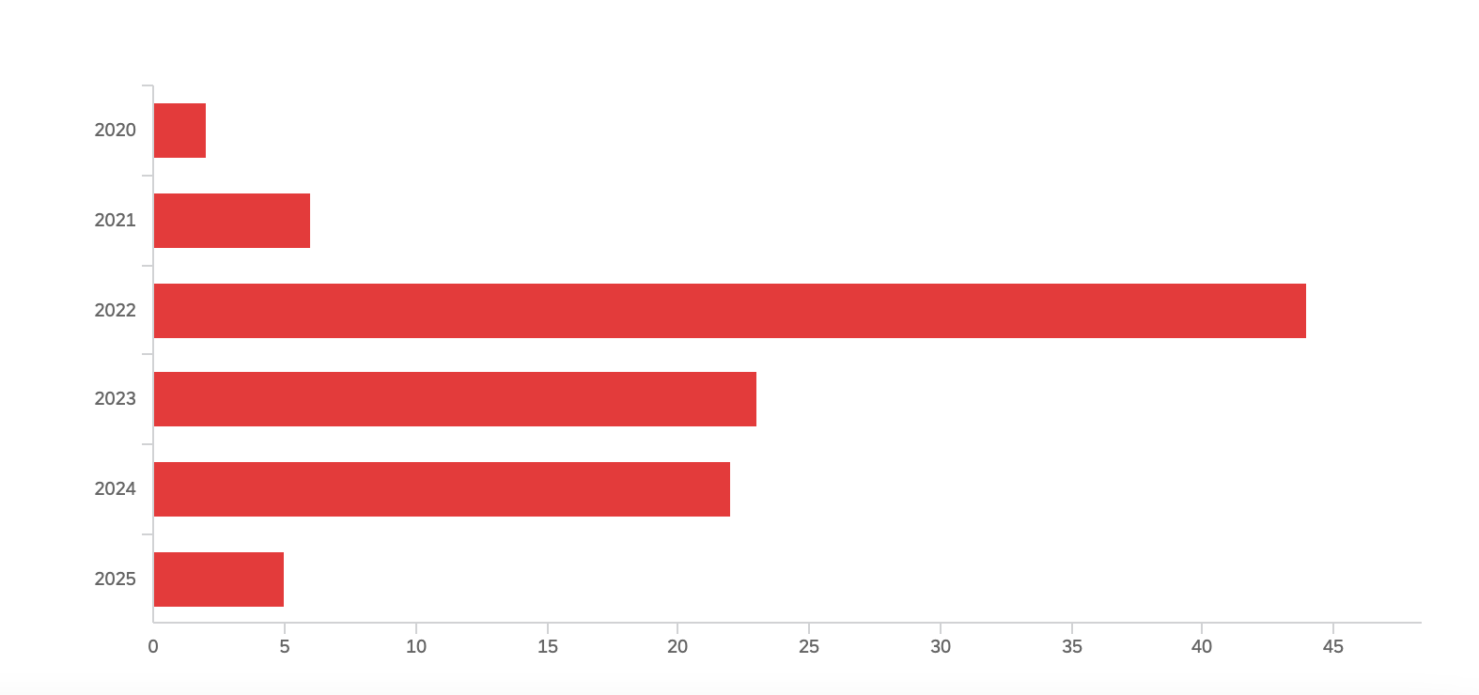
# of Respondents

The central findings for the first two Research Questions are as follows:
- Harvard students report low school spirit relative to their sense of belonging and comfort on campus
- The decentralized nature of Harvard creates isolated pockets of community within friend groups, extracurricular clubs, and residential dorms
- Harvard has a quantifiable lack of sports culture, limiting the prevalence for collective school-wide gatherings

These results do not exhaust every potential factor for school spirit on campus, but they represent common threads consistently found throughout the research. It is also important to note that numbers alone cannot offer an entirely accurate snapshot of student opinions and experiences, especially without a thorough statistical analysis. Therefore, I use interview and survey quotes to highlight certain shared sentiment among the research sample.

- Quantifying Harvard’s School Spirit Deficiency

Figure 2: Average rankings of agreement for Harvard-wide statements
Statement | Average (1=strongly disagree, 5=strongly agree)
Harvard College has school spirit | 2.47
I feel as if I belong within the greater Harvard community | 3.29
I am comfortable calling Harvard College “home” | 3.54
When asked where I go to school, I have no hesitation revealing I go  to Harvard | 2.63

The figure above reflects the average rankings for all survey respondents, giving Harvard school spirit an official grade: 2.47 out of 5. When controlling for demographic variables, this number is largely consistent. Students who reported receiving aid averaged 2.49, legacy students finished at 2.46, and inter-collegiate competitors ranked the spirit slightly higher with 2.67.

Currier ’24: “Harvard school spirit is so lame. Barely anyone supports sports or performances.”

Currier ’24: “School spirit is lacking, we have no chants or anything when we go to games, and no games are like big events except home openers and Harvard-Yale.”

The data immediately challenges the purported equivalence of school spirit and school belonging. Survey respondents averaged a 3.29 ranking in response to the prompt on greater Harvard belonging, with an even higher 3.54 when asked if they considered Harvard “home.” The clear difference in opinion between school spirit and school belonging reveals that there may be other external factors that prevent students from feeling a true school spirit. Literature would suggest a deficiency in agency and investment, but the data suggests another: outward pride.
In fact, the ranking about hesitancy to reveal one’s status as a Harvard student (2.63) much more closely correlates with the school spirit average. Such correlation does not imply that these two opinions are causally related, but qualitative responses suggest incorporating pride into the definition:

Xander: “School spirit is like nationalism: Pride in a space or community that you are in. That manifests itself in different ways. For some people, school spirit is really integrated in the understanding of their school.”

Sydney: “I think school spirit is pride in your college, but often it is more about being excited for your sports teams. But I think any kind of pride or excitement about your school counts as school spirit.”

It is important to note that undergraduates individually defined “school spirit” in various ways, and many respondents mentioned that wearing Harvard clothes could serve as a useful metric. The survey found that undergraduates wear at least one piece of Harvard apparel an average of 1.44 days of their typical week, with one third of respondents reporting that they never wear Harvard clothing. A few respondents noted that these low numbers should not be viewed as proof of low school spirit; rather, they are proof of an inherent recognition that outwardly displaying one’s status as a Harvard student carries a connotation of elitism:

Quincy ’23: “Wearing Harvard clothes feels obnoxious, especially at home— it makes a statement.”

Xander: “Harvard is interesting with school pride. It’s also showcasing elitism. Whenever someone wears a ‘Harvard’ something, you can be proud of your institution, but you’re proud of an elitist institution. Or you’re proud of your status, rather than just the place. At least that’s what some people assume, especially if you’re not around Cambridge.”

The question then remains: Does the privileged status of Harvard discourage students from outwardly revealing their school affiliation? Or instead, does Harvard’s selective identity actively limit its students from fully buying into collective school spirit? This research alone cannot provide a perfect answer, but the end result is the same: Harvard students generally opt against wearing the Harvard name.
Although most demographic variables produced generally homogenous results, one interesting trend in the data arose when controlling averages for social years. As Figure 3 depicts, First-Year students seem to begin their Harvard experience with above-average spirit, only to sharply decline sophomore and junior year. However, the sentiment slightly reverses course senior year, with social super-seniors averaging a continued increase. Because the sample size per social year is inconsistent, this trend is not completely generalizable, but there still may be truth in this finding. As the following section argues, students tend to prioritize and invest in their smaller clubs and residential halls. But it takes time for First-Years to find these groups, and the First-Year experience instead emphasizes full-class activities:

Sydney: “I wonder if First Year school spirit is maybe stronger because you’re trying to get know everyone and are attending more all-college events.”

Xander: “You have to concentrate what people want to do in one place. Berg [the First-Year dining hall] is where I had the most school spirit”

Figure 3: Average School Spirit vs. Social Year
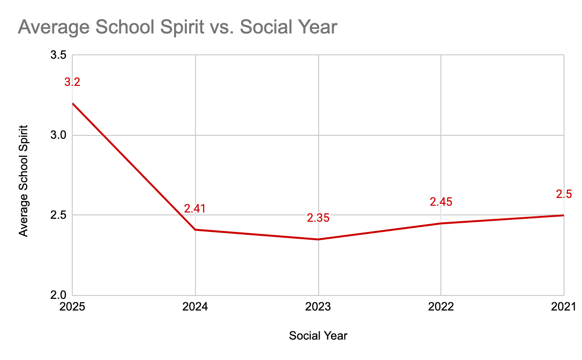

- Decentralized Nature of Harvard Creates Isolated Pockets of Belonging

Figure 4: Average rankings of agreement for statements regarding subsets of Harvard community
Statement | Average (1=strongly disagree, 5=strongly agree)
My residential House/Dorm has house spirit | 3.51
I feel as if I belong in my House/Dorm community | 3.71
I feel as if I belong within certain campus clubs and organizations | 3.77

In addition to gauging school-wide spirit and belonging, the survey asked respondents about their feelings on Houses and extracurricular activities. As Figure 4 exhibits, these students overwhelmingly expressed a higher level of House spirit than Harvard spirit (3.51 vs. 2.47) as well as a noticeable increase in House belonging (3.71 vs. 3.29). However, no measure of belonging could rival that of campus clubs and organizations at 3.77 out of 5.
This clear shift in opinion exposes the decentralized structure of Harvard University. The House system aims to answer any of a given student’s residential, administrative, and academic needs via specialized advisors, tutors, and common spaces. And because every House has their own dining hall, students need not even go outside to satisfy daily necessities. Perhaps this is why several respondents cited Housing Day as one of the only times where they felt a great sense of Harvard school spirit – it channels the energy and connection they feel to their House into a campus-wide event. In a quite ironic fashion, Harvard undergraduates are celebrating their separation from each other.

Sydney: “There is a strong identification with your House, but it does make me less interested in Harvard-wise things”

Xander: “I personally have Currier House spirit because I have to. In that way I have pride in my community and I want to show that off.”

Pfoho ’23: “There is quite a lot of school spirit, but it isn’t necessarily sport-oriented. Instead it’s a lot more house and dorm pride”

Students feel the greatest amount of belonging in their campus clubs and organizations. By self-selecting into these groups, undergraduates find communities of people with similar social, academic, and cultural interests. But because Harvard undergraduates invest themselves so heavily in these activities, they tend to deprioritize cross-campus events. Figure 5 depicts how the survey respondents would rank five activities if faced with free time on a Thursday evening. Overwhelmingly, Harvard students’ first choice was to hang out with close friends, with an optional club meeting following in second place. On average, students opted to work on an assignment due Monday before attending House Intramurals or watching a Harvard varsity athletics event. As the next section will discuss, sports attendance is not a perfect gauge for school spirit, but the results still reveal Harvard undergraduates’ consistent prioritization of close friend groups and campus clubs.

Figure 5: Responses to the scenario -- “It is 5pm on a Thursday and you have several options of how to spend your evening. Barring any urgent deadlines, please rank the following activities in order of preference from 1-5”
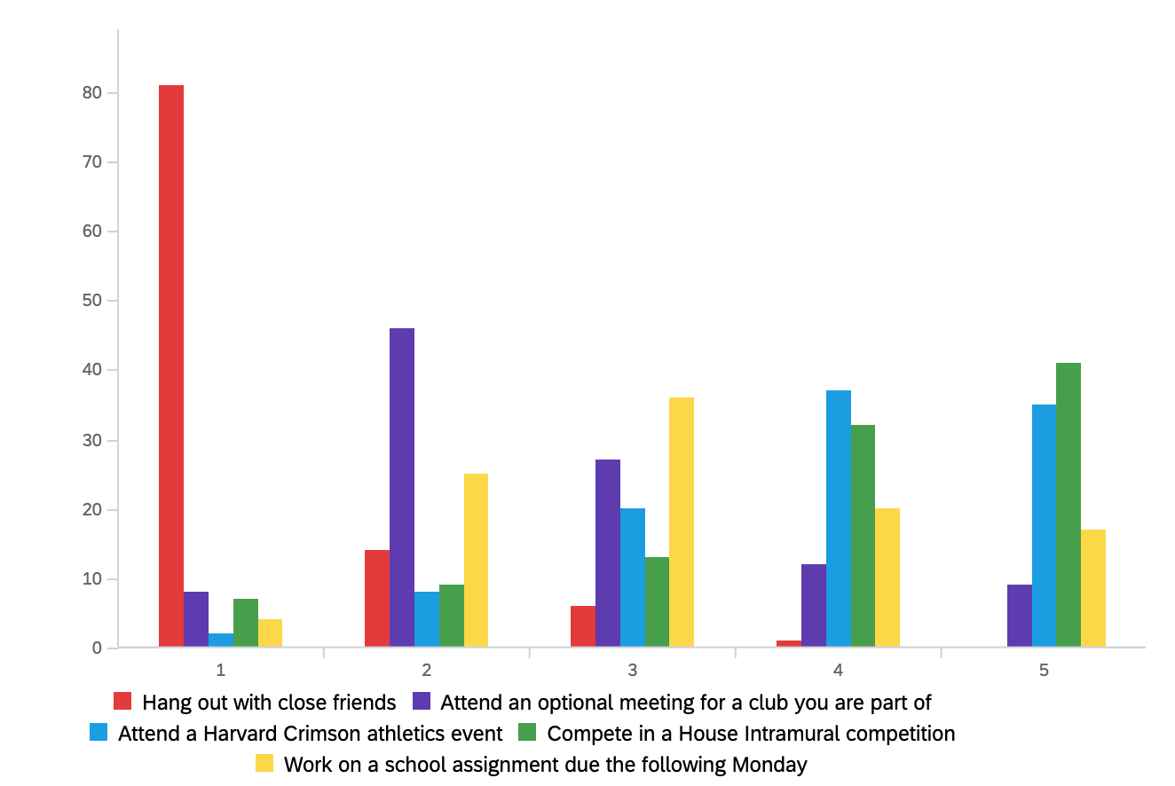
Chosen Ranking (1= First Choice, 5= Last Choice)

Harvard itself may also attract a student body that is less interested in partaking in a collective school culture. Research participants described their personal experience about this possible state of affairs:

Sydney: “Harvard students are very worried about their future and they spend less energy on engaging with the school and engaging with each other. Also our time is very limited: ‘This 15 minutes will be for this class and this 15 minutes will be thinking about what we’ll be doing next summer.’ And less of ‘Maybe I’ll go to a sports game.’ One of the challenges with school spirit is how do you make everyone feel connected when the ‘everyone’ has such diverse interests than each other. I do think it’s our strength, but in a way it is challenging to build school spirit.”

Currier ’23: “I don’t think there is much school spirit but I also think the kind of kid that comes to Harvard isn’t the kind that would be super into school spirit as it is.”

- Lack of a Sports Culture

Another reason that may account for Harvard’s school spirit problem is the clear lack of a collective sports culture. Figure 6 visualizes how many Harvard Crimson varsity sporting events respondents reported attending per semester. Averaging 3.26 games, Harvard undergraduates spectate a mere fraction of the approximately 100 events per semester across its nation-leading 42 Division I teams. Harvard football alone hosted five home games in the Fall of 2021, all of which were completely free of charge for students. Despite going to a school with the most varsity D1 teams in the country, Harvard students opt against making the trip across the river.

Figure 6: Number of varsity sporting events attended per semester (x-axis) per undergraduate (y-axis)
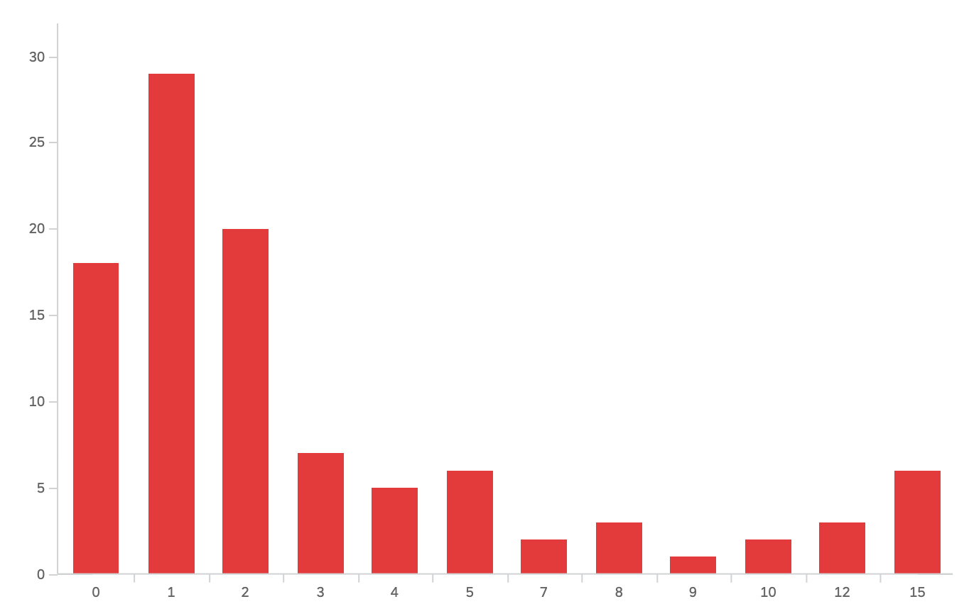
Varsity Crimson sporting events attended per semester
The low average alone does not tell the entire story. One remarkable caveat to this data set is that 80% of respondents attended the annual Harvard-Yale football game. This implies that a sizable amount, if not the majority, of students who reported attending just one varsity event per semester only went to The Game. Therefore, the true attendance average is even lower when excluding the Harvard-Yale weekend. Furthermore, I suspected that the heavy Currier and Quad House representation may have lowered the average game attendance due to the much larger distance between dorms and athletics fields, but the reverse was true. River houses averaged a mean of 2.59 varsity events per semester while Quad houses averaged 3.57. These results show that distance alone is not a complete excuse to opt against attending games; the students who live further from the river actually watch more Harvard sports.
Sports can be a valuable way to foster a sense of school spirit. A varsity athlete himself, Xander says:

Xander: “For athletics, I’m definitely more spirited. You have to be, that’s what sports are. There can be these moments of collective effervescent where everyone gets together and celebrates their school. With the Harvard Yale football game, that will be one of the few moments where we all sit together and say ‘Go School!’ For a spirit to be manifested, you need a lot of people in one place doing a thing, explicitly celebrating your school. Sports is really the only avenue that we do that, even as a society.”

Despite the collective benefits that sports can have on spirit, using varsity and intramural game attendance is not a completely accurate way to measure a student’s connection to Harvard:

Sydney: “I don’t necessarily view it as a problem that we’re not enthusiastic about sports. I think sports is one aspect of college that could be important to a person, but I think the idea of bringing people together is important, even if we have it in other ways.”

Currier ’21: “I don’t think it’s fair to judge school spirit based on sports game attendance. From my experience, a lot of people feel very proud they go to Harvard, and I think that's just as worthy of being school spirited. There's other ways to show that, too. For instance, lots of people like to give Harvard tours, and people run for student government. Even protest is a form of school spirit because they identify with the school and feel a responsibility to make it better.”

Additionally, this finding does not aim to argue that sports should be a school’s number one priority. Many schools across the country have an objectively strong sense of school spirit through their sports culture, but they spend millions of dollars hiring coaches and provide differential academic treatment to their varsity athletes. No aspect of this research suggested that students would be in support of such an extreme shift for Harvard. But although sports cannot reflect school spirit perfectly, attending events can contribute to a collective mentality and offer a unifying spectacle like few others on a college campus.

Analysis & Recommendations

The findings section above offered data to gauge the level of Harvard’s school spirit, as well as two potential factors as to why that spirit is not higher. This section addresses the final question: What can Harvard do about it? Relying heavily on qualitative survey and interview responses, this report has determined two main pathways for student and administrative actions: 1) Increasing frequency and number of cross-campus events and gathering spaces, with special focus to encouraging attendance for pre-established student groups, and 2) Instituting a popular Harvard mascot. Although individual pieces of data have suggested several more avenues for change, these two recommendations reflect the research at large.

- Increase frequency and accessibility of cross-campus events, incentivizing attendance for friend groups, clubs, and House communities

This report has found that Harvard students, when faced with limited time, generally prioritize close friend groups and campus organizations. Moreover, the quantitative data displayed significantly higher levels of belonging and spirit within individual Houses compared to Harvard as a whole. These findings suggest that Harvard students are quicker to invest themselves and develop a collective identity within smaller subsets of the campus population. Several survey responses echo this trend:

Currier ’22: “I don’t really attend athletic events other than Harvard Yale. I’ve only gone to an intramural game when my blockmate is playing.”

Quincy ’22: “I really enjoy spending time and obtaining the highest amount of energy when around people I enjoy.”

Sydney: “One of the things I like about our school is that we definitely value our close friendships. If you have a friend on a sports team or in a performing arts group, you’re more inclined to go. I think there’s a feeling of self-consciousness going to an event where they don’t know anybody else, either they’re not going with a friend or they’re not going to support a friend.”

Perhaps, then, the most efficient and effective way to encourage cross-campus events is to incentivize attendance for tight-knit groups. For example, extra funds can be dedicated to performances which explicitly involve a cross-section of Harvard’s talented art groups (e.g. an acapella and improv show), or the College can host campus-wide events that reward friend groups participating together (e.g. team trivia nights). Certain campus-wide events can even offer certain rewards (e.g. special Brain Breaks) to the House with the most attendees. These gatherings can be hosted right before certain varsity games as official tailgates to attract more undergrads to spectate. Phone apps such as Crimzone Rewards, which gives prizes for “checking in” at varsity sport games, should be made more known throughout Harvard’s campus. Xander underlined the powerful effect of these types of large-scale events:

Xander: “Freshman year we had First Chance Dance and Crimson Jam, we need more moments where we can all gather as a collective and Harvard needs to facilitate them. We need more giant school gatherings, since we don’t even go to our sports games. If we had the top fencer in the world, people still wouldn’t show up. We should have a CS50 fair but for everybody. I want to see what everybody is doing. If Harvard made efforts to make us all connected a little more, that would really help.”

Lowell ’22: “I feel like a model similar to my high school would work with Harvard—having school-wide dress up days, pep rallies, events, etc. indiscriminate of club affiliation. There also were class vs. class (or could be house vs. house) competitions, so I felt even more spirit with friendly competition outside sports that I don’t really participate in. I went to more football games in high school than at Harvard. Could it be related to school spirit?”

Furthermore, campus programming should be more widely and centrally publicized. Currently, clubs have the sole responsibility to make posters and Facebook events, but their success at outreach depends largely on how much time and capacity individual members have away from their other responsibilities. The website “the Hub” attempts to centralize campus events in this way, but it mostly serves to organize club leadership than offer undergrads a complete roster of upcoming events. The College would likely benefit from creating a system dedicated solely to listing and categorizing upcoming organizational events:

First-Year: “I think that Harvard could have more school spirit if the atmosphere were different, such as if the events were more publicized and better marketed if that makes sense because half the time I don’t even know they are happening.”

- Select and institutionalize a popular Harvard mascot

Lastly, Harvard should adopt a real mascot. By having one tangible symbol of the school to cheer with, as well as merchandise to wear around campus and back home, a mascot can provide an image that unifies the largely decentralized campus. Both quantitative and qualitative data from this research support this claim. Over 70% of survey respondents agreed that Harvard needed a mascot, and when asked on a scale of 1-5 if a mascot would be a positive influence on their college experience, survey respondents averaged 3.20. Students offered several of their own reasons:

Xander: “The idea of mascots can help with school spirit. I think it’s just identity, when you have that caricature. Once you have something manifested you can channel your energy into something physical, rather than an abstract concept.”

Currier ’22: “I feel like Harvard’s lack of mascot and insistence on calling it’s sports teams ‘the Crimson’ contributes to its pretentious image which makes it hard to connect with school pride as a whole.”

Currier ’22: “We need literally any mascot! Literally any!”

The survey also asked respondents about potential ideas as to what the Harvard mascot should be. From previous conversations with students, as well as extensive personal thinking on the topic, I offered two options up front: the turkey and the lobster. Winning over one third of the entire survey sample, the turkey proved the favorite. Their remarkable prevalence around campus offered a uniquely unifying image and motivated student thinking. The turkey is also a Thanksgiving nod to the unpopular caricature of John Harvard the Pilgrim sporadically used as a mascot twenty years ago. This is not the first time Harvard students suggested choosing the turkey as a mascot; hundred expressed interest in a 2016 campaign. Nearly 15% of students opted for the lobster, due to its Crimson coloring and strong connection to the Boston and New England area:

Figure 7: Undergraduate preferences for a potential Harvard mascot
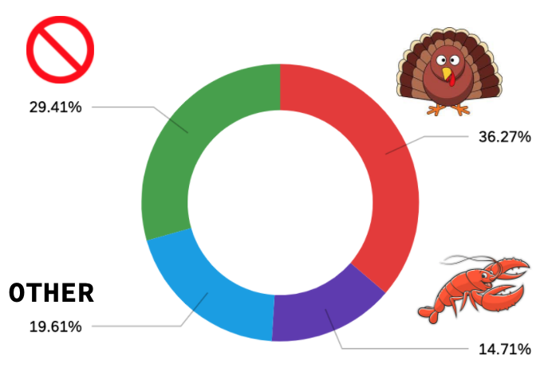

Nearly 20% of respondents believed that Harvard does in fact need a mascot, but preferred other options:

Lowell ’24: “We gotta one-up MIT with some intellectual animal, or an animal that displays leadership and innovation. Dolphins, crows, gorillas, ... but no pilgrims or John Harvard, ENOUGH with the white men.”

Lowell ’22: “I feel like a socially-acceptable mascot would benefit the Harvard experience. Not like a colonizer/pilgrim that I’ve seen before.”

Sydney: “I think humor’s great. For Harvard specifically, maybe not everyone thinks that. Would the administration be okay with having the turkey as a mascot? It’s a little silly-looking. I think alliteration would be fantastic. Like Harvard Hedgehogs, Hares, Herons, Hawks or Hammerheads… even ‘Human’ starts with H.”

The question of humor consistently arose around these discussions about choosing a Harvard mascot. Is it crucially important for the school symbol to be “taken seriously” by alumni and other universities? Or is there value to having a laughable costume on the field? Although some research participants voiced that “cookable” animals may give easy inspiration for opposing team chants and heckles, even more expressed how a funny and unique mascot may be the perfect rallying figure for Harvard undergraduates:

Xander: “Some mascots take themselves too seriously. We don’t need a lion. A funny mascot brings people together more than anything else because it’s just a joke, it’s so college-y. The Harvard ‘Crimson’ doesn’t lend itself to a mascot. I hate when people say ‘Oh well John Harvard’s our mascot.’ That’s weird, why is it just a really old white dude? There’s our history right there. Humor’s a way to get that collective effervescence, and if the mascot doesn’t get press in that way, nothing truly will.”

Despite the overall eagerness to adopt a Harvard mascot, it is important to note that the sentiment is not completely universal. Almost 30% of the undergraduate respondents claimed that Harvard did not need a mascot at all. Several respondents claimed that they would never meaningfully encounter a mascot because they don’t attend enough sports games. However, I argue that such indifference should not be a reason to avoid instituting a mascot. Mascots can appear at school functions completely unrelated to sports, and the image itself can be used on merchandise and College images. For example, each upperclassman House already has a mascot that appears on sweatshirts, crests, and interior decorations – rarely ever at intramural events themselves. Moreover, an effective mascot can possibly attract students to varsity games or school-wide gatherings, or at least provide a “conversation starter,” as phrased by one respondent. Overall, students agree that a mascot would provide a net benefit to the school and its campus-wide spirit.

Discussion & Conclusion

Although the survey attracted a large number of respondents from across Houses and social years, the research findings do not come without its limitations. COVID-19 has drastically altered the social landscape of universities across the nation, and Harvard is no exception. Returning to in-person instruction after a year of online school may have skewed undergraduate opinions about the strength of school spirit. Furthermore, the pandemic has prohibited, and may continue to prohibit, the types of school-wide in-person gatherings that this report recommends. However, I believe that these post-pandemic conditions further necessitate present-day action, and the College can take meaningful steps to bring its students closer together after the era of Zoom University.
Additionally, it is difficult to analyze quantitative data about school spirit when definitions of the term can vary person-to-person. For some students, wearing Harvard apparel exhibits pride; to others, it exhibits elitism and obnoxious bragging. Many undergraduates argue that connections they form with smaller subsets of the community are crucial components of school spirit; just as many point to consistently empty bleachers as proof of the opposite. This variation may be a central reason as to the scarcity of academic literature on the topic. My initial definition of school spirit incorporated belonging, agency, and investment, but my research since has emphasized the value of pride.
However, the data has shown that a student may rate their school belonging high and express heavy involvement in activities, yet report that Harvard College has little school spirit. Perhaps Harvard’s status as an elite institution dampens outward pride, restricting undergraduates’ “psychological ownership” of the University. Or possibly, smaller House and club communities satisfy undergraduate needs of school belonging and personal investment, leaving little incentive to devote their limited capacities to the greater Harvard community. In this way, Strayhorn’s argument for school belonging still applies to Harvard’s campus – But investing time into smaller groups only adds to an individual’s sense of belonging rather than the collective’s sense of spirit. Evidently, the existing literature has yet to provide a perfect framework for quantifying school spirit, but this research contributes a meaningful case study of student opinions, practices, priorities, and experiences.
In addition, this report can offer a foundation for a larger, more comprehensive study of school spirit at Harvard and at large. Avenues for further research include comparative research across universities in the United States, which could determine reasons for differing perceptions of school spirit. For example, I am personally curious to know 1) how climate affects the prevalence of outdoor campus events and gatherings, 2) how the inclusion of a mascot can differentiate school spirit between two otherwise similar colleges, or 3) how the presence of a rivalry can enhance a school’s sense of unity. Comparing how several different universities define school spirit could also add relevant perspectives to the literature. I am also interested in knowing if Harvard-specific spirit has changed over time, and if certain circumstances precipitated greater feelings of collective effervescence and cohesion. This longitudinal approach could also shed light on how alumni view Harvard spirit, adding more nuance to this student-centric analysis. Evidently, there is ample opportunity for extending this research.
Perhaps the most alarming results of this research were not the consistent statements about the deficit in school spirit and cross-campus community. Rather, it was the frequency of ambivalence. Going into this project, I hypothesized that many of my classmates would express dissatisfaction with a Harvard “collective effervescence,” but I did not expect the sizable amount of students who just did not care. Whether they had no interest in a Harvard mascot or felt content to pursue their individual path alongside a close group of friends, some students saw little value in altering the status quo. No one report or one school administrator can single-handedly change a school culture toward prioritizing campus spirit or Harvard pride, but academic literature and research results argue that the mission is worth pursuing. I can imagine a student body chanting a memorized “Ten Thousand Men of Harvard” to the beat of a Crimson-clad turkey conductor. I can imagine Harvard Stadium turning into a sort of upperclassmen Annenberg, with students eager to introduce themselves to fellow spectators despite living in different Houses, studying different concentrations, or having separate friend groups. I can imagine a more spirited Harvard. And after a year of social isolation, now is the perfect time to pursue it.

Word Count: 6430
Bibliography
Allen, Kelly, et al. “What Schools Need to Know about Fostering School Belonging: A Meta-Analysis.” Educational Psychology Review, vol. 30, no. 1, 2016, pp. 1–34., https://doi.org/10.1007/s10648-016-9389-8.
Axelrod, Jonathan. “School Spirit Not Dead Yet: Opinion: The Harvard Crimson.” Opinion | The Harvard Crimson, https://www.thecrimson.com/article/1994/11/19/school-spirit-not-dead-yet-pbtbheres/
Barroso, Kristina. “What Is School Spirit?” The Classroom | Empowering Students in Their College Journey, 10 Jan. 2019, https://www.theclassroom.com/school-spirit-5050088.html
Goodenow, C., & Grady, K. E. (1993). The relationship of school belonging and friends' values to academic motivation among urban adolescent students. Journal of Experimental Education, 62(1), 60–71. https://doi.org/10.1080/00220973.1993.9943831
Greason, Grace, and Mila Solaja. “Home Field Advantage?: News: The Harvard Crimson.” News | The Harvard Crimson, https://www.thecrimson.com/article/2017/12/8/student-attendance-athletics/
Hernández, Maciel M., et al. “Ethnic Pride, Self-Esteem, and School Belonging: A Reciprocal Analysis over Time.” Developmental Psychology, vol. 53, no. 12, 2017, pp. 2384–2396., https://doi.org/10.1037/dev0000434.
Korpershoek, H., et al. “The Relationships between School Belonging and Students’ Motivational, Social-Emotional, Behavioural, and Academic Outcomes in Secondary Education: A Meta-Analytic Review.” Research Papers in Education, vol. 35, no. 6, 2019, pp. 641–680., https://doi.org/10.1080/02671522.2019.1615116.
Novosel-Lingat, John Eric M., "MEASURING POSTSECONDARY STUDENTS’ SENSE OF BELONGING: PSYCHOMETRIC INVESTIGATIONS INTO STUDENT DEMOGRAPHICS AND COURSE DELIVERY CONTEXTS" (2020). Theses and Dissertations--Educational, School, and Counseling Psychology. 94.
Pierce, Jon L., et al. “Toward a Theory of Psychological Ownership in Organizations.” The Academy of Management Review, vol. 26, no. 2, 2001, p. 298., https://doi.org/10.2307/259124.
Pittman, Laura D., and Adeya Richmond. “Academic and Psychological Functioning in Late Adolescence: The Importance of School Belonging.” The Journal of Experimental Education, vol. 75, no. 4, 2007, pp. 270–290., https://doi.org/10.3200/jexe.75.4.270-292.
Rossman, Margaret. “School Spirit beyond 'the Game': Opinion: The Harvard Crimson.” Opinion | The Harvard Crimson, https://www.thecrimson.com/article/2002/11/15/school-spirit-beyond-the-game-harvard/
Sandra, Alabama-Huntsville, et al. “Measuring School Spirit: A National Teaching Exercise.” Teaching of Psychology, vol. 31, no. 1, 2004, pp. 18–21., https://doi.org/10.1207/s15328023top3101_5.
Schloss, Karen B., et al. “Effects of University Affiliation and ‘School Spirit’ on Color Preferences: Berkeley versus Stanford.” Psychonomic Bulletin & Review, vol. 18, no. 3, 2011, pp. 498–504., https://doi.org/10.3758/s13423-011-0073-1.
Strayhorn, Terrell L. College Students' Sense of Belonging a Key to Educational Success for All Students. Routledge, 2019.
Varsity Brands. School Spirit: the Connection between Student Achievement, Involvement and Confidence. http://www.casciac.org/pdfs/School_Spirit_White_Paper-FINAL.pdf

Appendix
Survey Respondent Demographics
Gender:
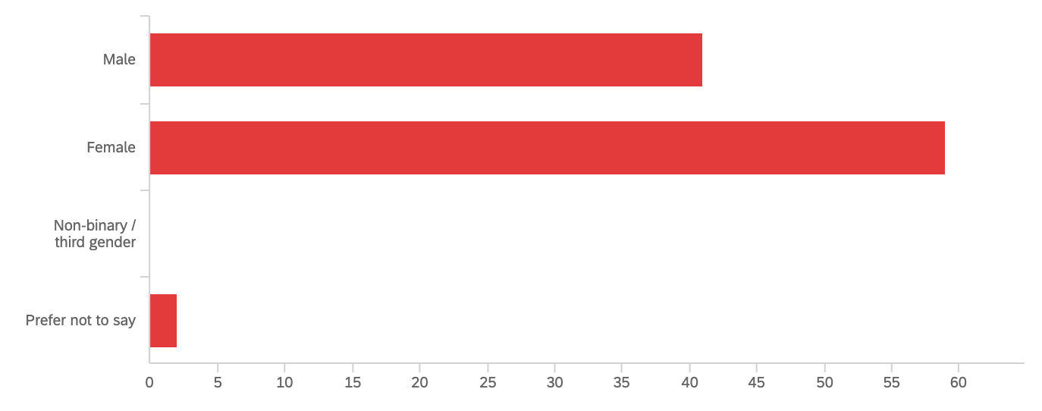
Receives financial aid from Harvard?
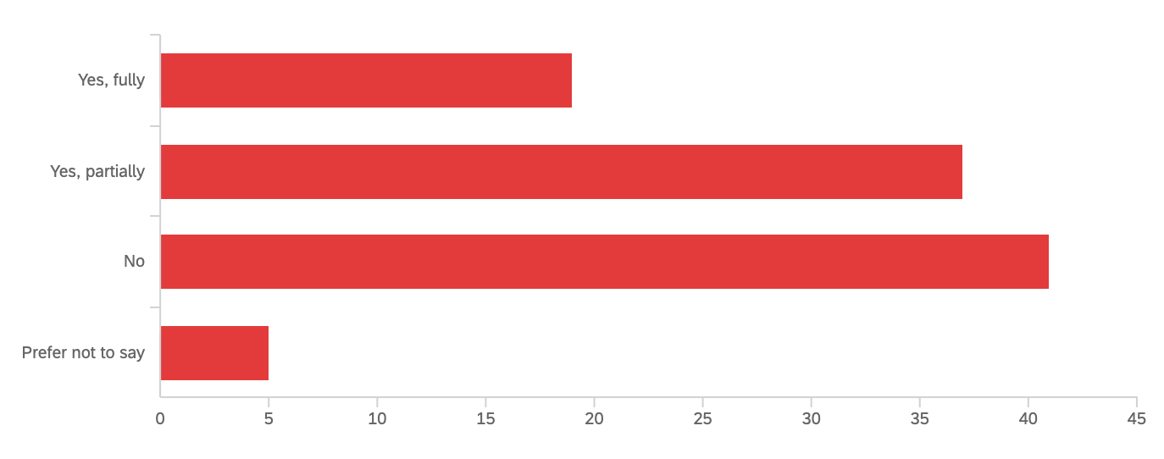
Legacy Status:
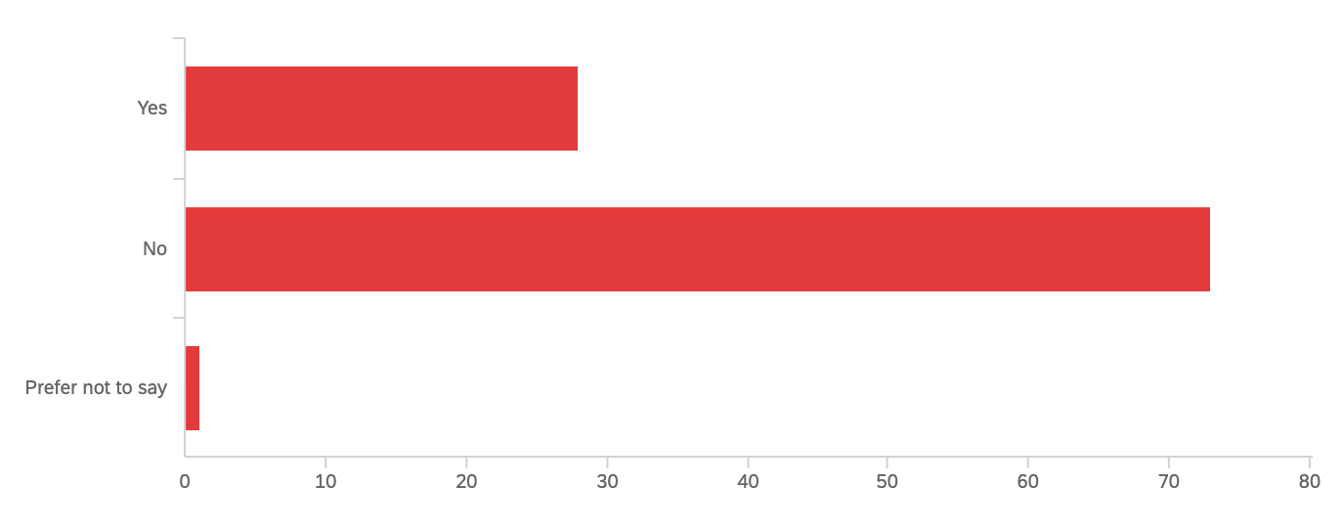
Competes Inter-Collegiately?

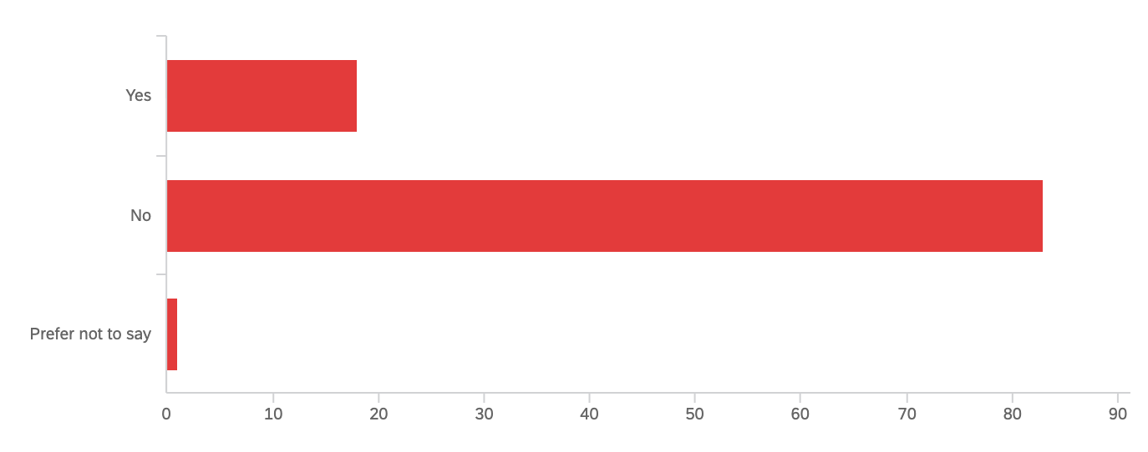

Survey Guide
Questions that appeared on the widely distributed survey included:

- Concentration, House:

- On average, how many Harvard varsity sport events do you attend per semester?

- On average, how many days of a typical week does your outfit involve at least one piece of Harvard apparel?

- Please rate your agreement with the following statements, on a 1-5 scale, with “5” being strongly agree:
- Harvard College has school spirit
- I feel as if I belong within the greater Harvard community
- I am comfortable calling Harvard College “home”
- When asked where I go to school, I have no hesitation revealing I go to Harvard
- My residential House has house spirit
- I feel as if I belong in my House community
- I feel as if I belong within certain campus clubs and organizations
- Having a Harvard mascot would be a positive influence on my Harvard experience

- It is 5pm on a Thursday and you have several options of how to spend your evening. Barring any urgent deadlines, please rank the following activities in order of preference:
- Hang out with close friends
- Attend an optional meeting for a club you are part of
- Attend a Harvard Crimson athletics event
- Compete in a House Intramural competition
- Work on a school assignment due the following Monday

- Optional: Please provide further elaborations on why you ranked in this order.

Demographics:
- Which gender do you identify with?
  - Female
  - Male
  - Gender variant/Non-Conforming
  - Not listed:
  - Would rather not answer
- Do you receive financial aid from Harvard?
  - Yes, partially
  - Yes, fully
  - No
- Do you compete for Harvard on an inter-collegiate scale?
  - Yes
    - Optional: Which one?
  - No
  - Would rather not answer
- Do you have family members that also attended Harvard College?
  - Yes
  - No
  - Would rather not answer

- Would you be willing to participate in a 20 minute Zoom interview to further discuss your answers to this survey?

Roundtable Subject Characteristics:

Sydney:
- House: Leverett
- Year: Junior
- Concentration: Statistics, Pre-Med
- Gender: Female
- Race: Asian-American

Xander:
- House: Currier
- Year: Junior
- Concentration: Social Studies
- Gender: Male
- Race: African-American

Interview Guide

Questions and prompts that arose arise during roundtable interviews included:

- How would you define school spirit?
- Please describe your personal experiences with Harvard College, as it relates to campus-wide school spirit.
- In what ways do you feel you belong at Harvard? In what ways do you feel that you may not?
- Describe your experience with your Residential House. How heavily involved are you with House events and intramural activities?
- Where do you find yourself spending the most time on campus? What are your experiences with clubs and organizations?
- Where have you recognized any shortcomings in fostering spirit across Harvard College?
- Where have you recognized any successes in fostering spirit across Harvard College?
- Do you have any suggestions on how to maintain or grow a sense of belonging at Harvard?
Recruitment Letter
SOCIOL1104 RECRUITMENT EMAILS

STUDENTS

Dear […] ,

I am taking a course on the sociology of higher education (SOCIOL1104). As part of this course, I am researching factors and student attitudes about Harvard’s school spirit. I would like to conduct one short, max. thirty minute interview at a time and place convenient to you to understand your experiences and opinions on the topic.

Your answers will be kept confidential and your name will not appear in any data records (transcripts), any information that could possibly identify you will be removed, and no names or other identifiable information will be used in the final paper nor on the HUSRHE platform: https://husrhe.fas.harvard.edu/ where my paper may be showcased. Immediately after the interview is conducted a special code will be generated for the record and the label will include following terms “student-date of interview”.

If you are willing to speak on-record, in which case your name and any quotations I might use, will appear in the paper, please let me know. In this case I will send you the paragraphs for final check before the paper will appear on HUSRHE.

The project is exempt from CUHS approval since it qualifies as course-related research.

We hope you can support our research by agreeing to be interviewed. Please let me know if you would be willing to be interviewed and when you would be available.

Thank you,
Felix Bulwa

Consent Forms
SOCIOL1104 CONSENT FORM FOR ONLINE SURVEYS

My name is Felix Bulwa, and I am asking you to take part in my class project on school spirit at Harvard for the research-intensive course SOCIOL1104 Sociology of Higher Education, in which I am an enrolled student this Fall 2021.

If you choose to participate, I ask you to complete a survey. This survey will help me learn more about how Harvard students perceive school spirit on campus and to what level they choose to express it.

You can skip questions that you do not want to answer or stop the survey at any time. Participating in this study is voluntary.

Your answers will be kept confidential and your personal information will not be shared with anyone.

If you want to participate in this study, click the Start button to start the survey.

Questions? Please contact the SOCIOL1104 course instructor Dr. Manja Klemencic at manjaklemencic@g.harvard.edu .

--
SOCIOL1104 Sociology of Higher Education

CONSENT FORM for INTERVIEW

My name is Felix Bulwa, and I am asking you to take part in my course research project on school spirit at Harvard for the course SOCIOL1104 Sociology of Higher Education offered at the Department of Sociology, Faculty of Arts and Sciences, Harvard University.

I would like to conduct a short interview with you as part of my research project. The interview will last about 20 minutes. Your participation is voluntary. Please tell me if you do not want to participate. You can skip questions that you do not want to answer or stop the interview at any time.

Consent for confidential or on-record interview

I am asking you to consent to a confidential interview or an on-record interview.

If you consent to a confidential interview, then I will keep the information I gather from this interview confidential and will not share your personal information or any information that could identify you with anyone. If I use any quotes from the interview, I will not disclose your name or position or any other information that could identify you. I will refer to the source of the quote in generic terms for the position and organization or group you are involved in (for example, “a Harvard administrator” or “a member of a student group” or “a leader of a student group”).

If you consent to an on-record interview, I ask for your permission to mention your name and position with any direct quotes I use from the interview. The information may be included in my paper that may be featured at HUSRHE website (https://husrhe.fas.harvard.edu/) which is openly accessible and viewable via worldwide web to anyone who gets a link.

Please inform me which interview you consent to:

I consent to a confidential interview. OR I consent to an on-record interview.

Greason, Grace, and Mila Solaja. “Home Field Advantage?: News: The Harvard Crimson.” News | The Harvard Crimson, https://www.thecrimson.com/article/2017/12/8/student-attendance-athletics/
Barroso, Kristina. “What Is School Spirit?” The Classroom | Empowering Students in Their College Journey, 10 Jan. 2019, https://www.theclassroom.com/school-spirit-5050088.html
Varsity Brands. School Spirit: the Connection between Student Achievement, Involvement and Confidence. http://www.casciac.org/pdfs/School_Spirit_White_Paper-FINAL.pdf
Axelrod, Jonathan. “School Spirit Not Dead Yet: Opinion: The Harvard Crimson.” Opinion | The Harvard Crimson, https://www.thecrimson.com/article/1994/11/19/school-spirit-not-dead-yet-pbtbheres/
Rossman, Margaret. “School Spirit beyond 'the Game': Opinion: The Harvard Crimson.” Opinion | The Harvard Crimson, https://www.thecrimson.com/article/2002/11/15/school-spirit-beyond-the-game-harvard/
For example, the 1994 op-ed is hopeful that the introduction of the new “Angry Pilgrim” mascot will increase sport enthusiasm. No Harvard student in the past decade has ever seen it.
Goodenow, C., & Grady, K. E. (1993). The relationship of school belonging and friends' values to academic motivation among urban adolescent students. Journal of Experimental Education, 62(1), 60–71. https://doi.org/10.1080/00220973.1993.9943831
Korpershoek, H., et al. “The Relationships between School Belonging and Students’ Motivational, Social-Emotional, Behavioural, and Academic Outcomes in Secondary Education: A Meta-Analytic Review.” Research Papers in Education, vol. 35, no. 6, 2019, pp. 641–680., https://doi.org/10.1080/02671522.2019.1615116.
Pittman, Laura D., and Adeya Richmond. “Academic and Psychological Functioning in Late Adolescence: The Importance of School Belonging.” The Journal of Experimental Education, vol. 75, no. 4, 2007, pp. 270–290., https://doi.org/10.3200/jexe.75.4.270-292.
Powerful affiliation with one’s university can even create subconscious color preferences (Schloss et al)
Strayhorn, Terrell L. College Students' Sense of Belonging a Key to Educational Success for All Students. Routledge, 2019.
Allen, Kelly, et al. “What Schools Need to Know about Fostering School Belonging: A Meta-Analysis.” Educational Psychology Review, vol. 30, no. 1, 2016, pp. 1–34., https://doi.org/10.1007/s10648-016-9389-8.
Pierce, Jon L., et al. “Toward a Theory of Psychological Ownership in Organizations.” The Academy of Management Review, vol. 26, no. 2, 2001, p. 298., https://doi.org/10.2307/259124.
For the purposes of this report, the names of interviewees have been anonymized
Note: Complete analysis of this data is difficult without quantitative comparison to other schools.
When asked about general thought on a Harvard mascot, multiple respondents simple stated “Gobble Gobble!”

